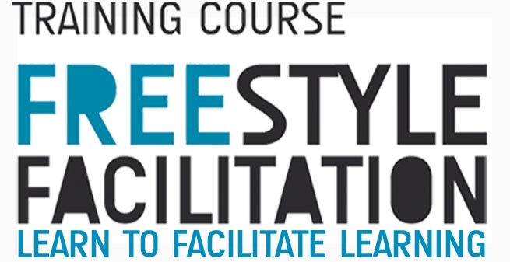

APPLICATION FORM

Please complete this form in English. The information in this form will help the trainers team to understand more about your training needs and expectations and also make sure you need this training course, so please be as complete as possible!

PERSONAL DATA

Name and current address of the participant
Family name |  | First name
Street address
Postcode |  | City
Region |  | Country
Telephone |  | Email
Personal details
Date of birth |  | Gender | female | male
Nationality
Special needs
Do you have any special needs (dietary needs, mobility problems, health care, etc.)?

Emergency contact
Please provide contact details of a person who can be contacted in case of an emergency.
Name
Telephone | _______________________

Language Abilities (Spoken)
1. English | poor | good | very good | excellent

ORGANISATION

Details of the organisation
Name
Street address
Postcode |  | City/country
Region
Email |  | Website
Telephone
Profile of the organisation
Please give a short description of your organisation (regular activities, target group, member of, etc.):

What is your role in the organisation?
.

EXPERIENCE & MOTIVATION

Previous experience
Please describe your experience as a youth worker/youth leader, concentrating especially to the ways you plan learning of young people during your work.

Motivation
Why would you like to participate in this course?

Learning needs
The TC is build on the participants learning and training needs. Please tell us what whould you like to learn and/or practice during the TC?

Results
How do you think to put into practice all that you´ll learn during the course?

Comments
Do you have any other comments as far as the Training Course is concerned?

DECLARATION

I agree that my personal data given in this application form may be made available to other participants.
I also accept to pay 30 euros as participation fee and 30% of my travel cost.

Name:

Place and Date: Signature:

Please answer the above questions as thorough as possible.

Please return this application form to:

[freestyle.facilitation@gmail.com]

Before the 30 of March 2014

THANK YOU!!!

