EMPOWERING WOMEN IV:
Youth work for young women entrepreneurship

Partnership building seminar, 26-31 October,2014 İstanbul, TURKEY

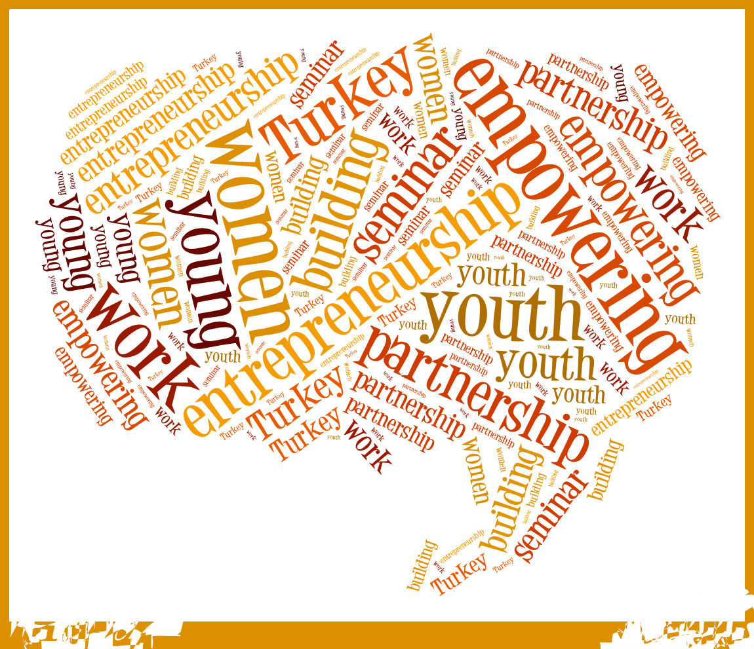

Catchy sentence
“You must do the thing you think you cannot do.” – Eleanor Roosevelt

Presentation of the activity

Activity type: Partnership building seminar.

Organisers and partners

Turkish National Agency, SALTO EM, SALTO SEE, SALTO EECA, French National Agency

Text

Empowerment surely has to start from within: it relates to your POWER and LIBERTY, plus the
CAPACITY and KNOWLEDGE to decide and to take action. But you surely need the
OPPORTUNITY to fulfill your aims.
Youth Work can thus play a fundamental role in the empowerment of women, especially in terms of providing opportunities for self-assessment, development of skills and competences and by giving practical support in the attainment of self-realization.
After the great success of the previous editions in France - in 2010 with a very general approach on the role of women in society, in 2012 with a more specific analysis on women in the field of social economy, in 2013 with an emphasis on the promotion of young women employability through non-formal education – we are now moving to Turkey for dealing more specifically on the topic of entrepreneurship and the role youth work can have in its support and encouragement.
In this partnership building seminar we will focus on the concept of entrepreneurship, the competences needed both for the target groups and youth workers and above all we intend to set an inter-sectorial partnership among participants for future cooperation.
We intend to give visibility to the importance of youth work in this field by realizing a video of high communication impact to be spread in the networks of participating organizations, stakeholders and external society.

Working language: English

Aims and objectives:

1. facilitating the inter-sectorial networking process among participants and promoting new common projects on the specific topic
2. letting participants deepening the topic of empowerment of young women
3. deepening the analysis of the realities of young women entrepreneurship through youth work in the four regions (EU + MEDA + SEE + EECA)
4. setting a strong link between the possibilities youth work can have in promoting young women entrepreneurship, and giving visibility to the process
5. giving inputs for understanding and designing practical methods for fostering young women entrepreneurship through youth work
6. getting a direct touch with the external environment, with organizations and bodies with strong connections with the thematic
7. sharing experiences and good practices in the field

Target group:
- Youth workers, trainers belonging to:
  - organisations working with women dealing with youth work and/or entrepreneurship
  - social enterprises
  - private sector working in social businesses
  - public bodies dealing with the topic
2. Coming from EU and the three regions (MEDA + SEE + EECA)
3. A gender balance is highly endorsed

45 participants

Competencies:

- Knowledge and experience in the field of youth work and young women entrepreneurship.
- High motivation in sharing experiences and opinions and in participating actively and concretely to the seminar.
- Curiosity and interest in deepening in the subject in the different countries while getting the most of local realities.
- Will to set new inter-sectorial cooperation focusing on the importance of youth work for young women entrepreneurship empowerment
- Digital competencies are highly appreciated, especially in video making (please make sure to note this in your application form).

Venue:

İstanbul - Turkey, 26-31 October, 2014

