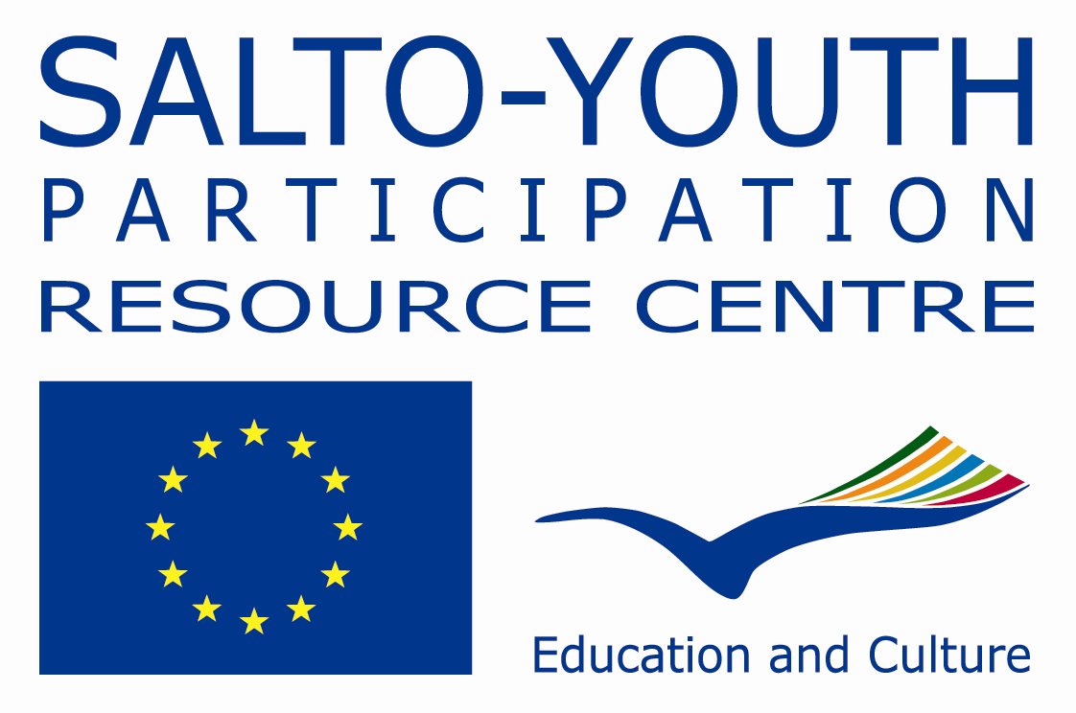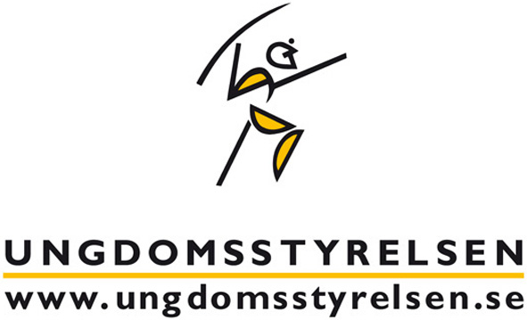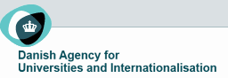
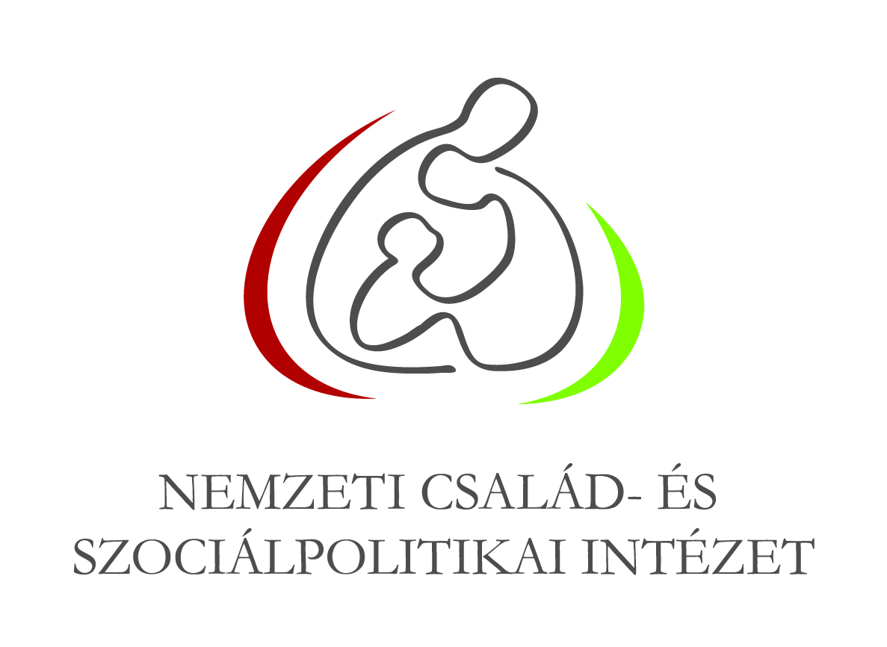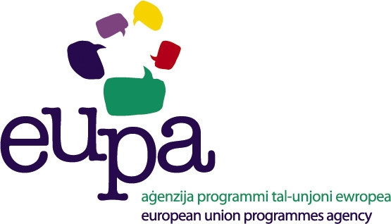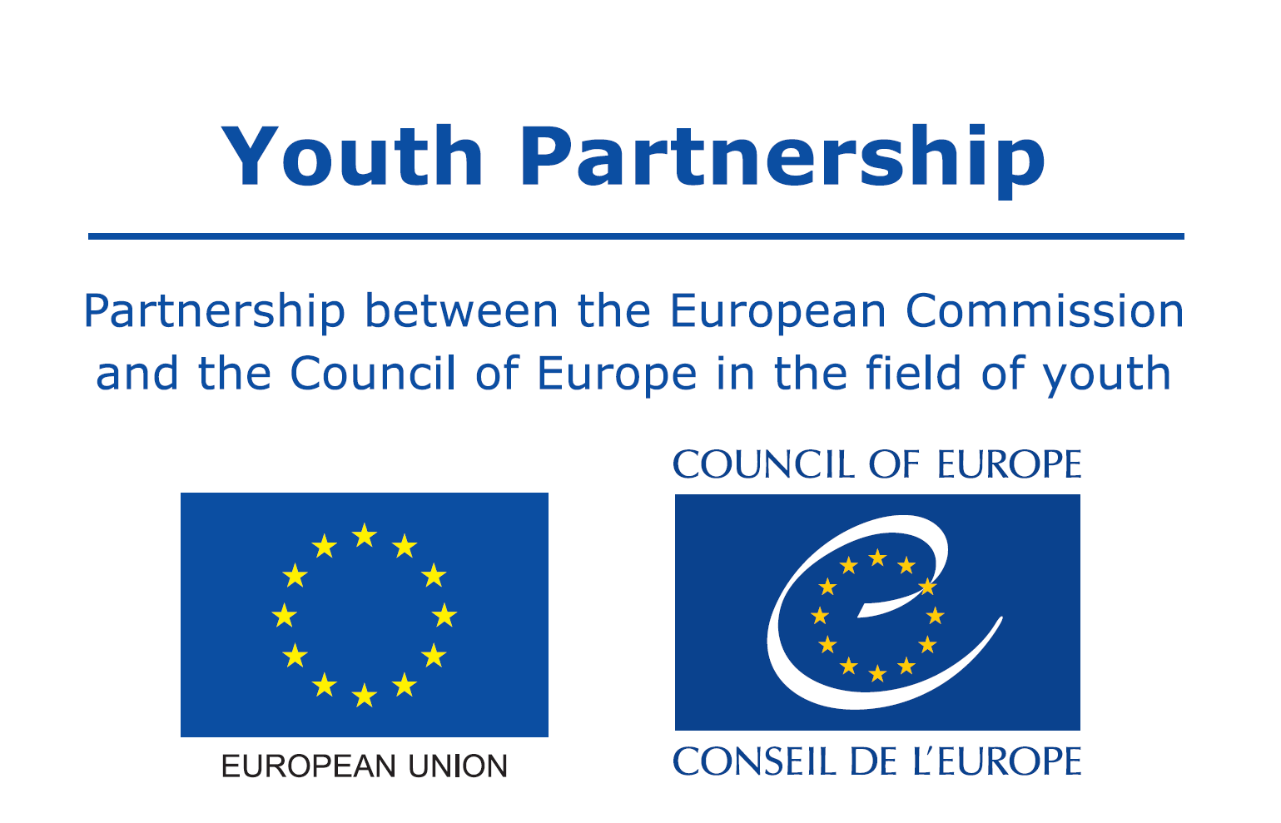

NEXT STOP: TO VOTE OR NOT TO VOTE?

Invitation to apply for an international

seminar on the electoral participation of young people

23 to 27 April 2014

Are you a youth leader/youth worker with experience in working on the electoral and political participation of/with young people looking for an opportunity to:

- Better understand the current trends an situations with regards to electoral participation of young people?
- Share initiatives aiming to encourage their participation?
- Explore the role of social media in supporting young people’s participation in political and electoral processes?
- Develop cooperation with other participants?

If so, take a look at the following invitation for an International Seminar on the electoral participation of young people!

Background

The Belgian-FR, Danish, Hungarian, Swedish and Maltese “Erasmus+:Youth in action” National Agencies, together with the SALTO-YOUTH Participation resource centre, have decided to focus their attention on the electoral participation of young people in Europe. As the European and national elections in various EU Member States approach, we take this opportunity to organise a seminar to look at research findings, existing practices and initiatives tackling the political and electoral participation of young people and stimulate cross-sector co-operation.

The Partnership between the European Commission and the Council of Europe in the field of youth supports the seminar‘s conceptual development and organisation.

A study visit in Malta will be organised prior to the seminar to explore the country’s high voter turnout and encourage participants to cooperate on a campaign which can ultimately result in various projects under all key actions of Erasmus+.

These events are to be seen as the first steps of a long-term process on the topic initiated by the organising team. Other activities will be organized in the future, such as training courses, seminars, study visits and publications.

Where & When?

The seminar will take place in Brussels Belgium, from 23 to 27 April 2014.

Why such a seminar?

To explore the causes of the low electoral participation of young people, identify and showcase different measures taken to entice young people into getting interested and involved in elections and enhance further cooperation on the topic.

What for?

- To understand the current electoral participation of young people (background, experiences, motivation, obstacles, etc.) through research findings and good examples of practice;
- To share local, national and European initiatives aiming at encouraging young people to participate in elections, especially first-time voters and help them make informed choices;
- To explore the role of social media in supporting young people’s participation in electoral processes;
- To stimulate and reinforce co-operation among participants;

Who can apply?

The seminar will be open to 30 participants with the following profile:

Professionals with experience in working on electoral and political participation of/with young people: youth workers, youth leaders, representatives of formal education and local/regional/national public administration, youth researchers, civil society actors, think tank representatives, policy makers, etc… expected to act as multipliers in their organisations.

Participants should be willing to disseminate the outcomes of the seminar and implement them in their future work.

What is it all about?

The programme will include the following elements:

Participants and organisations | Participants present themselves, their organisations/institutions; and get to know other professionals and organisations/institutions working on the topic in Europe.
Resources | Recent research findings will be presented by a youth researcher in the field of youth (Pool of European researchers of the EU-CoE youth Partnership)  Numerous examples of practice and publications will be provided to support discussions.
Erasmus + programme, SALTO-YOUTH Participation and EU-CoE Partnership | General information will be provided about the Erasmus + programme, SALTO-YOUTH Participation resource centre and the EU-CoE youth Partnership.
National realities & practice exchange | Participants will have the opportunity to share information about their national realities as well as their practice on political/ electoral participation of/with young people.
Panel discussion | MEP’s and various experts will participate in a panel discussion about the electoral participation of young people in Europe. The panel discussion will be followed by a visit of the European Parliament.
Social media workshop and platform | A social media platform containing a live blog, pictures, videos and audio materials - will be set up to make the sharing of the resources possible between all the participants. This would also give people who can not attend the chance to follow the seminar and be part of the process.  A social media workshop will be organised to explore the role of social media in supporting young people’s participation in electoral processes.
Action planning | Action-oriented proposals will be produced at the seminar.

Which methods will be used?

The seminar will be based on the principles and values of non-formal learning/education taking into account participants’ experiences.
A diversity of working methods will be used to highlight the causes of low electoral participation of young people, identify the measures taken to encourage young people into getting interested in elections and enhance further cooperation on the topic. To ensure a balance between theory and practice, a range of workshops, inputs, simulation exercises, presentations, discussions, debate and sharing will be included.

How will the costs be covered?

- Travel and visa costs of selected participants will be covered by the sending National Agencies. Please check with your National Agency if any additional participation conditions apply.
- Hosting costs (accommodation, food, programme activities, local transport) will be covered by the organising National Agencies.

What will be the working language?

English

How to apply for the course?

- Application online available on SALTO European Training Calendar www.salto-youth.net/trainingcalendar
- Deadline for applications is [17 March 2014]
- Selection of participants and the allocation of places will be completed by [28 March 2014]
- Contact person: Stéphanie Dreze , BE-FR NA project officer (stephanie.dreze@cfwb.be , +32 (0) 2 548 38 83) & Raluca Diroescu, project coordinator, SALTO-YOUTH Participation - raluca@salto-youth.net, +32 (0) 2 22 75 282.

