29 April-06 May 2014
Antalya, Adrasan/TÜRKİYE

TURKISH NATIONAL AGENCY

“EUROCITY”
INTERNATIONAL TRAINING COURSE
INFOPACK

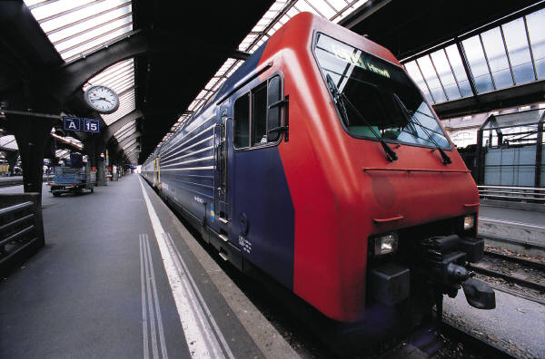

CONTENT OF THE INFORMATION PACK

1. What is EuroCity Training Course? 3
2. Aim and objectives 3
3. Erasmus+ Program 3
4. Approach and Methodology 4
4.1 Used Methods and Techniques 4
4.2 Programme Elements 5
…..4.3 Venue Place/Venue Country 5
4.4 Daily Program… 6
5. Checklist Before the EuroCity ……………………………………….7

- What is Eurocity Training Course?

The EuroCity is a training course which addresses;
- Citizenship
- Active participation
- Youth Policy/Youth Work
- Human rights
- Globalization

Training course will be implemented in a simulation, which will be going on during the course. Training will set up in a city which is named Euro. Trainers’ team will be moderators for the activities of everyday. During the course, each day the trainers will organize some simulations related to the topics, and the participants will be living in the city and organizing activities as the citizens of the EuroCity. The training will be an effective practice on non-formal and experiential learning.

2. Aim and Objectives

The main aim of the training is to understand the concept of living democracy on individual level and to increase the understanding on active participation and how to live it as a way of life.

- To discuss youth approach on global issues, such as youth unemployment, poverty, social exclusion and healthy life style,
- To share experiences on youth policy/youth work in different countries and exchange good practices and useful methods/tools to encourage youngsters for their active participation,
- To inform about Erasmus+ Program and Key Action 3,
- To raise awareness on European citizenship,
- To build future partnerships in order to develop qualified projects and,
- To understand the situation globally and focus on human rights issues in their everyday life.
- Erasmus + Program

The training is planned based on overall aims, objectives and priorities of the Erasmus+ Program especially Key Action 3: Support for Policy Reform, Structured Dialogue: Meetings between young people and decision-makers in the field of youth.

Those objectives and priorities are like followings:
- Promote participation in democratic life in Europe, active citizenship, intercultural dialogue, social inclusion and solidarity,
- Foster quality improvements in youth work, in particular through enhanced cooperation between organisations in the youth field and/or other stakeholders,
- Improve the level of key competences and skills of young people, including those with fewer opportunities.

- Approach and Methodology

In conjunction with the topic of this course –European Citizenship– this determines that learning process will:

• be based on intrinsic motivation of the learner;
• be learner –centered and based on the experience of the participants;
• be based on a personal responsibility for learning, supported by a strong group dynamics and collective approach;
• enable participants to apply and transfer what they have learned to their youth work and their social life.

- Course will be in a small environmental habitat. During the course, the participants will be in a simulation. EuroCity is a globalized city with many social problems and metaphors, participants will try to solve and analyze different problems, to participate in social life and to enable changing. The team of the trainers will be the moderators of the city. City will have its own mechanisms such as city council, city court, NGO’s and …All participants will have a role in their social life and each of them will be given different themes related to the course program by the trainers.
- take into account the needs and motivation of the participants and is open to
feedbacks and evaluations.

In the setting, the content and the methodology of the training activities is focus on participation, active involvement, sharing of thoughts and feelings, learning by doing, group work and the intercultural dimension. Creativity and variety of the methods are important in the training approach.

Main methodologies are learning by experiencing, intercultural communication, reflective approach and the educational approach. The intercultural setting is an overall educational approach during the training as working/living/leisure experience.

4.1 Used Methods and Techniques

A range of non-formal methods are used: interaction methods, task-orientated and cooperation methods, game and instruction methods, reviewing methods…

Training will be implemented as two parts; the simulation and the debrief /informative parts. By the way the team of trainers will create a city and the participants will be the citizens of this city and establish their own rules, the Constitution, the youth system and the rights of the city. Trainers will give different instructions each day to the participants. On the second part the trainers will take debrief of the simulation (informative part).

4.2 Programme Elements

- Citizenship
- Youth active participation
- Youth policy/Youth work/Governance
- Democracy
- Globalization and youth approach on global issues
- Social participation/Inclusion
- Cultural Diversity
- Intercultural Learning
- Erasmus+ Program/Key Action 3

4.3 Venue Place/Venue Country

Training will be held in Adrasan, Antalya, TÜRKİYE (Turkey).

4.4 Daily programme

EUROCITY
INTERNATIONAL TRAINING COURSE
DRAFT PROGRAM*

29.04.2014 | 1.Day 30.04.2014 | 2.Day – 01.05.2014 | 3.Day – 02.05.2014 | 4.Day – 03.05.2014 | 5.Day – 04.05.2014 | 6.Day – 05.05.2014 | 7.Day 06.05.2014
A  R  R  I  V  A  L  S | Breakfast &  Energizer | Breakfast & Energizer | Breakfast & Energizer | Breakfast & Energizer | Breakfast & Energizer | Breakfast & Energizer | Breakfast
A  R  R  I  V  A  L  S | Intro to the training  Team building  Pre-departure for EuroCity | The values in EuroCity community | Living in EuroCity  Village & Living democracy | Working meeting of Parliamentary Assembly of EuroCity on global affairs | Youth Work/Youth Policy Researchers | Project presentations and feedback | D  E  P  A  R  T  U  R  E  S
A  R  R  I  V  A  L  S | Lunch |  | Lunch | Lunch | Lunch | Lunch | D  E  P  A  R  T  U  R  E  S
A  R  R  I  V  A  L  S | Welcome in EuroCity  Euro-Citizenship | Le Cafe de EuroCity  -European Values  -Global Citizenship  -European Citizenship | -Living Democracy  -Country Realities on democracy, participation,  and citizenship | Trip | PCM  Erasmus+ Key Action 3  developing projects | EuroCity History Museum  Final Evaluation  Closing | D  E  P  A  R  T  U  R  E  S
 | Reflection Groups | Reflection Groups | Reflection Groups | Trip | Reflection Groups | EuroCity History Museum  Final Evaluation  Closing | D  E  P  A  R  T  U  R  E  S
Dinner | Dinner | Dinner | Dinner | Dinner in the town | Dinner | Dinner | D  E  P  A  R  T  U  R  E  S
Welcome Cocktail | EuroCity Cultural Evening | Free evening | Free evening | Evening out | Free evening | EuroCity Costume Party | D  E  P  A  R  T  U  R  E  S

* Draft Programme of the training course can be developed and changed by the trainers later.

- Checklist Before the EuroCity

Get ready your mood for a fantastic training in EuroCity

Get ready your language (don’t forget to put sun clothes, sun glasses and raining suits as well)

Don’t forget to bring food, music and something cultural for the EuroCity Cultural Evening

Don’t forget to bring a special costume for Costume party
on 6th night

Prepare information about your country’s reality about
democracy, citizenship and youth work/youth policy

Don’t forget your camera

