
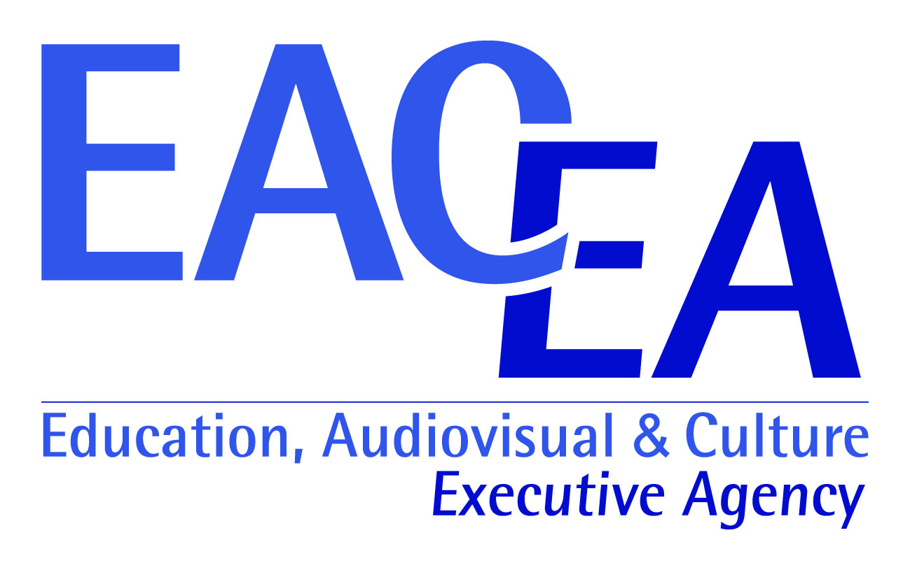



“Negotiation Lab”
International Training Course
Yerevan | Armenia

| March 13-20, 2014 |

General Idea:
Title: Negotiation Lab
Training course 3.1
Date/location: March 13-20, 2014, (8 days), Yerevan
Host organization: Privatissima Educational Fund (Armenia)
Partner Countries: Romania, Moldova, Turkey

In an increasingly interdependent world, negotiation skills have become the inextricable part of young leaders and youth workers both in Europe and the neighboring countries. We buy and sell, manage our subordinates and work for supervisors, deal with friends, family, colleagues, organizations, and institutions all the time. Moreover, equipping youth with this skill contributes greatly to the promotion of participatory policy-making, improving results of deliberative processes, and promoting regional understanding and peace. In this regard, the dynamics and mechanism between and within EU institutions is valuable example to study and learn from.

Designed to accelerate youth workers’ negotiation capabilities, The “Negotiation Lab” through non-formal education methodologies will examine core decision-making challenges, analyze various negotiation scenarios, and provide a range of cooperative negotiation strategies and tools. The training course will be anchored on EU model providing participants with a practical insight into the negotiation processes within EU and raise awareness about EU decision making processes. Participants will take part in various real-life based negotiation simulations which will be recorded and analyzed step by step to reach maximum learning. The analysis, discussions, and the flow of learning will be constructed on the spot upon participant’s personal experience.

This program will help young leaders and youth workers shape important deals, respect and manage cultural diversity, improve working relationships, claim (and create) more value, resolve seemingly intractable disputes and expand their knowledge about EU decision making processes.

Objectives of “Negotiation Lab”
- Train and equip youth workers with effective negotiation skills, attitudes for conflict management and value creation.
- Provide participants with a practical insight into the negotiation processes within EU and raise awareness about EU decision making processes.
- Contribute to the promotion of participatory policy-making, improving results of deliberative processes, and promoting understanding, tolerance and peace.

Dates:
The Training Course will be organized from March 13-20, 2014.

Application
To apply please fill in the attached form and send to liana.avanesyan@yahoo.com
Important notice: Applications will be evaluated as they come. Applying early will increase your chances!
Application final deadline: February 7, 2014.

Participants profiles:
15 participants: youth workers or /and young leaders with age over 18 interested in developing their negotiation skill. Participants must have excellent knowledge of English as all negotiation simulation exercises and case studies will be in English. Thus, good language skills are necessary for effective participation. Furthermore, participants must demonstrate clear interest and commitment to fully attend and make the most out of the training.
2 trainers
2 Support staff

List of Partner organizations, number of participants and maximum travel costs:

Country (city) | Promoter organization | Number of Participants | Male | Female | Reimbursement limit
Romania (Bucharest) | ASOCIATIA TINERI PARTENERI PENTRU DEZVOLTAREA SOCIETATII CIVIL | 3 | 2 | 1 | 476 Euro/ person
Moldova (Orhei) | Agentia de Dezvoltare Rurala – Centru | 3 | 1 | 2 | 500 Euro/person
Turkey (Istanbul) | Yaşayarak Öğrenme Merkezi – Informal Education Youth Centre | 3 | 2 | 1 | 220 Euro/person

Financial Condition/ Travel Cost:

The Training Course will be implemented in the frame of the EU Youth in Action Program, Action 3.1. Accommodation, food, visa fees and materials will be covered fully by the organizers. Travel expenses will be reimbursed at 70% of the real cost.

Insurance is obligatory and should be arranged and covered by each participant.
The organizers will cover/reimburse 70% of participants' travel costs (with cheapest mean of transportation) in return of original tickets.

As a participant you have the following 2 options:

Option 1
We (Privatissima Educational Fund) will buy your ticket after you have sent us 30% of the ticket cost.

We introduced this option to make it easy for you to come to Armenia without the need to commit big amounts and wait for reimbursement. (You will still need to provide us any tickets, printed out e-tickets, boarding passes, etc. Also the original documents, tickets, boarding passes for the return flight must be sent by post to us).

Please contact Liana AVANESYAN (liana.avanesyan@yahoo.com) to book your tickets and arrange the transfer of your 30% share of the cost to us, so that we can proceed with your ticket purchase.

Please have in mind that the transport from Yerevan Airport to the hotel in Yerevan will be organized by the organizers and that you have to cover 30% of these costs.

IMPORTANT notices!
- If you cancel your participation after your ticket has been purchased by us or fail to provide the boarding pass or other proofs of travel, you will have to compensate the other 70% of the ticket cost. So please make sure you are committed and able to participate before asking us to buy your ticket.
- As an organization we buy the tickets through a local travel agency. There is non-reimbursable fee 48 EURO which must be covered by the participant in case you request us to buy your tickets. Unfortunately as an organization we cannot purchase online.

Option 2
You buy your tickets and get 70% reimbursed after the end of the training course via bank transfer.

Please note that you should bring with you sufficient and adequate proof/ evidence of your travel costs – you should have the originals of invoices, tickets, printed out e-tickets, boarding passes, etc. On all the documents a price should be clearly visible; otherwise we will be unable to reimburse the costs.

NB!!! Please note that participant’s travel costs should not exceed the travel budget limits which were approved by EACEA and the travel route should also be in accordance. Find the travel limits above!
If you have problems to stay within the indicated travel limits please contact the organizers.

70% of the travel cost will be reimbursed via bank transfer. During the project the participants should present all the documents presented above. The original documents, tickets, boarding passes for the return flight must be sent by post to this address:

Lianna Avanesyan
26 apt. 20b. Moldovakan st.
N.Nork 2nd, 0062, Yerevan, Armenia

As soon as we will receive the remaining documents by post we will make the bank transfer. [Transfer fees of any intermediate or receiving bank will be deducted from participant’s reimbursed amount]

Please have in mind that the transport from Yerevan Airport to the hotel in Yerevan will be organized by the organizers and that you have to cover 30% of these costs.

Travel Dates:
Arrival: |  | March 12, 2014 in Yerevan
Departure: |  | March 20, 2014 from Yerevan

Transport Details:
Most of you will arrive at Zvartnots International Airport. For more information about the airport, please visit http://www.zvartnots.aero/.
While arriving, please look for someone from our staff with the TC name.
In case of emergency or any travel changes you can call or send a text message using this number: +37455385428

Visa:
Only Participants from Turkey need a visa to enter Armenia.
You can apply for e-visa here http://www.mfa.am/eVisa/
Please, check the validity of the passports before the departure!

Venue: Accomodation and Food
The Training Course will be hosted in the capital Yerevan. Information regarding the hotel will be provided later. We will do our best to provide comfortable rooms and facilities for this project.

Organizers will provide participants with three meals per day & coffee breaks. Please, keep in mind, that the provided food may differ from the food you are used to have in your country, and, even in case of providing food for special groups, e.g. vegetarians, it may not fully meet your expectations. We strongly recommend participants to inform the organizers IN ADVANCE about any special needs.

Checklist – what you need to bring with you:

- Proof of all the travel expenses you wish to reclaim: No payment will be made without a proof of your expenses! If you come by plane, please be sure to bring evidence of the sum actually paid (invoice, copy of credit card slip), a copy of the ticket and your boarding passes, or in the case of an email booking, a print out of the reservation confirmation and financial transaction. DO KEEP ALL FLIGHT/TRAIN/BUS TICKETS, BOARDING CARDS, INVOICES ETC WITH YOU AND DO NOT THROW THEM AWAY!!!
- Other Expenses: All other expenses during the activity, such as board, lodging and transportation, will be borne by the organizers. However, all participants’ personal costs (like telephone calls, gifts and souvenirs, etc.) and/or any other cost not linked to programe’s events have to be covered by the participants and will be settled directly by them.
- “Standard seminar equipment”: An alarm clock, any dictionaries you might require, music CDs and tapes, instruments that you may need, comfortable clothes, warm clothes to be worn both inside and outside, etc
- Please bring all necessary identity documents (social and medical insurance, I.D. etc.) in the case of need.
- Any materials you need to present you country (food, drinks, music, post cards) during the intercultural evening, specific working methods or tools, and your organization

Local Money:
The Armenian Currency is called ARMENIAN DRAM. In the shops US dollars and Euros are not taken. There are many places in Yerevan where you may exchange money (from Euros and US dollars). We recommend using cash instead of credit or debit cards as fees usually have to be paid when withdrawing money in Armenia.

Armenian Mobile Phones:
There are three mobile operators in Armenia: Beeline, VivaCell-MTS and Orange. In case you need an Armenian Mobile/Sim card, please inform the organizers and we’ll help you get one!

Organizers:
Project will be implemented by Privatissima Education Fund in cooperation with its partners and is responsible for application, organization, administration and logistics of the Training Course.
Contacts:
Liana Avanesyan | liana.avanesyan@yahoo.com | +374 55 38 54 28
Application Form
“Negotiation Lab”
International Training Course: Yerevan | Armenia | March 13-20, 2014 |

Please submit this form to:
liana.avanesyan@yahoo.com
Before February 7, 2014
[Applications will be evaluated as they come. Applying early will increase your chances!]

Contacts

Country |  | Your photo
Full Name |  | Your photo
Date of Birth |  | Your photo
Citizenship |  | Your photo
Gender |  | Your photo
Full address |  | Your photo
E-mail |  | Your photo
Phone number |  | Your photo
Facebook profile link (if applicable) |  | Your photo

Education

Work

Other activities and interests (including other trainings you have taken in the past)

What are your expectations from this training? Do you need negotiation skills in your daily life? What do you want to get and learn?

English Language requirement: This training will be based on materials and cases developed by Harvard University Program on Negotiation. You would need to read case studies and role simulation instructions and negotiate with each other in English. Thus, good language skills are necessary for effective participation. Do you think you have the necessary level of English to comfortably participate in the training.

- Yes ……..
- No ……..

Comments:

Which travel arrangement option do you prefer? [check info pack for info and terms of reimbursement]

□ Option 1 :We (Privatissima Educational Fund) will buy your airline ticket after you have sent us 30% of the ticket cost.

□ Option 2: You buy your airline tickets and get 70% reimbursed after the end of the training course via bank transfer.

Any special needs (regarding food, accommodation, transport..etc)?

