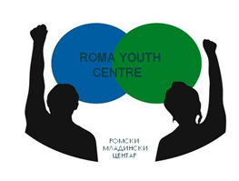

Application Form

“Young Community Leaders”

Date: 15-24 March 2014
Venue: Macedonia

Participant’s details:

Name and Surname:
Country:
Age:
Gender:
Address:
e-mail:
Mobile Phone:

Organization’s Details:
(If you are applying as individual do not fill this field)

Name of organization / institution:
Type of organization (NGO, public body…)
Country:
Address:
e-mail:
Phone/fax:
Web:

Please answer the following questions:

(If you are applying as individual do not fill this field)

What is your role in your organization/institution (employed youth worker, volunteer, project coordinator…)

How can you contribute for this activity as a participant?

Why do you want to participate in this project?

Do you have any special needs?

How much cost the cheapest kind of transport from your town to Skopje and back?

Please send the filled application form to info_romayouthcentre@yahoo.com by the:

DEADLINE: 25th of January 2014

Good Luck !

