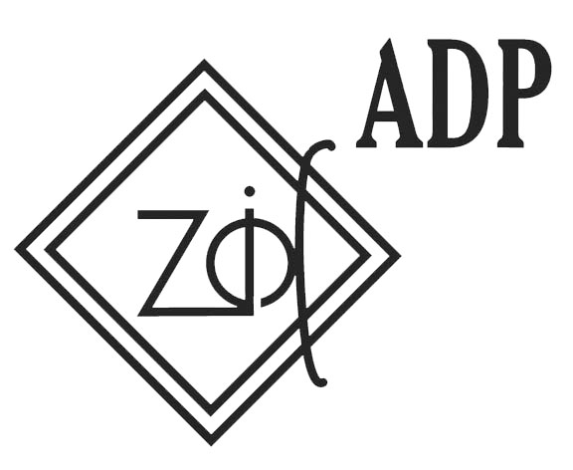

With the financial support of
the European Youth Foundation

CALL FOR PARTICIPANTS
“Effective measure for inclusion of Youth and their preparation for the labour market trough engagement in CSO's.” – Training for Youth Leaders

From 05th until 12th, November 2013
Bar, Montenegro

Dear,

I am pleased to inform you that Association of Democratic prosperity – Zid preparing training for youth leaders from 05th until 12th, November 2013. Training will be held in Bar, Montenegro.

Main aim of training is to provide knowledge, skills and methods to active volunteers, peers and excluded youth how to successfully enter into labour market presenting to them the possibilities of employment through different ways of engagement (intern, long-term volunteering, internship, part-time contract), tackling initiatives based on needs of different sector (private or public) in order to gain new knowledge and to increase their self confidence.

Objectives of the meeting:
• To increase knowledge of 20 participants coming from different countries and backgrounds about different working engagement and its possibilities of (intern, volunteering etc)
• To present to participants institution on European level in general and those having youth as target group in particular
• To explore deeper key competence that can be developed by different working engagement.
• To fight against poverty and marginalization and to encourage and include youth coming from different backgrounds to take initiatives and express their ideas and creativity
• To promote main decision and declaration adopted in the Council of Europe to encourage the contribution of young people and youth organizations to the implementation of the priorities at local and national levels.

Objectives of the training are tackling the issue of youth unemployment as well as projects aimed to stimulate inclusion of young people's mobility and active participation in society. The project is outcome of direct work with youth and organization dealing with youth, and research on their needs on national and international level.

Training will gave opportunity to youth to hear what representatives of several Montenegrin institutions and representatives of international business sector think about youth engagement and their perspective, also they will be more aware about how important is having all that start – up skills before starting even to ask for job. Conclusion would be list of possible engagement (from European institution as high level, then in public sector and on the end in NGOs on volunteer position).

Methodology and main program elements:

Workshops and non-formal education will be used to improve knowledge of participants referring the main topic of the meeting; Approach and methods will be based on self directed learning as it is important to discover their capacities and preferences, but as well trainers would put forward their self esteem and self confidence. Training course will gave space to participants to practice non developed competencies or as well as opportunity to be facilitated in their practical work. There will be presented which kind of competencies youth can develop by being engage in CSO, public or business sector.

Presentation and debate about influence of different decisions, recommendations and declarations of CoE as European Quality Charter for Mobility, Ohrid Process Declaration, European charter on the youth participation, Agenda 2020.... Sheering good practice examples about main topic of the meeting; end so on.
The methods used over the training will be:

- Visual presentations
- Lectures
- Group discussions and brainstorming
- Group debates
- Case studies
- Role-play
- Good practice examples
Host Organisation: Association for Democratic Prosperity - Zid
Working languages: English

Participants: 20 participants,

Advantage during the selection would have participants who have work or voluntary engagement in organization where they can use and implement knowledge, experience and connections from this training.

Financial conditions: 70% of the travel cost covered. Full board during training will be provided for all selected participants.

Please fill and send application:
by email hosting.zid@gmail.com
or by fax: +382 20 20 71 31

not later than 20th October 2013

