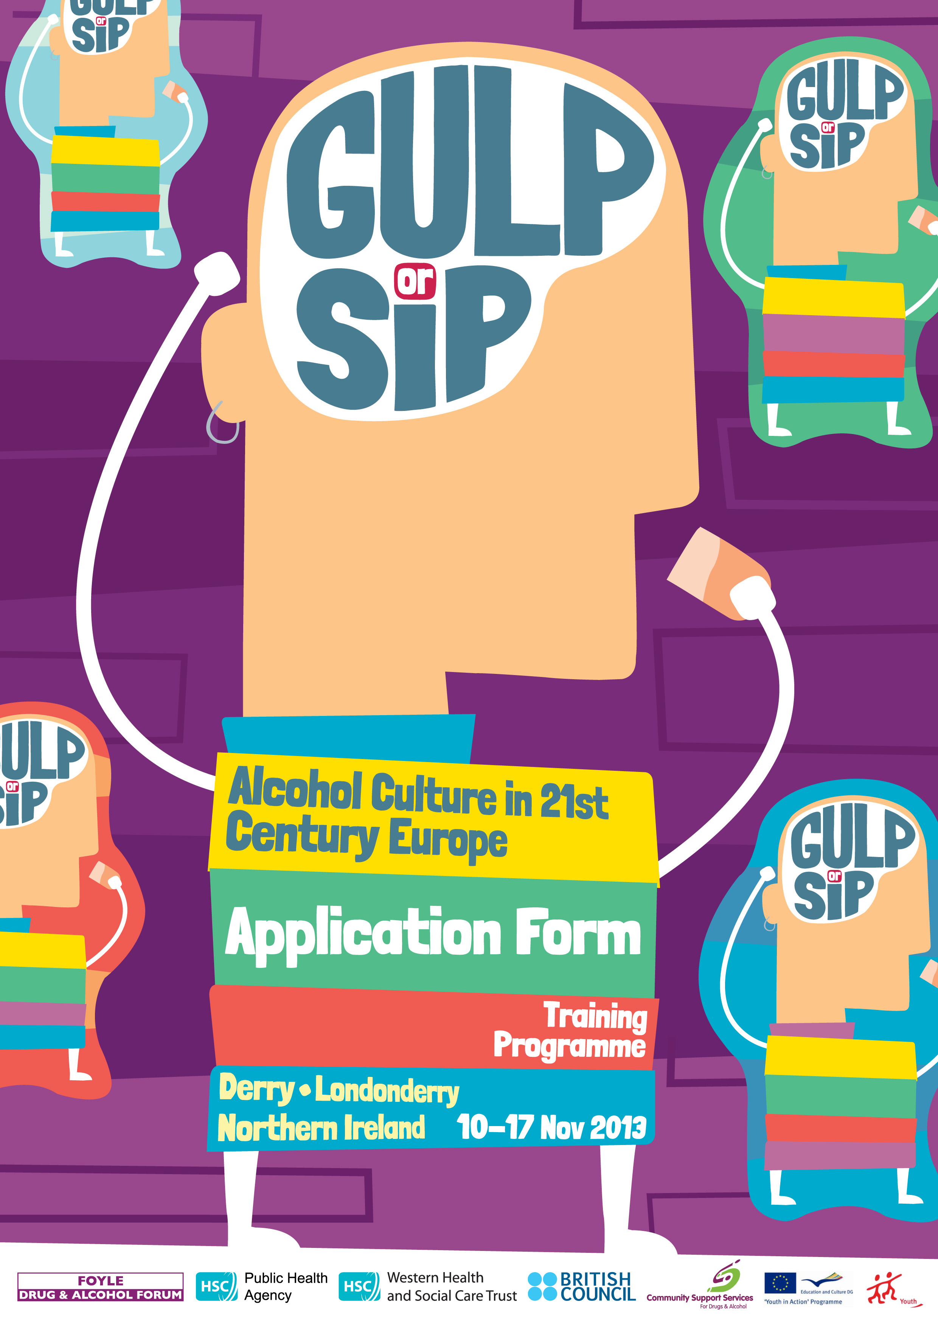



c/o Community Support Services for Drugs and Alcohol,
Health Improvement Department,
Maple Villa, Gransha Park,
Derry ~ Londonderry
BT47 6WJ
(0044) 02871 865236

Gulp or Sip? Alcohol Culture in 21st Century Europe. Application Form

Personal data

Surname: First Name:

Address:

Date of birth (dd/mm/yyyy): Gender: male female

Phone: Fax:

Email: (this is the email we will use for further contact !)

Facebook or other Social Media:

Passport No & Issuing Authority:

Special needs (e.g. dietary requirements, accessibility...):

Contact Person in case of emergency (name and tel no):

Working language will be English, please tell us your language abilities:
Level |  | fluent | good | medium | basic | poor
 | English
Second Language
Third language
Fourth language

Your Organisation (if applicable)
Name:

Address:

Phone/FAX: email/website:

Are you working there as a Volunteer: or in paid capacity:

Please describe briefly the work of your organisation:

Please note that in answering the following questions there is no ‘right’ or ‘wrong answer’ – that said we don’t want a book for each answer nor will one or two ‘abstract’ lines suffice unless for example the answer is a simple yes or no or ‘I don’t have experience in this area’.

The form is not designed to ‘trip you up’, annoy or exhaust you but rather to offer us a ‘picture’ so that when making decisions about who gets selected for programmes we are in a best position to make the right choice and to ensure that the programme is likely to offer you what you are looking for.

So, we’re not looking for you to sit up the whole night but then again we’re not looking for you to complete it during your mid-morning coffee break – give us something to go on..... ☺

Describe your experience in youth work in a few words (what kind of young people you are working with or have worked with, methodological approaches used and practical activities organised).

If you have any international youth work experience can you please describe it.

What is your motivation for attending this programme?

What do you expect from this programme?

What would make this programme ‘work for you’, i.e., what would make the experience worthwhile, what needs to happen in order for it not to be a waste of time for you? Can you also say something about your responsibility towards this, i.e., what you will do to ensure that the programme is not going to be a ‘waste of time’ either.

Have you participated in similar programme before? If so please tell us a little about it, if not, please tell us a little about what your understanding of the programme is in your own words?

Please describe your specific experience with the subject matter being proposed in the training (if you have any). If you have addressed this in the previous question just state ‘see previous question’

How would you plan to ‘multiply’ this training experience, i.e., organise programme or programmes in response to your participation in the training? What do you think you can or will do with it? What kind of support might you need to help make things happen on your return?

If someone else was to describe you what would he/she say? Please use this space to describe you in a personal and professional capacity – this should include both strengths and areas where you can improve upon.

Where did you learn about this programme?

Anything else you would like to add in support of your application?

Referees: (one should know you in a professional capacity and neither should be a family member - names, organisation, address, position, e-mail and telephone number.

In addition to returning your application to your respective partner organisation (see table overleaf) all applications should be forwarded to aaron.mcshane@westerntrust.hscni.net by Friday 4th October 2013.

PARTNER ORGANISATIONS CONTACTS

Organisation | Name | Country | Email
Community Support Services - FDAF | John Mahon | N Ireland | john.mahon@westerntrust.hscni.net
UNESCO Initiative Centre | Piotrek Dobrosz | Poland | piotrek.dobrosz@unescocentre.pl
Alcohol Forum Limited | John O’Kane | Rep of Ireland | john@alcoholforum.org
Club Young Scientists | Dimitar Grudev | Bulgaria | dimitar@cys.bg
No Excuse Slovenia | Dais kokol | Slovenia | dasa.kokole@noexcuse.si

