How does the voluntary engagement of young people enhance their active citizenship and solidarity?

A research seminar that will provide a better understanding and knowledge of voluntary activities of young people across Europe

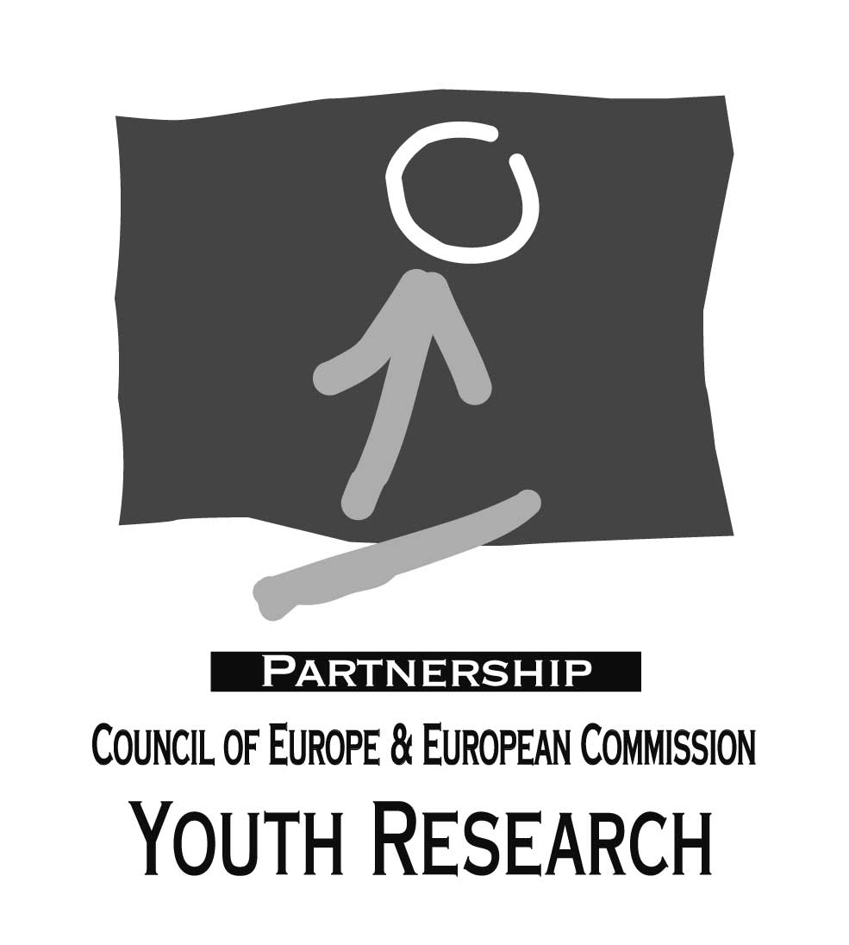

5-7 July 2004 Budapest

Call for applicants from the field of inter disciplinary researchers

A Partnership on Youth Research

The seminar takes place in the context of the research partnership between the European Commission and the Council of Europe. In April 2003, the Council of Europe and the European Commission initiated co-operation in youth research under the terms of a two-year partnership agreement.

The aim of the research partnership is to bring together research knowledge about the situation, needs and lifestyles of young people in Europe today in order to inform European youth policy and educational practice. The research partnership also seeks to strengthen the role of research in policymaking and educational practice, on the grounds that research makes an essential contribution to evidence-based decision-making in youth policy and action.

The programme of this partnership is built on a yearly schedule of three research seminars on different topics, follow-up publications, an annual network meeting of experts on youth research and information and the development of the European Knowledge Centre for youth policy makers.

Voluntary activities of young people in the context of policy-making

Council of Europe

The Council of Europe has a number of existing tools for policy implementation of voluntary activities: a Recommendation on the Promotion of Voluntary Services and a Convention on the Promotion of a Transnational Long-Term Voluntary Service for Young People (currently this convention has not yet been ratified).

The Recommendation is towards national governments to create a definition of voluntary services that emphasises both educational aspects and importance for society and to promote voluntary services. It also recommends to remove the difficulties for volunteering across national boundaries in Europe in particular for central and Eastern European countries and to support financially individuals or groups who wish to volunteer on a European level. It finally recommends encouraging increased co-operation between the European Union and the Council of Europe, in order to create an appropriate political, legal and financial framework of support for voluntary service in all European countries.

The Convention sets a legal framework for transnational volunteering providing details of the roles and procedures of all actors involved in the sending, hosting and participation in volunteer activities.

- Recommendation: http://cm.coe.int/ta/rec/1994/94r4.htm
- Convention: http://conventions.coe.int/Treaty/Commun/QueVoulezVous.asp?NT=175&CM=8&DF=06/04/04&CL=ENG

The governing bodies of the Council of Europe are currently evaluating the next steps for the support of voluntary activities in Europe. This seminar will form an important input to this debate.

European Commission

Proposal for common objectives for voluntary activities of young people

In the European Commission’s White Paper “A New Impetus for European Youth” of November 2001 voluntary activities were identified as a priority in the youth field, alongside with participation and information of young people and a greater understanding and knowledge of youth. These priorities are all tackled by the open method of co-ordination.

In the framework of this method a questionnaire was sent to the 25 EU Member States as of 1 May 2004 as well as to the three candidate countries requesting information on voluntary activities of young people. The answers to the questionnaires were analysed in a synthesis report and formed, together with the results of consultations of young people the basis for a proposal of the European Commission for common objectives in this field. These proposals for common objectives are envisaged to be adopted by the end of April by the European Commission. They will subsequently be submitted to the Council of Youth Ministers who will probably decide to adopt a Resolution on common objectives on voluntary activities of young people by the end of this year.

European Voluntary Service (EVS)

The European Commission has the well developed European Voluntary Service (EVS) which is one action of the YOUTH Programme which funds activities of young people. The EVS allows around 3.500 young people between the age of 18-15 to engage in volunteering in a big variety of areas with a funding of approximately 33 million EURO this year. The EVS is more than a funding programme; it is a quality model for transnational voluntary service. A key element is the balance between providing a service to the community and non-formal learning: Young volunteers receive training and acquire important new skills and competences, which can enhance their employability. A European certificate is issued upon the end of the service.

In the framework of the intermediary the EVS has recently undergone an evaluation whose results will be integrated into the discussions of the seminar. The European Commission also plans to develop the EVS further in view of giving it a stronger impact and visibility, but also to strengthen it collective aspect.

EVS: http://europa.eu.int/comm/youth/program/sos/vh_evs_en.html
YOUTH Programme: http://europa.eu.int/comm/youth/program/index_en.html
Evaluation: http://europa.eu.int/comm/youth/program/evaluation_en.html

European Parliament and Council of Ministers

The European Parliament and Council of Ministers have produced a Recommendation on Mobility within the Community for Students, Persons Undergoing Training, Volunteers, Teachers and Trainers (2001/613/EC). The Recommendation states that involvement in transnational voluntary activities helps to shape young people's future careers, develop their social skills and smooth their integration into society, thereby fostering the development of an active citizenship. It also emphasizes that not recognising the specific nature of voluntary work is a hindrance to the mobility of volunteers. Therefore Member States should consider the removal legal and administrative obstacles but also support the learning of languages and cultures.

- Recommendation: http://europa.eu.int/scadplus/leg/en/cha/c11015.htm

The research seminar

I. Content

Young people who participate on a voluntary basis provide a service that benefits the individual volunteer and society alike. The individual volunteer benefits from a feeling of belonging and contributing to society and learns skills and competencies that are beneficial to life and labour market opportunities. The society benefits from the volunteer who acts as a responsible citizen helping others in their community and becomes part of the system for renewal of civil society as a whole.

On a European level this argument is then widened to needs of a European civil society, developing a sense of European citizenship and creating the European knowledge based society.

This seminar will take the opportunity to critically reflect on this commons sense belief of volunteering using the evidence from research to develop a more precise understanding of the links between volunteering and national and European citizenship, social inclusion and the development of the ‘knowledge society’. The seminar will also examine the evidence of access to volunteering, exploring barriers to participation and will also evaluate the quality and impact of the experiences from a voluntary activity.

The seminar will further serve to provide a better understanding of volunteering giving an empirical picture of volunteering across Europe analysing those young people who are volunteers. It will explore the difficulties for participation such as mobility and citizenship rights for young people from third countries and young EU nationals in third countries as well as for those without passports. It will also examine the reasons why young people with fewer opportunities participate less in a voluntary activity and how they could be encouraged to do so more. Obstacles such as gender stereotyping of voluntary work will be considered along with disabilities and opportunities for young people from rural regions for volunteering activities.

In terms of citizenship the seminar will engage with the issues of how voluntary activities provide an experience that gives young people a sense of belonging an identity within society. The seminar will serve to explore how volunteering tackles today’s needs of young people who are increasingly feeling isolated through the phenomena of individualisation, ‘risk society’ and globalisation. When exploring the issue of renewal of civil society this seminar will be the opportunity to critically ask, what the relationship is between voluntary activities and the development of citizenship, at both national and European level? And what is the relationship between compulsory military service and conscientious objectors civic service and the development of citizenship? From the evidence, what are the next steps for European and national policy on voluntary activities of young people?

This debate will build on the findings from the Rome conference ‘The First Conference on Civic Service and Youth’ that was organised on 28-29 November 2003 by the Italian EU Presidency with support of the European Commission. The conference aimed at allowing an exchange of views, activities and national practices on the civic service of young people. Another objective of the conference was to identify ways of a closer cooperation between civic services at European level, including the European Voluntary Service (EVS). Participants were high level officials from the Member States and future Member States, the Commission and NGOs active in the youth field or in voluntary service.

The conference emphasised the need for reinforcing transnational cooperation between civic services as well as of the exchange of young volunteers. It also reiterated the need for recognition of young people’s civic service experience and a systematic and regular exchange of information and good practices.

Rome conference report: http://europa.eu.int/comm/youth/doc/rome-conclusions-final_en.pdf

In terms of the development of the ‘knowledge society’ this seminar will explore what the skills and competencies that young people learn in completing voluntary activities are and how they can be recognized in order to give greater confidence to the young person participating as well as greater opportunities in the labour market.

This seminar will utilise the findings from the previous seminar on ‘The Youth Sector and Non-formal Education/Learning: working to make lifelong learning a reality and contributing to the Third Sector’ which will be held on 28-30 April2004 Strasbourg, and will in particular reflect on the Council of Europe’s and the European Commission’s joint text entitled ‘Pathways Towards Validation And Recognition of Education, Training & Learning in The Youth Field’. This joint text explores the links between voluntary and other non-formal learning activities with formal learning as part of the Life- long learning agenda and the common principles of validation.

Various method of recognition which can be used for voluntary activities will be examined, both on European level (such as the EVS certificate system and Europass) and on national level (initiatives such as the Finnish Recreational study book).

Life-long learning: http://europa.eu.int/comm/education/policies/lll/life/communication/com_en.pdf
Joint text of the Council of Europe and the European Commission: http://europa.eu.int/comm/youth/doc/working_paper_en.pdf

Panels

The seminar will be organised around a series of interlinking panel discussions, each of which will feature three presentations and subsequent debate. Contributions are invited on the following themes:

Panel 1: Exploration of the link between volunteering and citizenship in particular considering the links between the concepts civil society, voluntary activities and voluntary service and the relationships between these concepts in a European context.

Panel 2: Better understanding and knowledge of voluntary activities - providing an empirical, cross cultural and comparative picture of volunteering across Europe. This panel can be built on studies carried out in the framework of evaluating the European Commission YOUTH Programme.

Panel 3: Facilitate voluntary activities - exploring the obstacles to young people’s participation in voluntary activities (mobility/visa issues, gender stereotypes or young/single families, economic conditions, etc...).

Panel 4: Recognition of voluntary activities – focusing on what young people learn from voluntary activities and how this can be recognised. (build on results from the seminar on non-formal learning in April);

Panel 5: Developing voluntary activities of young people -this panel will explore how to improve the quality of voluntary activities from examining evaluation studies carried out, and in particular the mid-term evaluation of the YOUTH Programme.

Panel 6: Promotion of voluntary activities - research that explores the impact of voluntary activities on the young people and their future contribution to civil society (research on the biographic stories of young volunteers would be of interest) as well as possibilities for promoting voluntary activities of young people in particular in view of creating a more positive image of volunteering.

Definitions

In order to facilitate the Member States’ replies to the questionnaire the Commission has used the following definitions in the entire process of developing a proposal for common objectives. These definitions will also be used during the research seminar. They are as follows:

Voluntary activities are understood as comprising all kinds of voluntary engagement. They are characterised by the following aspects: open to all , unpaid, undertaken of own free will, educational( non-formal learning aspect), added social value.

Voluntary service is understood as being part of voluntary activities and is characterised by the following additional aspects: fixed period (no matter if short or long-term), clear objectives, contents and tasks, structure c and framework, appropriate support, legal and social protection.
Civic service is a voluntary service managed by the State- or on behalf of the State- e.g. in the social field or in civil protection.
Civilian service is an alternative to compulsory military service in some countries, but not voluntary.

II. Practicalities

Working language

The working language of the seminar is English only.

Profile of participants

Participants shall be:

- Researchers with or about to complete Masters or PhD studies on relevant topics
- Researchers with an interest in contributing to the development of youth policy on the topic of voluntary activities
- Applicants may apply who have direct experience of volunteering or NGO background of supporting volunteers but they must also have a research profile on this topic.

Selection

We anticipate a maximum number of 30 participants at the seminar. 10 participants will be pre-selected and 20 participants will be selected from applications from this call. Applicants should send in a CV and an abstract explaining their potential contribution to the seminar and its outcomes. Selection of presenters will be made on the basis of quality and relevance to the seminar themes. All participants must be able to work in English. The final selection will also take into account gender and regional balance amongst participants.

Participation in the seminar

Those selected participants who will make a formal presentation at the seminar will be contacted about the middle of May. Whatever the length of a written paper, the programme will give each presenter ten minutes to speak. Those participants whose abstracts have been accepted for the seminar must deliver their full papers by 15th June 2004. We reserve the right to make papers available on the internet prior and/or after the research seminar in the European Knowledge Centre for Youth Policy.

Those interested in participating in this seminar should send the following documentation to the address shown below by 10th May 2004:

- a completed application form (attached below);
- a succinct CV (maximum one page);
- 500 word abstract of the proposed presentation that mentions which panel the paper is proposed for;

The organisers of the research seminar reserve the right to select papers for presentation.

Presentation of papers for publication

The outcomes of this seminar will be published as an edited collection. Papers presented at the seminar may be selected for inclusion (as one of approximately 15 chapters) in this collection; the organisers will make the selection. Selected contributors will receive a fee of 500€ once the collection’s editor accepts the final manuscript. Paper presenters invited to publish their contribution in the collection should expect to revise and edit their manuscript to publication standard and in accordance with the editor’s recommendations.

Financial and Practical Conditions of Participation
The research seminar will take place at the European Youth Centre in Budapest, Hungary. Arrival is foreseen Saturday 3rd or Sunday 4th July preferably before dinner, which will take place at 19.00h. The decision should rest on the cost of the flights. Should more reasonable travel expenses (APEX flights) require early arrival, the organisers will cover additional board and lodging. Departure is foreseen for 8th July 2004, after breakfast. Board and lodging in rooms with en suite bathroom is provided at the European Youth Centre, Budapest. Further information concerning how to get to the EYCB from the different points of arrival in Hungary will be forwarded at a later date to confirmed participants.

Participants are expected to make use of the most economical means of travel available and to take advantage of reduced tariff, APEX or weekend fares. Travel arrangements should be made according to the travel rules of the Council of Europe, which will be communicated to confirmed participants at a later date. Only those who travel according to the rules and who participate for the entire duration of the seminar can be reimbursed their travel expenses.

Please submit your proposal/abstract, CV and application form, in electronic copy, to the organiser at the following details:
BRYONY HOSKINS, PhD, Research Officer
Tel: 00 33.390 21 45 12

European Youth Centre Strasbourg
30 rue Pierre de Coubertin
67000 Strasbourg
FRANCE
Fax: 00 33 3 88 41 27 77
e-mail: bryony.hoskins@coe.int

NO LATER THAN THE 10th May 2004

Application form

Surname: First name:

Country of Residence: Date of Birth:

Sex: ◻ Male ◻ Female

Complete Address for Correspondence (including street number, postal code, place and country)

Address where you will travel from if different from above

Telephones:
(Please give full international access dialling codes for all your telephone numbers)
Home: Work: Fax:

E-mail:

Please specify any special needs or requirements you might have (e.g. dietary, disability, etc.)?

If you will need a visa for Hungary please indicate (EU citizens do not need Visas):

Your date of birth:

Your passport number:

What is meant here is accessibility for everyone without discrimination. It does not necessarily refer to an age limit.

