Training on the spirit of initiative and entrepreneurial attitude
for youth workers in inclusive youthwork
Transferability towards Youth in Action projects

The Netherlands, 6th until 11th of April 2013



Do you dare to take a chance, or do you wait for it to come?
Do your young people know what they want, and dare to take initiative?
Do you know how to inspire your young people to do more than they ever thought they could?

Empowerment of young people, the spirit of initiative and entrepreneurial learning are key words in this training. Why? Because that’s where many things start when it comes to opportunities and chances for young people to change, also when it comes to employment. This training is about how to stimulate and spark a mindset and attitude amongst your young people in Taking Chances!

Entrepreneurship and personal leadership are a necessity to take a next step and succeed in life.

Active citizenship is the opposite of victim behavior. Youth in Action is a programme that offers opportunities for youngsters. Youth workers, teachers, educators can use this programme to stimulate and develop personal leadership and entrepreneurial qualities of young people. We aim at inclusive youth work.

This training is delivered within the framework of non-formal education. The participants will potentially develop future (YIA) projects and other youth projects together.

Initiative and entrepreneurship have different aspects to it:
- Personal level: the competence of managing yourself: self-knowledge, discipline, a realistic self-image, dealing with difficulties and successes in a constructive manner, social skills, strategic choices, etc.
- Social level: the competence and attitude of responsibility and interaction with your environment. The ability to take constructive action in the social and economic reality we create together.
- Economical level: create wealth in a sustainable manner, finding ways to earn your money and make a living.

By the end of this training course you will have:

1) Developed and experienced the skills and attitude of initiative and entrepreneurship yourself

2) Learned tools and methods to develop the skills and attitude of initiative and entrepreneurship with your target group.

3) Improved your theoretical understanding of the different aspects of initiative and entrepreneurship

4) Translated all these aspects to your local reality

5) Exchanged practical (international) tips and tools for working with young people.



This training is about these different aspects of initiative and entrepreneurship and how to stimulate and foster these when working with young people.

You will learn, work and exchange in an international group of professionals: harvest from intercultural experiences.

An excursion will be part of the programme to see examples of initiative and entrepreneurship among youngsters.

Part of the training will be the development of new initiatives and proposals which can be funded through the YiA programme.

Experiential learning, group work, discussion, bodywork, workshops, self-reflection, exchange of experience, Art of Hosting principles and methodology, Theme Centered Interaction (TCI).

Living Learning: All the insights will be linked to the experiences within the international group or the experiences at home.

The personal background of the participants (youth workers) as well as their own initiative and entrepreneurial experiences will be part of the learning material.

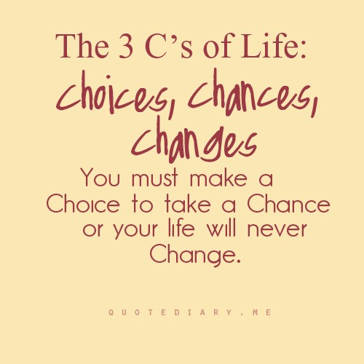
Practical information

Working language | English
Participants | 25 participants (youth workers – professional/voluntary) of YIA Programme countries. Diversity in background of the participants can be an extra learning opportunity
Profile of participants | The participants:  •Are willing and able to communicate in English  •Are at least 18 years old  •Have the position and the possibility within their organization to organize Youth in Action activities.  •Work directly with young people  •Are willing to reflect on their way of working.  •Have the intention of using a YIA project as a tool for stimulating entrepreneurship among groups and individuals – writing new proposals
Trainers team | Baud Vandenbemden, Belgium  Femke Gordijn, Netherlands  Both experienced international trainers with a personal and professional background on this topic. The training will be organized by the Dutch National Agency, Mireille Unger.
Date and venue | 6 – 11 April 2013, Stayokay hostel, Arnhem, The Netherlands.  Accommodation is in shared rooms.  Arrival 6 April 17.00 – departure 11 April after breakfast.
Costs | Board, lodging and programme costs will be provided and paid for by the Dutch National Agency of Youth in Action.  The travel costs will be paid by the National Agency of Youth in Action in your country (in case they will support your participation). In some cases National Agencies ask for a participant contribution. Check your National Agency
How to apply | Application is online via Salto youth. Deadline for application is  The 24th of February 2013. Your National Agency will make a pre-selection by the 4th of March. The final selection will be communicated on the 7th of March.
More information | In case you need more information, please contact Mireille Unger (m.unger@nji.nl) of Youth in Action in the Netherlands.

Programme training: Taking Chances!
Arnhem, The Netherlands, 2013

6 April | 7 April | 8 April | 9 April | 10 April | 11 April
 | Exploring & reflecting | Inspiration | Making sense | Applying
Breakfast | Breakfast | Breakfast | Breakfast | Breakfast | Breakfast
 | Frame of this training, understanding the meaning of initiative and entrepreneurship | Visit of experts. Exploring some interesting cases in depth | Introduction of the YIA programme and its opportunities  Start action plans: needs analyses of target group | Preparation of action plans – any proposals to be funded by YIA? | Departure
Lunch | Lunch | Lunch | Lunch | Lunch
Arrival of the participants | Exploring professional context of each other in relation to fostering initiative and entrepreneurship | Excursion to relevant organisation, get inspired by successful examples! | Entrepreneurship on a personal level: workshop on inner strength  Preparation of action plans continued | Presentation of action plans with feedback of the Dutch National Agency of YiA.  Youthpass  Evaluation & Closure
Dinner | Dinner | Dinner | Dinner | Dinner
Welcome evening &  Getting to know each other | Organisational market with taste! | Dinner in town & evening out | Discovering your personal history with entrepreneurship | Goodbye evening and celebration

