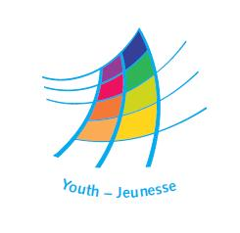
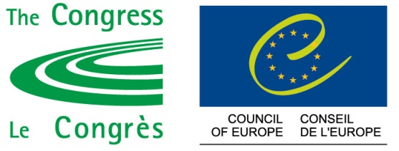

DDCP/YD/EnterLTTC(2012)4 Strasbourg, 6 November 2012

Enter!
Promoting Access to Social Rights for All Young People
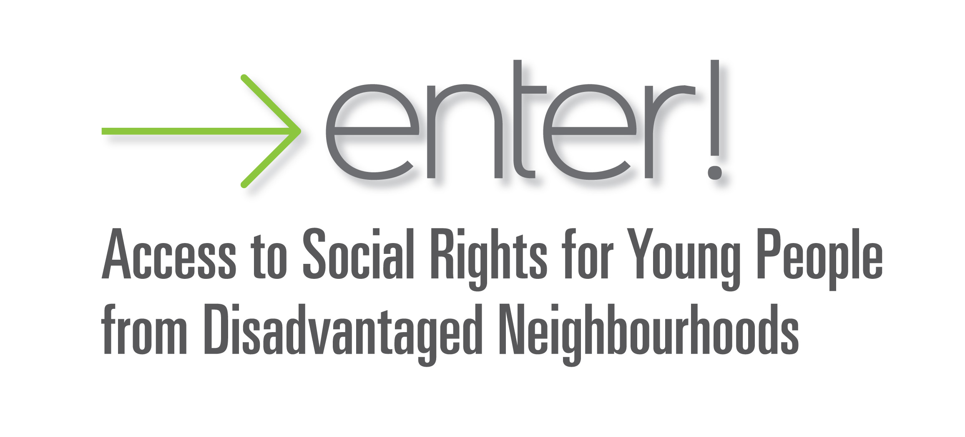

A project by the Youth Department of the Council of Europe aimed at promoting access to social rights for young people, in particular of those exposed to social exclusion, discrimination and violence

Long-Term Training Course for Youth Workers
(2013-2014)

Residential seminar: 11 – 21 March 2013, Strasbourg
Project development and learning: April 2013 – June 2014
Evaluation seminar: 2014 (dates t.b.c.)

CALL FOR PARTICIPANTS

Deadline to apply: 20 December 2012

Introduction
Many young people in today’s Europe live in situations where they experience exclusion, discrimination and violence. This is not only a youth issue, as it often affects young people during their youth and in their adult life, their environment (family, schools, communities, social networks, etc.), their intergenerational relations and the way society in general relates to young people. In their transition to adulthood, young people experience situations of socio-economic vulnerability and other forms of fragility in their place in society. When this multi-dimensional vulnerability is accompanied by exclusion, discrimination and violence, when young people do not have access to their human rights, when they experience poverty of opportunities and means, then they experience a serious disadvantage, which youth work, local and regional authorities and youth policy have the duty to tackle.

Youth workers and youth organisations are often at the forefront of projects designed to provide alternative non-formal education and leisure time activities, counter discrimination and exclusion of young people, promote participation and citizenship, often with the aim of easing social tensions. In the situations in which young people experience disadvantage, youth work has an important role:
- when young people lack confidence and self-esteem because they have often experienced failure or rejection (in school, in society, in the labour market, etc), youth work can offer them opportunities to do something they feel proud of and to experience success, thereby acting as a counter point to their negative experiences;
- when young people lack opportunities for being responsible and therefore also act irresponsibly, youth work provides them with opportunities to be responsible for something (a project, other young people, their communities, etc), gaining ownership and pride in their own potential contributions to community and society;
- when young people lack space and resources to express themselves so that when they claim such space are stigmatised as violent and rowdy, youth work can provide safe and constructive spaces for young people to engage in non-intimidating ways with issues and concerns of their interest and to express themselves in non-threatening ways on them;
- when young people are marginalised from mainstream participation (political, economic, cultural), youth work can them to develop their understanding of their rights and responsibilities as citizens through political, social and cultural activities;
- when young people are sceptical of and intimidated by the idea of engaging and cooperating with policy actors because the measures implemented by such often do not lead to positive change in their situations, youth work can help young people overcome their ‘passive-aggressive’ attitudes to cooperation with policy actors by providing platforms for ‘confidence building measures’ and partnership building.

Local and regional authorities, as well as other governmental agencies and institutions working at the local level, also have a significant role to play when it comes to ensuring young people’s access to their social human rights. In many places in Europe, ensuring access to social rights comes under the remit of local and/or regional authorities and other governmental agencies whose responsibilities have been devolved from central government to the local level. Very often, youth workers and local and regional authorities have complementary roles in their work on access to social rights for and with young people.

The Enter! project of the Council of Europe
From the perspective of the Council of Europe, social cohesion is firmly based on human rights (as codified in the European Convention on Human Rights and the Revised European Social Charter), as well as an acceptance of shared responsibility for the welfare of all members of society, especially those who are at risk of poverty or exclusion. In line with this, the youth policy of the Council of Europe aims at “providing young people with equal opportunities and experience which enable them to develop knowledge, skills and competencies to play a full part in all aspects of society”.

In order to respond to situations of violence, exclusion and discrimination which affect more and more young people in Europe, the youth sector of the Council of Europe has developed since 2009 the Enter! project. The project promotes access to social rights for young people, in particular of those exposed to social exclusion, discrimination and violence. The objectives of the Enter! project for 2012 – 2014 are:
- To address situations social exclusion, discrimination and violence affecting young people living through non-formal education and youth work projects;
- To develop the competences of youth workers to initiate, support and evaluate projects for and with young people as a tool for youth empowerment and youth participation for access to social rights;
- To develop conceptual, educational and practical means of translating access to social rights for young people into the realities of youth work and policy-making;
- To advocate for the access of young people to social rights, particularly by developing partnerships between civil society actors, young people and policy-makers, at local, national and European levels;
- To consolidate the results of the first three years of the Enter! project (2009 – 2012), particularly in the areas of youth policy, non-formal education and recognition of youth work.

The Enter! project includes initiatives run in partnership by the Youth Department and the Congress of Local and Regional Authorities of the Council of Europe. An advisory group, including researchers, representatives of local/regional authorities, the statutory bodies of the youth sector, and the European Youth Forum will support the whole project.

Aim and objectives of the LTTC
The Enter! project has its main core in the Long-Term Training Course (LTTC) for youth workers on access to social rights for all young people. The experiences of the training course will have a particularly important role in informing other activities of the project, by bringing the direct input of youth workers and young people and by bridging experiences from the European to the local level. This is a complementary training offering youth workers who undertake activities with young people that experience disadvantage the opportunity:
- to gain insights into how the European level and engagement with policy actors can support their efforts to empower young people, and,
- to promote access to social rights for young people, in an effort of overcoming the disadvantage young people face due to exclusion, violence and discrimination.

The LTTC will develop the competences of 30 youth workers, in developing and implementing responses, projects and partnernships in support of youth-led efforts to overcome discrimination, exclusion and violence, in a European perspective.

The objectives of the course are:
- To introduce participants to socio-educational project development, management, implementation and evaluation (especially focusing on evidence based needs analysis);
- To support participants in developing youth-led socio-educational projects (aiming to overcome youth disadvantage determined by discrimination, exclusion and violence), based on human rights education and with a clear policy advocacy dimension;
- To develop participants’ understanding and knowledge of the human rights framework and the policy fields that are relevant to the situation of the young people with whom they work;
- To develop participants’ competence and confidence for engaging with decision-makers and other actors in the youth and social policy fields for improving access to social rights for young people;
- To introduce participants to relevant European (and related national) mechanisms and instruments for supporting young people to overcome disadvantage determined by discrimination, exclusion and violence;
- To contribute to the social and education recognition of youth work and non-formal education for social rights in participants’ realities and at European level.

Training curriculum and competences
Throughout the training course, participants will improve their competences in the following areas:
- Understanding concepts and manifestations of exclusion, discrimination and violence, and their links with access to social rights;
- Human dignity, social (human) rights and their relevance to youth work and young people: understanding concepts, approaches to social inclusion (human rights based approaches, wellbeing approaches, quality of life approaches), international framework and implementation of human rights in local realities;
- Policy-making: understanding mechanisms, examples of social rights policies, relevant policies for young people’s access to social rights, the role of civil society in policy-development;
- Developing partnerships with different social actors, from the local authorities and civil society, for policy development and enhancement of the dialogue between young people and decision-makers;
- Carrying out social analysis and using research for formulating youth work responses to discrimination, exclusion and violence affecting young people;
- Having the competences required to carry out activities in the framework of human rights education, non-formal education and intercultural learning, in order to facilitate the access of young people to social rights;
- Understanding the role of human rights education, intercultural learning and non-formal education in promoting the autonomy and social integration of young people;
- Using conflict transformation in local youth work, to deal with situations of violence, exclusion and discrimination affecting young people;
- Developing democratic and participatory approaches in youth work;
- Planning youth-led projects and including systematic evaluation in youth work;
- Fundraising and financial management of projects;
- Getting informed about and being able to use European programmes, instruments and policies (Council of Europe and European Commission) for facilitating the access of young people to social rights;
- Improving competences in communication and presentation skills;
- Networking and negotiation.

Expected results
Throughout the course and as a result of its educational process, participants will:
- Improve their core competences in the areas related to the course curriculum;
- Follow a full cycle of intercultural learning, from needs assessment to evaluation of learning;
- Receive institutional and educational support to develop projects with young people, as well as increased visibility for their youth work activities;
- Exchange practices with other youth workers from different contexts and network among participants, for instance in international projects on access to social rights for young people;
- Develop their organisations’ capacity on the topic of improving access to social rights for young people;
- Establish or develop a dialogue and partnerships with local and regional authorities and with civil society organisations;
- Receive social and educational recognition for their involvement in the training course;
- Improve their competences in using European programmes for youth work and tools at the local level.

LTTC methodology and calendar
The LTTC is composed of four phases, which participants need to follow:

Preparatory phase January – March 2013 | This phase will include preparatory activities for the course. Participants will get to know each other and develop an analysis of social rights related policies in their realities.
First residential seminar  12 – 21 March 2013, European Youth Centre Strasbourg | The residential seminar is an essential element of the course, allowing for participants to improve their competences on the key course curriculum elements and to kick of their projects, by reviewing and developing their project idea.
Project development phase and ongoing learning  April 2013 – September 2014 | During this phase, participants will implement local youth-led projects in cooperation with local authorities and civil society.
Evaluation residential seminar  September 2014, dates to be confirmed | During this evaluation seminar, participants will evaluate their learning and the impact of their projects for the young people which were involved in their project. The seminar will also include training elements in order to consolidate participants’ competences development.

In all phases of the course, participants will benefit from the educational support by trainers, advice from the Advisory Group of the project and institutional support from the Council of Europe.

The course overall evaluation will be finalised by the end of 2014. An evaluation meeting of the course will be organised to review the results of the course and provide input for the course follow-up.

A youth meeting involving young people that have participated in the local projects developed will be organised in 2014 or early 2015.

The methodology of the course will allow for a good balance between theory and practices, learning and project implementation. A diversity of working methods will be use, based on non-formal education.

Participants’ profile
Candidates must be youth or social workers, working directly with young people, and
  - they carry out their activities in a non-governmental entity (for example, a youth organisation, a human rights organisation, an organisation working on specific social rights or with specific target groups etc.) or in a local authority (for example, local community centres, youth centres, information office of a Municipality, school communities, etc.),
  - they have experience in projects tackling exclusion, discrimination and violence affecting young people,
  - they are either professionals or volunteers.

All participants must also:
- have the motivation and capacity to develop projects for and with young people on access to social rights;
- have an interest to work in partnerships with local authorities on enhancing dialogue for improving access of young people to social rights;
- have a specific target group of young people they will be working with throughout the LTTC;
- are motivated to learn and to develop their professional and personal competences;
- intend to remain active in their organisation/institution for the next 2 years and multiply their learning in their organisation/institution and community;
- be aged 18-35, with exceptions possible;
- be resident in one of the countries of the European Cultural Convention of the Council of Europe;
- be able to work in English or French (tbc);
- be available for full participation in all four phases of the course.

The candidates must be supported by their organisation for the whole duration of the course. This means, concretely:
- the candidate must present a support letter from their organisation in the application phase;
- the candidate should be allowed to participate in the residential seminar of the course and in other local and regional meetings for the whole duration of the course;
- there should be a priority among the organisation’s work plan on developing partnerships with local and regional authorities and policy-makers and respectively civil society organisations for candidates working in the public sector;
- the candidate will implement a local project for and with young people, with specific quality criteria, and this means support form other colleagues will be needed.

It is a requirement for the selection that candidates’ organisations have developed or are in a position to develop partnerships with local and regional authorities/civil society for the enhancement of social inclusion of young people.

Role of the participants’ local youth projects in the LTTC
During the training course, each participant is expected to develop a local youth-led project based on active participation of young people and addressing specific challenges that young people face in their access to social rights, and as a consequences of the negative effects of discrimination, violence and exclusion.

Projects provide the practical basis for learning about how to promote the social rights of young people and how best to use youth research for youth policy action. They should be implemented in co-operation with local or regional authorities. Through the involvement of local authorities, other organisations and various actors in the social field, the projects aim at bringing real change and impact at community level concerning the access to social rights of the young people. The community awareness of the project is also important to secure the sustainability of the project and its support by the local authorities.

Working languages
The course proposed languages are English and French, with interpretation ensured during the residential seminars.

Application procedure and selection of participants
All candidates must apply online, completing the application form through this link: http://youthapplications.coe.int/

Before applying, each candidate should prepare:
- a support letter from their organisation, stating the support offered to the participant throughout the course, and
- a social analysis and an outline of the project idea that the candidate intends to develop during the project development phase, which should specify the role of local authorities and civil society organisations in the project. The project outline is important to illustrate what the applicant has in mind and the social context within which the project is placed. The possible acceptance of an applicant does not imply, for the Council of Europe, automatic support or acceptance of the project. Participants will, as part of their learning process, look for funding sources for their projects themselves.

The letters of support for the candidate should explain the need and the value for the sending organisation or authority and for the candidate to attend this course. If an organisation wishes to propose more than one candidate, the order of priority should be clearly indicated and justification for the priority list should be provided. Applicants without recommendation letter will not be accepted.

All candidates must apply online and send their recommendation letters by 20 December 2012, at midnight Central European Time. Support letters have to be uploaded on the platform or sent separately by e-mail to eyc.programme@coe.int by the same deadline.
A group of preselected participants will be announced by the mid-January 2013. Only candidates who will be able to provide after the preselection and before the seminar a generic support letter from local or regional authorities (or other relevant governmental agencies and institutions working on the local level), and respectively for preselected candidates working for public institutions a letter of agreement from civil society organisations, will be invited to the course.

The selection will be done respecting the candidates’ organisations’ priorities, but also ensuring a balance between sexes, geographical regions, different types of experiences, backgrounds and organisations, institutions or projects. A waiting list may be drawn up.

Financial conditions
Meals and accommodation for the residential seminars will be provided and paid for by the Council of Europe.
Travel costs for the seminars will be fully reimbursed according to the Council of Europe rules.
An enrolment fee of 60 Euros is payable by each participant. This amount will be deducted from the amount to be reimbursed for travel expenses or paid during the residential seminar. The Council of Europe will not reimburse any fees related to the usage of Internet during the course.
Other Courses of the Youth Department
If you are interested in a training course in international youth work, but your profile does not fully correspond with the requirements of this course, please note that the Youth Department organises other training courses for youth workers, youth leaders and trainers. Further information about the courses can be obtained from the Youth Department:
http://www.coe.int/youth

Further information and contact
Jackie Lubelli, email: jackie.lubelli@coe.int

Extracts from expert input provided by Yael Ohana for the preparatory seminar of the LTTC, September 2012.
In the European Social Charter, social rights are those that cover the following areas: education, work, social security, health, housing, quality of life, poverty alleviation.
Committee of Ministers Resolution CM/Res(2008)23 on the youth policy of the Council of Europe

