Coaching for

Call for participants!
Training on positive approaches and solution focused coaching and practical communication for youth workers, social workers, teachers and educators
Luxemburg, Romania, Slovakia, Netherlands, Germany, Croatia and Hungary
October 7th – 18th, 2012.

Do you work with youngsters? With disadvantaged people? Do you find sometimes you communication skills don’t bring you the results you wanted?
Do you want to learn new ways and start using them imediately?
Are you a youth worker, social worker, teacher or educator?
If yes, then this training is for you!

Goal of the training:
"You cannot teach people anything. You can only help them to discover the learning within them." – Galileo.
This is the approach our training uses - we believe that everybody knows how to do things right and has the knowledge to solve the problems they have. All they need is guidance to find the answers for themselves.
“Coaching for success” is a 10-day training on coaching and practical communication skills for social, youth workers and educators who work with people on a daily base, especially with youngsters and disadvantaged groups.
During these days we plan to deliver a very practical program – basically a long coaching session to our participants. Through these days they can develop and practice their own coaching style and get immersed in this methodology by practicing with others.
Our objective is to give a useful tool for youth and social workers and educators working with disadvantaged groups. With the help of this knowledge and practice they will empower their clients, so those can reach their goals and live a more successful life.
Also we would like to provide a unique opportunity to see the method working in a “real life situation”, by arranging and realizing their own complete and successful coaching session, by having a client, who will be young adults with a disadvantaged background and support them in creating their vision for the future. The first coaching sessions will take place during the training and we will create a system to continue after the training for 6 months as a follow-up.

Topics of the training:
- coaching concepts
- creating and being in rapport
- conversation techniques
- questioning techniques
- assignments, sessions
- coaching styles
- self-coaching
- group coaching
- coaching paradigms - narrative coaching, onthological coaching, appreciative approaches

Methods of the training:
- experiential learning
- one-to-one coaching sessions
- video playbacks, analyzing professional coaches
- simulations
- role plays
- reflections, feedback
- group discussions and interactive presentations
- coaching youngsters - real clients
- NLP
- media tools
Date: October 7 - 18, 2012 ( including travel days) – 10 days of training + 2 days traveling
Place: Galyatető mountain resort, Hungary
Participants: 28 social workers, youth workers, educators, teachers coming from Luxembourg, Netherlands, Germany,Croatia, Slovakia, Romania and Hungary aged 18+.
Costs: The project is funded by the Youth in Action program covering 70% of all travel fees, as well as all food and accomodation.
We ask for a participation fee of 80EUR from our participants.
How to apply: Fill in the attached Application Form and send it by email to akoskoltai@gmail.com by 2012, September 14th (or earlier)! We will then make the selection of who can participate and you will get a confirmation email from us.
If you are selected:
If you are selected for participation please sign and scan your Application Form and send the scanned version by email to akoskoltai@gmail.com by September 14th (or earlier). Bring the original signed version to the training.
You can then proceed to buy your travel tickets to Galyatető, Hungary according to the Conditions of the Reimbursement. Please read it!!
We can only give you back the money if you bring all the invoices and tickets and they have the right data!
Arrivals and departures:
Arrival till | 18:00 | Sunday 7th October, 2012
The program starts | 09:00 | Monday 8th October, 2012
The program finishes | 22:00 | Wednesday, 17th October, 2012
Departure till: | 12:00 | Thrusday, 18th October, 2012

We are asking you to arrive on the date given above, to the accommodation.
If you arrive 1-2 days earlier or leave later, please arrange your own accommodation for the extra time.
We expect you to participate on the whole training!
It means coming later or leaving earlier is not allowed!
We cannot reimburse your tickets if you leave earlier or come later!
Venue
The training will take place in Galyatető, Hungary, at the Fogadó a Táncoló Kecskékhez.
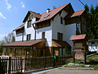
In the accommodation there are 3-4 bed bedrooms with shower.
The address is: Galyatető, Madách u. 7.
website: www.tancolo-kecskek.hu (only in Hungarian, but you can check the photos☺)
How to get there?
Arrange your trip to arrive on time at the arrival day!
Take a flight from your country till Budapest Liszt Ferenc Airport (previously Ferihegy)
Catch a bus from the airport (no. 200E) till the final stop (which is the metro station) and go with the BLUE metro till Deák Ferenc tér! From Deák Ferenc tér you change metro line to the RED one and go till Stadionok station.
ATTENTION! You have to buy a ticket for the vehicles (price: 320 HUF). Use one ticket for the bus and one for the metros (ticket price includes metro transfer)!
At Stadionok station go to the ticket officer at the bus station and ask for a ticket to Galyatető! Watch out there are buses that go there directly 3 times a day. Time schedule is: 8:15; 13:15; 16:45, and the trip takes two or three hours.
What to bring?
Bring clothes for ten days. We will do exercises both inside and outside, and the venue is located at 1000m, so it can be cold. Prepare for every type of weather! October in the mountain region of Galyatető might bring sunshine and autumn warmth, but also wind, rain or even snow and temperatures bellow 0! There is no washing machine at the accommodation - of course you can handwash.
Make sure you bring:
- Sleeping bag – in case you will feel like sleeping outside
- Sleeping pad
- Waterproof boots (that hold your ankle)
- Waterproof trousers
- Waterproof coat or jacket
- Backpack
- Scarf, gloves and hat
- Towel and toiletries
- All personal medication
- Some food and drinks and material to introduce your country to the others
- Camera, MP3s with music, laptops –optional if you have them and find them useful
The project has received grant from the Youth in Action Programme of the European Community and Visegrad Fund.
Information on the Programme is available at http://europa.eu.int/comm/youth/index_en.html
However the content of the project doesn’t necessarily reflect the opinion of the EU and the Hungarian National Agency.
The project is not under the responsibility of these institutions.

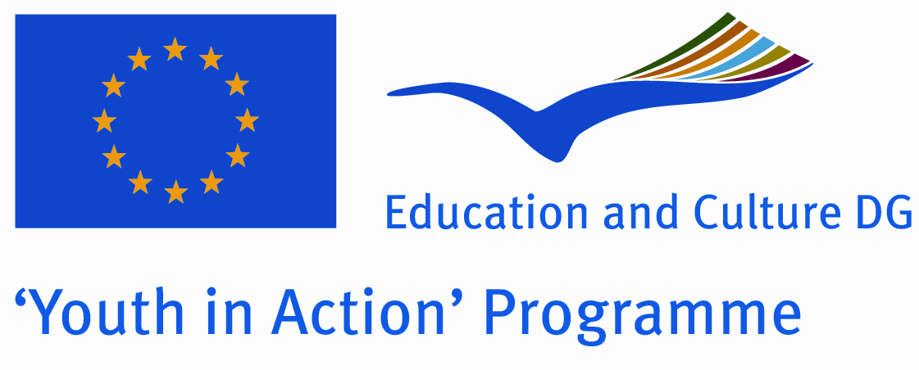
About the organizer – Academy of Experience (Hungary):
Academy of Experience public benefit association was founded at the end of 2005 by 12 volunteers, who would like to dedicate their future to the non formal education and development of young and adult people. The objective of the organization is to develop the public and personal skills and attitudes of participants by using so called outdoor activities, adventure education, dance and art, communication skills training, coaching, and applying the methodology of experiential education - learning by doing.
Our organization focuses on increasing the feeling of personal and social responsibilities, sustainable environmental education, helping the development of life-leading skills. Our organization gives the possibility to use the world of experiences as classroom, to discover and develop your hidden resources through real adventures and challenges.
One of our main missions is to train social and youth workers, trainers and educators to use innovative, new methods in their everyday work.
More info at: www.elmenyakademia.hu.

