
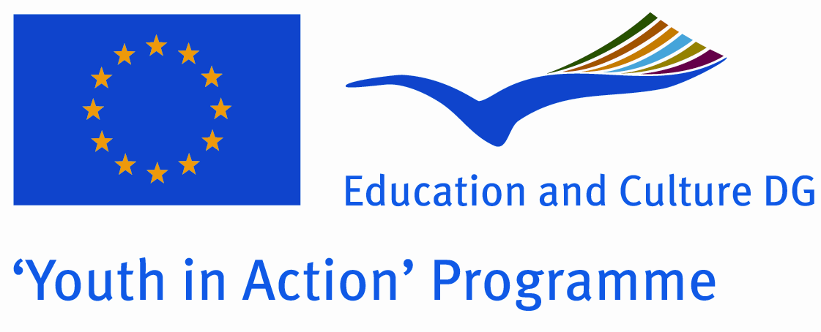

CALL FOR PARTICIPANTS

“DARE TO TAKE ACTION”
Social Entrepreneurship Training for Young Persons dealing with Unemployment or Underemployment Issues

Timing:
4-11, Sept 2012

Venue:

Sovata/Szováta, (Transylvania, Romania)
At the Outward Bound International Youth Center

APPLICATION DEADLINE
17th of August 2012

The training course is implemented within the Youth in Action Program /Youth Support Systems sub action “Training and networking of those active in youth work and youth organizations.”
The project partnership consist of the lead organization and host, Civic Engajement Movement (CEMO)/RO,
and the partner organizations: International Student Club, CTU Prague/CZ, Luck 33/FR, Emberség Erejével/HU, Step4Inclusion/IT and Tursiticno Drustvo Zetale/SL.

Main contact/lead and host:
Civic Engagement Movement (CEMO)
540430 Tirgu Mures, Romania
Phone: +40-770-908-264

www.cemo.ro

ABOUT THE TRAINING COURSE?
The present training course tries to give an appropriate answer to the problems that young people are facing in the present: the high percentage of unemployment. We are aware of the fact that the employment problems cannot be tackled by one Training course although we believe that there are several ways and means that can assist young people in their attempt to enter the job market.
One of the possible answers to the present issue of joblessness is that of engaging in entrepreneurship.
The overall purpose is to stimulate young people to think about social entrepreneurship and its role, as well as to analyze the changes taking place in their own countries and communities and last but not least to inspire them to consider self-employment as a career choice.

The Training Course “Dare to Take Action” will offer an excellent learning opportunity to those who want to explore new ways and means of employment, who want to end their jobless cycle, to think about social entrepreneurship, to gain appropriate knowledge build capacities and skills in the field of self-employment, consider resources and practice attitudes that are needed in order to start off in establishing their own social enterprise.

Above all, this Training Course is just for YOU, to self-develop new competences, to tackle social entrepreneurship, to gain entrepreneurial practices, to address and engage in solution finding processes related to societal problems within your own community.

THE PROGRAMME
The seven day training program is designed to assist those young persons who would like to:
- Become their own boss by starting a social enterprise/organization/institution;
- Bring change in their communities;
- Recognize and implement practical and innovative solutions to community problems;
- Learn the process of creating new products and services;
- Express a strong commitment for the enhancement of the society;
Themes of the training will be the following :
- What is Social Entrepreneurship?
- Differentiation between Business and Social Entrepreneurship
- Qualities of a Social Entrepreneur
- Review of Personal Entrepreneurial Motivation
- Planning and Managing a Social Enterprise
- Case Studies of Leading Social Entrepreneurs
- Information about Obtaining Finance
The Course is designed as an open space of mutual learning, based on non formal education and experiential learning methodologies applied under the monitoring and the support of the Training Team.
The Training course will be based on the principles and practice of non-formal education taking account the participants needs, motivations and previous experiences as starting point of the program. The working methods that are going to be used during the training series will include a variety of methods such as active methods for group dynamics, small group works, working in mixed group, based on the essential motivation of the learner, learner centered and based on the previous experiences of the participants, based on active participation, supporting by a strong group dimension and a collective approach, enabling participants to apply and transfer what they learnt

PROFILE OF PARTICIPANTS AND SELECTION PROCEDURE
The course is open to altogether 26 participants from organizations located in Czech Republic, France, Hungary, Italy, Romania and Slovenia. From each participating countries there are 4-4 places except Romania for which there are 6 available places.
Participants attending the course will be young people who are facing the difficulties that are present in the job market, therefore likely to be affected by unemployment, are presently unemployed and/or likely to become unemployed who wish to build capacity and gain skills in the field of social entrepreneurship, community issues with the aim to become more active in the life of their community, who want to become responsible for positive changes and be a part of the transformation, and who wish to develop international partnership with the other participants. In order to asses the applicants personal features and thus further shape the program/ prepare specific sessions of the course accordingly the selected participants will have to fill in a brief questionnaire to be sent before the course.
The training course will be carried out in English language!!! Therefore all participants should be able to fully participate in English! Bear in mind that nobody will be native speaker, so be confident with your competences and ready to develop your communication skills!
Please, find attached to this call the application form for participants.

Participants will be selected by the Training Team and recommendations from the sending organizations will be taken into consideration.
The main principles for the selection will be: motivation of participants, diversity, social and economical situation of the participants, geographical and gender balance, and willingness to remain involved in the development of the social media blogs after the course.

FINANCIAL AND PRACTICAL CONDITIONS OF PARTICIPATION

Travel expenses
The 70 % of expenses are covered by the project and will be reimbursed on presentation of the relevant receipts. The mentioned expenses are covered only for the participants who attend the entire training course. The payment will be made at the end of the course in cash or bank transfer (in Euros). There are some maximum travel costs foreseen in the budget, so, before buying tickets all participants will have to consult with the organizers/project partners in the participating countries.

Accommodation
Board and lodging will be provided and paid by the Organizers of the Training Course. Participants will be accommodated in rooms of four/five people. The venue of the course will be at the Outward Bound International Youth Center resides on the outskirts of Sovata., located at the end of 1 Mai Street, nestled in a beautiful mountain valley alongside a flowing stream, far away from any city (http://outwardbound.ro/index.php?area=22&language_id=1&page_id=85)

NOTE!! Applications should be addressed to program coordinator Ms. Orsolya (Orsi) Szálasi, representative of the lead partner to the e-mail: szalasi.orsolya@cemo.ro, tel: 0040-770-908264.

APPLICATION DEADLINE
17th of August 2012
Selected participants will receive more detailed information about the course.

