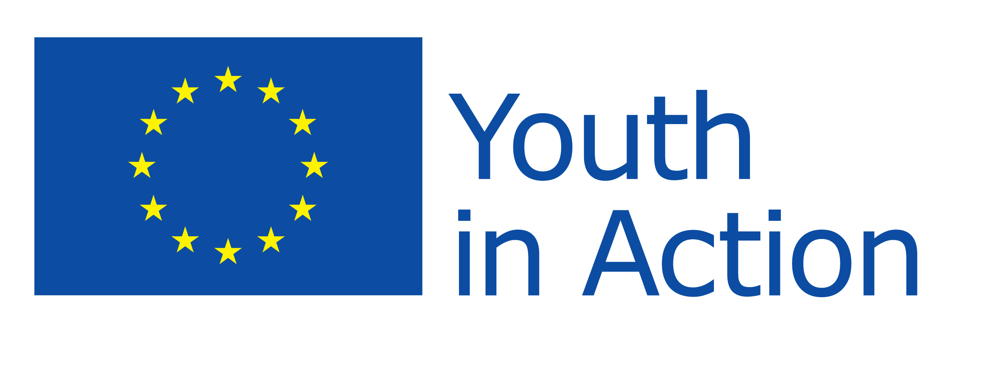

Listen Up - Young Voices for Democracy
Youth in Action seminar
Wednesday 27 – Thursday 29 June 2012, London

Overview

1. Summary

- As the UK National Agency for the Youth in Action (YiA) programme, and in preparation for the European Year of Citizens (2013), the British Council will host a seminar on young people and democracy in Europe;
- The event will be aimed at young leaders, policy-makers and others in positions of influence in youth and community affairs – from all Youth in Action programme countries;
- Participants will consider initiatives in youth democracy from different European countries, and link examples of good practice in Youth in Action and other programmes to policy developments nationally and internationally. They will have opportunities to visit youth projects currently underway in the UK and discuss opportunities for future project development.

2. Aim/objectives

The aim of the event is to showcase what works: projects that make a real difference to how young people see democracy and to how they contribute to democratic processes – locally, nationally and internationally.

Specific objectives are,
- to demonstrate current approaches in the UK and other European countries to maximising young people’s democratic participation;
- to provide opportunities for young people to engage with policy-makers/influencers in an international forum;
- to raise the profile of the Youth in Action programme in building the skills and experience of young people – and to increase take-up of YiA Actions 1.3 and 5.1.

3. Policy context

- The Youth in Action programme is the principal mechanism for implementing the EU’s overall strategy for young people. It includes specific measures to encourage young people’s awareness of democratic structures and capacity for direct involvement (Action 1.3). It also provides for EU-wide consultation and discussion between young people and policy-makers – a process known as Structured Dialogue (Action 5.1).

- Youth participation is a priority under the EU Presidency trio (Poland, Denmark, Cyprus) and the seminar will take note of recommendations made at the recent Youth Conference in Denmark.

- Ministers responsible for Youth in Council of Europe Member States will meet in St. Petersburg (September). Discussions will include young people’s access to democratic rights. This is a further point of reference for the planned seminar.
- Any discussion on young people’s participation in society and the democratic process must also consider the background to the riots which took place in UK cities in the summer of 2011 – as well as similar experiences in other European countries.

- Across the EU, approaches to the youth sector have recently been reviewed – or are now being reviewed – to take account of continuing economic uncertainty and the effects of social change. In England, for example, the Government issued a new strategy, Positive for Youth, in December 2011. This gives an important point of reference for policy dialogue.

4. Participants

The planned total number of participants is 80 – to include:

- young leaders from Youth in Action Programme Countries
- policy-makers/influencers from Youth in Action Programme Countries
- representatives from youth democracy projects in the UK, supported under YiA Actions 1.3 and 5.1 and demonstrating good practice/innovation
- representatives from Council of Europe and European Commission
- representatives from UK Government
- representatives from UK National Agency for Youth in Action (British Council) and from other YiA National Agencies

Criteria for selecting conference participants will include ability to pursue agreed recommendations after the event – for example, through involvement in national and international decision-making fora.

Subject to budgetary constraints, participation will be invited from a small number of Council of Europe Member States, outside the European Union.

5. Programme content

- Young people and youth workers will present case-studies on individual projects – and identify the points of wider significance for discussion by all conference participants. In this way, the seminar will build on processes established through Structured Dialogue to develop young people’s skills and experience in influencing European policy;

- In order to fully utilise the experience and ideas of both senior participants and young people’s representatives, some parts of the seminar programme may designed as parallel sessions;

- Participants will be invited to take part in external visits to London-based projects which demonstrate innovation and good practice in boosting young people’s democratic participation.

6. Resourcing

Participants will be fully funded for,

- international travel (economy class return fare)
- all UK aspects of the event (including accommodation, venue costs, meals and local travel).

The seminar is being planned and managed by the British Council.

http://ec.europa.eu/youth/documents/youth_report_final.pdf
http://ec.europa.eu/youth/documents/joint_recommendations_eu_youth_conference_soro_20_march.pdf
Urban Solutions, a seminar to consider current social challenges in urban environments, will take place in Birmingham, UK, 29 May – 2 June, hosted by the UK National Agency in association with SALTO Inclusion and SALTO Cultural Diversity (http://www.salto-youth.net/rc/inclusion/inclusiontraining/urbansolutions/)
http://www.education.gov.uk/childrenandyoungpeople/youngpeople/Positive%20for%20Youth/b00200933/positive-for-youth-the-statement

