
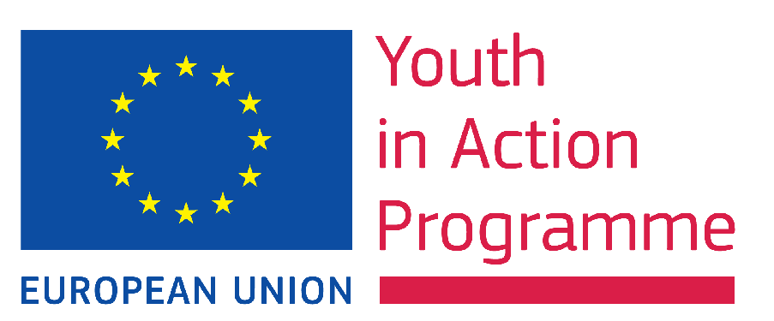
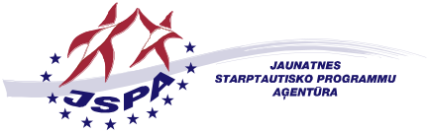

Call for participants
“UNIQUE R.I.D.E.”
- unique space for further personal and professional development of trainers working in the youth field
21-28 October 2012, Latvia
Deadline for applications: 15th June 2012

Organisers: UNIQUE, European network of training, consulting and research organisations (www.unique-network.org) and National Agency for “Youth in Action” in Latvia, programme (www.jaunatne.gov.lv).

Questions for potential participants:

- Are you a trainer actively working in the youth field at national or European level?
- Do you feel the need for further personal and professional development?
- Have you been facing challenging situations in your training practice that you would have liked to understand better through sharing with colleagues?
- Did you feel moments of losing motivation and sense of purpose of what you are doing?
- Have you been often overstressed and burning out in your work, losing the sense of balance in your life?
- Have you been wondering how to effectively deal with emotions in a training situation?
- Would you like to reflect on your current training practice, reconnect to your passion and redefine professional vision?

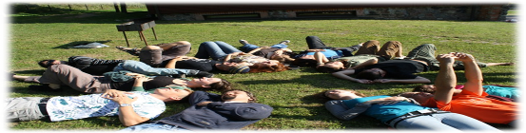
If you have answered positively to most of the questions above, you might consider UNIQUE R.I.D.E. as an exciting opportunity for your personal and professional development!
Why UNIQUE R.I.D.E.?
The training is an exciting, but stressful job, where trainers, themselves, are the main tools, who need proper maintenance, too…
…therefore, it is no surprise that there is a natural need to have a break, reflect about your practices, get feedback from your colleagues, exchange good practices, develop new competences and reflect about the future directions/professional development objectives. These needs were clearly expressed in several meetings within the trainers’ community and by former participants of UNIQUE R.I.D.E.
Abilities like dealing with conflict situations, self-management in training, understanding one’s own and participant’s emotions, handling short-term and long-term stress, increased level of self-awareness and acquiring healthy work-life balance are not only personal objectives, but also essential professional competencies.

What participants of UNIQUE R.I.D.E. events say about it?

- “You should attend the R.I.D.E. - It will pull you from routine and bring you to another level.”
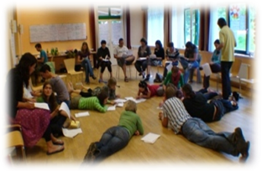
- “Come the UNIQUE R.I.D.E. if you need to clarify your mind and see your life from “out-of-the-box” point of view, and get inspiration and support from your colleagues in a friendly and supportive atmosphere”
- “Come and re-think / re-enjoy / re-discover /re-define / re-invent / re-make / re-build /re-experience / re-imagine your life as a trainer by being a participant and choose, if you want, to STOP, REWIND, FAST FORWARD or just PLAY”
- “It is a powerful and shaking ride to a new balance.”
- R.I.D.E is like a drop of nice smell in the ocean of emotions; coming in waves and staying for a long time - driving you from one island of your soul to another, helping you to take out the best and go forward with joy…”
- “It’s like being put in the best compost! What you do with that is up to you and the universe!”
- “This training was like 6² hands massage of my mind, body and soul!”

Target group for UNIQUE R.I.D.E.

- Trainers working for training pools of Youth in Action National Agencies
- Freelance trainers working in the youth field at national and European level
- Actively working as trainers at least two years
- Able to communicate in English
- Able to participate in the full duration of the course
- Motivated for further personal and professional development
- Supported by National Agency or willing to self-finance the participation

Key benefits for trainers-participants:

- Increased level of self-awareness and enhanced emotional competence
- Trying new techniques and approaches transferable to their own trainings
- Increased understanding of challenging situations in training
- Gained useful insights and tools from psychology and psychotherapy
- Increased ability to handle stress in training and life in general
- Meaningful discussions about “burning issues” and training-related dilemmas
- Clarity on reasons and desired directions in further professional development
- Set personal and professional development plan
- Regained passion and motivation for work

The methodology and approach of UNIQUE R.I.D.E.

- Combination of outdoor and indoor educational methods
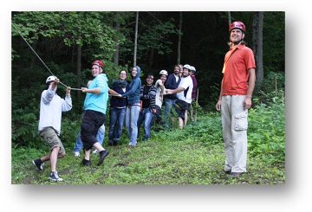
- Involves professional coaching and inter-vision possibilities
- Brings together insights from psychology and psychotherapy and experiences from training
- The programme is run in a carefully planned stress-free timeframe
- Includes optional well-being space to share effective strategies and practices in dealing with stress
- The R.I.D.E. is held in a “well-being venue”, which support reflection and provides possibilities for relaxation, sport and enjoyment

The UNIQUE R.I.D.E. topics:

- Personal and professional development
- Training-related dilemmas and challenging situations
- Understanding emotions in training
- Emotional intelligence in training
- Stress management and burn-out prevention
- Well-being in training and achieving the work-life balance
- Rediscovering passion and motivation for work
- Discussion on relevant “burning issues” set by the participants

The team of UNIQUE R.I.D.E. trainers brings extensive experience and unique combination of expertise in youth work, professional training, non-formal education, experiential learning, supervision, psychotherapy and coaching. The team members are:
- Žilvinas Gailius
- Darko Markovic
- Hazel Low
- Laimonas Ragauskas

Practicalities and financial conditions for participation:
The UNIQUE R.I.D.E. includes the programme of 6 full working days plus arrival and departure days.
The participation fee for the course is 120 EUR and should be paid by bank transfer to UNIQUE network within 1 month after the selection. Accommodation costs are covered by the Latvian National agency and the travel costs should be covered by your National Agency for Youth in Action programme or self-financed. In case of participants from South East Europe and Eastern Europe and Caucasus regions travel costs will be covered by the Latvian National Agency. For contact details of your National Agency see: http://ec.europa.eu/youth/youth/doc152_en.htm

How to apply?
- Contact your Youth inaction National Agency for a possibility to cover your travel costs
- Apply on-line: http://www.salto-youth.net/tools/european-training-calendar/training/unique-r-i-d-e-unique-space-for-further-personal-and-professional-development-of-trainers-working-in-the-youth-field.2547/
- Deadline for submitting your application is 15th June 2012.

