Exploring New Shores - great changes create chances

This training course supports young people being in a new environment and situation to define goals, raise self-awareness and take challenges as chances for personal growth

29th April - 4th May 2012, Solothurn Region /Switzerland

Methodology
A non-formal, interactive and self-directed approach to explore the participants' needs and develop skills for self-empowerment, ownership of their life and dealing with challenging situations as well as foster their coaching skills to support young people dealing with change in their environment.
The program involves indoor and outdoor activities, discussions, group processes and individual work.

Participating countries
Switzerland (hosting), Bulgaria, Czech Republic, France, Hungary, Ireland, Italy, Spain

Target Group
Youth leaders, youth workers dealing with a changing environment as volunteers or as starting professionals (involved in international volunteering programs, study programs or exchange programs). This involves dealing with change of the personal environment or supporting young people in their changing environment.

Number of participants: 24

Trainer team
Oliver Schneitter (Switzerland), Bara Blahova (Czech Republic), Gabi Steinprinz (Netherlands)

Contact and Information
Bara Blahova, barbora.blahova@gmail.com, +420 777 619 737

Training objectives

- to support young people in their personal leadership and to generate strategies and tools that serve them to use their creativity and talents to achieve their goals and dreams
- to deal with change as professional or personal learning opportunity
- to promote international volunteering, exchange experiences and to support intercultural understanding between young people from different backgrounds.
- to promote active citizenship and responsibility to make change in one's and others life
- to support “Soft skills” of young people like communications and team work

Context
To be in a new, foreign environment offers young people an opportunity of learning about personal and professional ambitions, patterns and strategies. Along with the discovery of a new place goes the discovery of oneself.
Therefore we will focus on concepts, which young people raise to themselves, while being in a new environment or new life situation, such as the meaning of freedom and responsibility, expectations and beliefs as well as personal leadership and communication.

The training course will take place in the region of the Jura mountains, in the mountain house “Obere Wechten”.

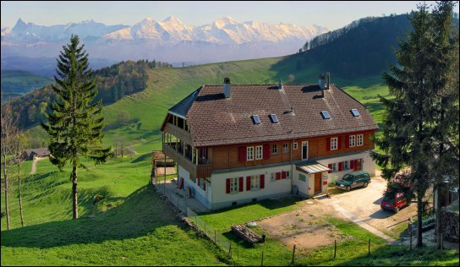

Accommodation and food during the training course will be provided by the organizers. 70% of the travel costs of the participants – minus a participation fee of 40 Euros – will be refunded after the training course.

Interested? ………then complete the application form on http://goo.gl/tJjP2
and return it by Saturday 17th March 2012.

