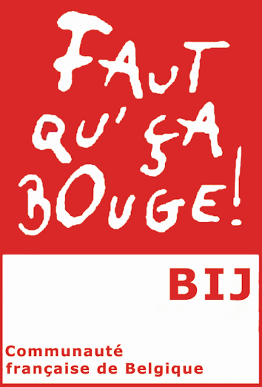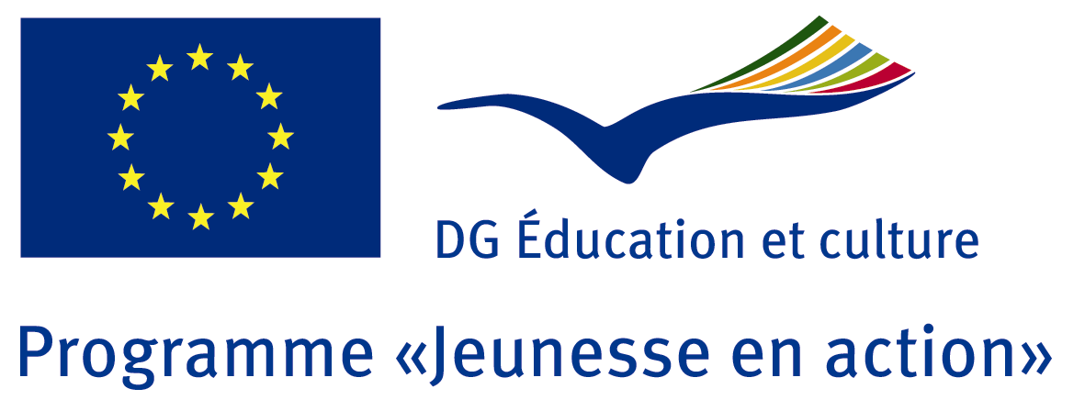

TRAINING COURSE :

“YOUTH EXCHANGES : FACILITATING THE PROCESS OF COMMUNICATION IN ENGLISH”

Blackpool, UK, 14-19 May 2012

➢ You are a youth worker or you work directly with young people
➢ You have experience or you wish to gain this kind of experience
➢ You wish to make a youth exchange within the framework of the EC YOUTH in ACTION programme
➢ You have basic knowledge of English but your level or the lack of practice:
- stop you making the first move to establish contacts with potential partners abroad
- make it difficult to present your association/group, to state what you want in a clear way or to negotiate a programme with your partner

In other words, you need :
- a confidence boost
- tools to communicate as much as you can with what you know in English
- opportunities to practice your English in the specific context of youth exchanges

The BIJ (Bureau International Jeunesse) National Agency the French speaking Community of Belgium, is organising a training course to facilitate the process of communication in English between youth workers and to establish contacts for further youth exchanges.
The trainer will work in an interactive way to develop confidence and skills. She will use a variety of activities such as pair work on situations linked to youth exchanges, games, use of relevant “Youth for Europe” materials (partner request forms etc…), use of the video tool.
Practical information

Dates: 14-19 May 2012
Starting: Monday, May the 14th. The programme will begin at 6 pm.
Ending: Saturday, May the 19th after breakfast

Venue:
Blackpool, UK. Host stays: participants will lodge with youth workers from Blackpool in order to maintain and encourage the linguistic immersion aspect of the course and to allow them an insight into the field of youth work in the UK.

Participants:
- Maximum 16 participants including 4 youth workers from the French speaking Community of Belgium
- Participants with basic knowledge of English

- Respective national agencies are responsible for the pre-selection of their participants. Apply through Saltowebsite by the 20th of March at the latest.
- Your NA will do a preselection by the 26th of March.
- The trainer will test the pre-selected participants on the phone before the final selection.
- The BIJ will be responsible for the final selection which will be decided by the 9th of April 2012.

Registration

- Travel and visa costs of selected participants will be covered by the sending National Agencies. Please check with your National Agency if any additional participation conditions apply.
- Hosting costs (accommodation, food, programme activities, local transport) will be covered by the BIJ (hosting National Agency).

Information

Gloria ARICI – Tel : +32.2.548.38.82 or gloria.arici@cfwb.be

Bureau International Jeunesse
20-22, rue du Commerce – 1000 Bruxelles
Tel : +32.2.219.09.06
Fax : +32.2.218.81.08
Website : www.lebij.be

