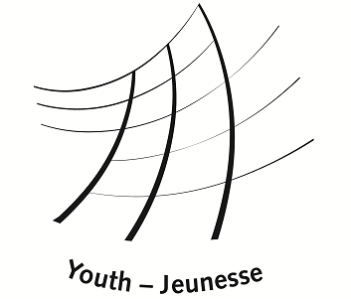

Minorities of Europe

Study Session

Minority Rights Protection – 20 Years On

European Youth Centre Budapest
May 6 – 13, 2012

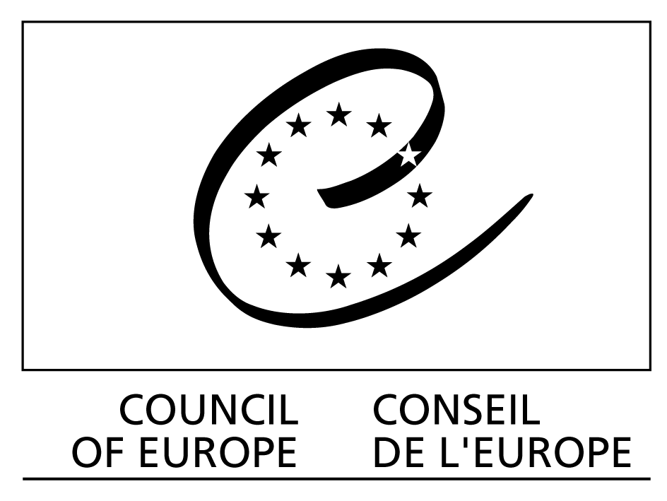

Supported By:
Background information

Minorities of Europe (MoE) is a pan-European minority youth platform which seeks to support and assist the co-operation, solidarity and exchange between different minority communities and young people in Europe.

MoE’s main international activities are: training courses, study sessions, seminars, youth exchanges and other activities in which young people are involved, especially those ones from minority background.

At European level, Minorities of Europe is particularly concerned by the following issues, as identified by the Council of Europe’s consultation on minority youth participation and other relevant European consultations specific to minority Rights in Europe:
- Active participation and involvement of minority groups and communities across Europe, in particular of young people and those communities that are at a greater disadvantage or have lesser possibilities of access to their rights.
- Understanding and respect of cultural and religious diversity as the basis for intercultural exchange and cooperation across Europe, including its spiritual dimension and inter-religious dialogue.
- Responsibility and solidarity among minority communities and among minorities and ‘majorities’ as the basis for further social cohesion and addressing multiple forms of discrimination.
- Awareness and empowerment of groups and individuals as a way to promote and safeguard the human rights of everyone.

Since May 2005, Minorities of Europe built a structured network of minority youth organisations consisting of members and regional MoE Centres across Europe.

MoE prepared and organised numerous training activities concerning minority issues. Evaluation of these events lead to the conclusion that more events of similar kind should be developed to provide space for reflection and skills development for young people in the field of protection of minorities. This is why MoE decided to organise this Study Session with the help of an experienced international team and contributions from participating youth organisations from across Europe.

Background information of the Study Session

The beginning of 1990s were characterised by major political and social changes in Europe. The disintegration of two federal states – Yugoslavia and the Soviet Union contributed to the shift of the perception of minority rights the international human rights law from individual rights to collective rights.

Year 1992 was a milestone in this regard - three intergovernmental organisations - the Council of Europe, Organisation for Security and Cooperation in Europe (OSCE) and the United Nations showed their commitments in this area:
- European Charter for Regional or Minority Languages was opened for signature by the member States of the Council of Europe;
- Declaration on the Rights of Persons Belonging to National or Ethnic, Religious and Linguistic Minorities has been adopted by the United Nations;
- The post of the OSCE High Commissioner on National Minorities (HCNM) was established.

It further led to the adoption of new documents and commitments,
- Framework Convention for the Protection of National Minorities has been opened for signatures in 1995, one of the most comprehensive treaties designed to protect the rights of persons belonging to national minorities
- different recommendations elaborated by the HCNM: Hague Recommendations Regarding the Educational Rights of National Minorities (1996); Oslo Recommendations Regarding the Linguistic Rights of National Minorities (1998); Lund Recommendations on the Effective Participation of National Minorities in Public Life(1999); Recommendations on Policing in Multi-Ethnic Societies (2006); Bolzano/Bozen Recommendations on National Minorities in Inter-State Relations (2008).
- UN Working Group on Minorities was established in 1995, replaced by UN forum on minority issues 2007.

Despite of these legal developments there numerous problems remain in the area of minority protection remain unsolved and new challenges are emerging. This gives an even more important responsibility to third sector organisations, as politicians in contemporary Europe often resort to populist rhetoric and refuse to address minority issues and to fulfil the obligations arising from international human rights documents signed by their countries. As of recently, this is often blamed on the global financial crisis.

Moreover, despite of the fact that important international organisations, such as Council of Europe, OSCE and the UN provide an extensive legal framework for protection of minorities from discrimination, knowledge of them is very limited. As the experience show, young people are not aware about the international obligations adopted by their governments within these 20 years in the area of minority protection and in many cases they are not aware how to approach these international organisations dealing with human rights in genera and minority rights in particular.

This study session therefore aims at the empowerment of members of minority youth NGOs from the Council of Europe member states and provide them with knowledge of the existing legal frameworks of minority protection, but also in specific skills of education about human rights in general and minority rights in particular, which can be used by them in their local settings to support the minority groups they work with on the daily basis. The Study Session also aims to be a catalyst for international cooperation and campaigning for recognition of minority rights lobbying for the fulfillment of all legal documents all CoE member sattes signed up to, and seem to forget nowadays, looking for various excuses.

The study session seeks to broaden the knowledge of youth workers in the existing framework of legal protection of minorities in within intergovernmental organisations, such as the Council of Europe, Organisation for Security and Cooperation in Europe and the United Nations as well as knowledge of local realities of minorities in Europe.

The main aim of the study session is to reflect on and raise awareness of the role of international institutions and legal frameworks dealing with minority rights and minority youth organisations as the actors of civil society representing minority interests on local level and to provide space and opportunity for young people representing different countries and coming from different cultural and social environments and working on such issues as minority rights, to meet, share experience and work together on this issue and to expand participants’ knowledge of the existing national and international legal human rights protection framework.

The study session’s programme will focus on the following issues:
- Minority status: equal rights versus special rights
- Changes in social landscape: “new” minorities versus “old” minorities
- Integration strategies in Europe
- Positive action
- Implementation of international conventions into practice in CoE Member States
- Positive developments of international legal instruments versus poor implementation of international standards into practice
- Activities of minority youth organisations over the last 20 years

Study session will seek to look into different issues related to minority rights on local and international level and especially on minority – related issues and on strategies and approaches young people can use while working on these issues in their home countries and on international level after the study session.

The objectives of the study session:

- To develop the participants’ knowledge and competence in key concepts of international legislation on the protection of national and ethnic minorities
- To develop the key competencies, skills and attitudes for young people working with minorities issues in non-formal learning settings
- To exchange and analyse practice and experience, methodologies and approaches of youth work on the projects and activities related to minority rights.
- To enable participants to develop activities addressing minority protection and human rights education at local, national and international levels
- To build new partnerships between participating organisations
- To develop solidarity and promote tolerance among young people, in particular in order to foster cohesion in the CoE member states.
- To develop an understanding of different aspects related to minority rights
- To develop new projects for and with minority groups, with particular reference to young people

Methodology of the study session

The experiences and realities of participants, as youth workers and youth leaders, will serve as the starting point of the programme and of the learning process. A range of working methods will be used which will facilitate learning and exchanging experiences about minority issues. Active participation, focus on group work and team work, learning by doing approach, exercises made through simulation, and role-play and other, as well as theoretical inputs will form the basis of the study session. The study session will also be supported with the thematic inputs provided by the trainers and experts.

The study session will give participants opportunity to get new experiences in minority – related issues as well as experience different cultures.

Profile of participants

The study session seeks to bring together youth workers and youth leaders directly interested or concerned by the themes of the event (minorities and youth work).

All participants must:
- have experience in the topic of the study session (minorities)
- be highly motivated to participate and contribute to the event and to implementation of its results
- be ready and able to work as multipliers
- be aged between 20 and 30
- be able to attend the full duration of the training course
- be able to work in English
- reside in a Council of Europe Member State

Selected participants will also be required to prepare a short country profile on minority issues before the study session (all details will be provided for selected participants only) and contribute to the final report for the Study Session.

Dates, venue and working language

Dates: Arrival day – Sunday 6th May 2012
Departure day – Sunday 13th May, 2012.

Venue: European Youth Centre, Budapest (http://www.coe.int/t/dg4/eycb/default_EN.asp)

Working language: English

Preparatory team

Max Fras, UK, Course Director
Jaroslaw Wisniewski, Poland
Irina Vasiljeva, Latvia
Luca Frongia, Italy
Ana Dervishi, Albania

Travel reimbursement & Enrolment fee

Travel and visa expenses will be fully reimbursed. An enrolment fee of 50 Euros is payable by each participant. This amount will be deducted from the amount to be reimbursed for travel expenses. For participants with travel costs lower than 50 Euros, the difference needs to be paid to Council of Europe at the EYCB during the course. Please note that an individual limit set up by CoE for travel reimbursement is 340 EUR. Should your travel costs be higher than that, please consult the Study Session Team first.
You can only buy tickets after receiving a formal approval to do that from the Study Session team.

Application procedure and selection of participants

All those interested in attending must submit application by e-mail by 26 February, 2012 to stsminorities2012@gmail.com.

The preparatory team will select 40 participants on the basis of the profile outlined above and ensuring a balanced group (gender, geographical regions, experience, cultural backgrounds and organisations).

The team will notify successful applicants by 19 March 2012. Please note that due to the usually high number of applicants we will only be able to inform selected participants.

Questions and comments
Should you have any questions or comments related to the study session, please contact the Study Session team at stsminorities2012@gmail.com.

Forum for Security and Cooperation at that time
The list of the member states of the Council of Europe is available here: http://www.coe.int/lportal/web/coe-portal/home/country?dynLink=true&layoutId=10&dlgroupId=10226&fromArticleId=

