4 SAIL 

a PartnerSHIP-building activity
on a sailing ship
in which couples of youthworkers and youngsters share projects and build partnerships for sending and hosting
short-term volunteers

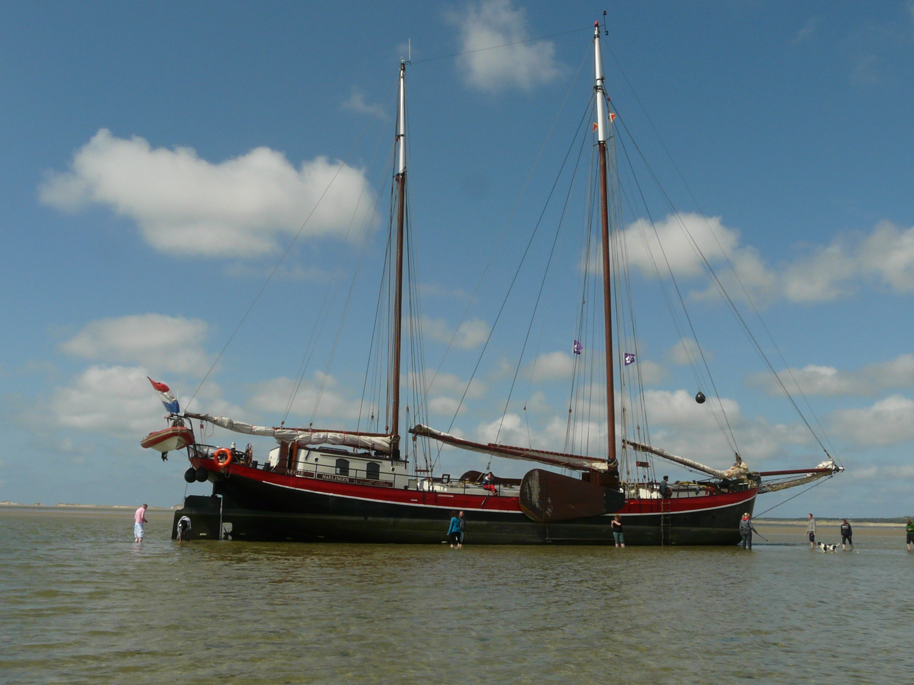

Waddenzee, the Netherlands

1 - 6 MAy 2012

Why? | Some youngsters that have the opportunity to go abroad for a short term EVS are hardly motivated to take this chance.  They seem not interested in spending a month in another culture. Due to their living situation, bad experience in school they might have low self esteem. Are scared to go ‘into the unknown’, to a place and country that they do not know and where another language is spoken.  The main idea behind this partnership building activity is that these young people will have the opportunity to meet other potential volunteers and build relationships. This will motivate them to make the step for volunteering abroad because the ‘unknown’ has a face and a name. The aim of the training is that the youngsters will make concrete plans for a short term evs for this summer 2012.  Youthworkers or mentors that are directly involved in hosting and sending can build solid partnerships and can make sure that ‘their’ young people are safe and taken care off while being abroad.
What is this Partnership Building Activity about? | During 4 days, an international group of youth workers/mentors will focus on building reliable partnerships using intercultural learning methods to discover and discuss the needs of their young people. They will be able to present their project and find a possible volunteer.  The young people will focus on making friends and exploring possible volunteering projects.  The activity is based on methods and approaches within the non-formal education field.  Why on a ship? Young people have to work together and can make friends. Youth workers have to work together as well, which gives them a start to talk about responsibilities and expectations in partnerships.  The ship is small and it takes effort to live and work together and that is a good basis for further exploration in that theme.
Aims & Objectives | By the end of this partnership building activity, participants have:  - Knowledge about EVS and responsibilities of promotors.  - Exchanged information about their projects where volunteers can stay and work in.  - Defined needs of youngsters with fewer opportunities on evs and exchanged experiences.  - Know how to make a safe project together relating to hosting young people.  - Build partnerships and made agreements about hosting and sending their young people preferably for summer 2012.  - Have discussed and reflected on active participation and volunteering within a European context.  - An understanding about the significance and possible outcomes of non-formal learning approaches.  - Have an understanding about teamroles and teamwork.
How will we do this | Experiential learning and contactmaking by sailing the ship together as a team, interactive workshops, exchange of experiences and projects, individual and groups reflections, exercises, etc.
Working Language | English
Profile Participants | This activity is open for all youth workers/ mentors from programme countries who work with young people that have fewer opportunities and work in/for a project which can send/host short term evs in summer 2012 (fewer opportunities, because the youngsters might be dropped out of school, have less chances on jobs, have less money or live in a deprived area. Because the 4SAIL will take place on a ship, the activity is not suitable for participants with physical diabilities for safety reasons). Participants come in couples, a youthworker and a youngster (from the age of 16) that can be motivated to go abroad for one (or two) month(s).  The participants should have a clear intention in hosting and sending short term volunteers and there EVS accreditation (Expression of Interest) must be valid. We are looking for participants from organisations with concrete short term evs-projects for summer 2012.  The activity will be conducted in English; therefore the participants should be able to understand and to communicate in this language.  Participants have to be able to swim! (or have to wear a life-jacket)  There is place for 10 couples only. Therefore it is important that applicants are screened carefully and should really fit in the profile.
Team | Claudia Schäfer, Switzerland  Ingrid van Ommen, the Netherlands
When and Where | The activity starts Tuesday June 1st until Sunday May 6th 2012.  The activity takes place on the sailing ship Aegir and we will sail on the Waddenzee, a beautiful area in the north of the Netherlands. NB: as we will be on sea, it is not possible to arrive later or leave earlier.
Costs | Board, lodging and programme costs will be provided and paid for by the Dutch National Agency.  The travel cost will be paid by the National Agency that will send you.  In most cases National Agencies ask for a participant contribution. Check your National Agency.
How to apply for this training | You can apply online through SALTO youth.net  Deadline 22th of March 2012  The National Agency in your country will make a first selection.  The final selection of participants will be communicated  on the 3rd of April 2012.
For more Information | Contact the National Agency in the Netherlands  Mireille Unger, m.unger@nji.nl, +31 30 2306508

