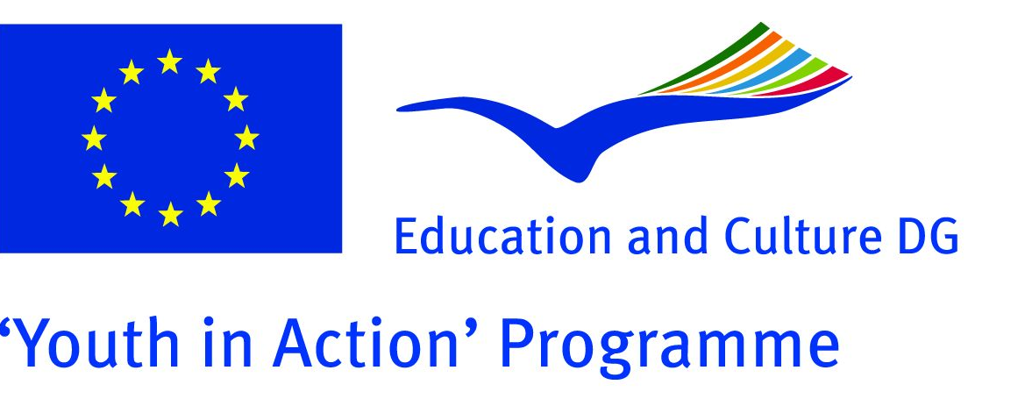

“glocal impact”
what about the local impact of international projects?
Youth in Action program, action 4.3 - Training Course
Italy, Lecce 10-16 of January 2012

Take a look to description below and if the training course is interesting for you and your organization, and if you are a youth leader, youth worker, trainer, project manager just apply for it!!!

Contents
The main aim of the project gLocal Impact is to increase the knowledge and experience in terms of meanings, technics, methodology, practice about the local impact of European projects, to diggin the concept of local and international dimensions, to explore new ways of involving local communities in projects design process. Thanks to that we want to improve the quality of planning, promoting, organizing and implementing projects especially in the frame of the Youth in Action Programme.
The training course will take place from the 22nd 28th November 2011 in Corigliano d’Otranto (Le), Italy. The training will take 6 working days.
During the training youth leaders, youth workers, trainers, project managers, will get to know other organizations dealing with “local impact” in their work, especially in international projects. The main idea of the project is to practice how the “local impact” of international projects can be more visible, useful, for the local communities. That’s why we will organize a “local action”, in the venue of the project with which we will nteract with the local community.

What we would like to focus with the training course:
- how to make sustainable locally an international project;
- how to raise the visibility of local projects
- how to improve the involvement of the local community
- why and how to make a proper needs analysis;
- how to measure the so called local impact;
- reasons to start a project from the local level/needs and reasons to start from the International level/priorities;
- how to improve the work with press and media

Aims
To increase the knowledge among youth leaders/workers on the meaning and methodology of the local impact in international projects.

Objectives:
- to acquire awareness on the concept of “local”, “local community”;
- to explore possibilities of International projects for local change;
- to start new projects;
- to learn about methods and tools;
- to get to know new organizations

Target group of the ITC:
- youth leaders,
- youth workers,
- trainers
- coordinators of international projects,

Duration, place:
- Lecce, Italy
- 10 (arrivals) – 16 (departures) of January 2012
Costs:
Participants cover 30% of travel costs and contribution to activities 20 EUR, food, accommodation and program is provided by the hosting organization in the frame of the “Youth in Action” program.

For further informations or questions you can contact us:
insight.epd@gmail.com
Salvi Greco (project coordinator): +39 338 3492709 - salvigreco@gmail.com

