 | 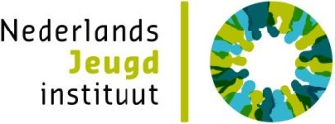 |  |  | 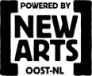 |  | 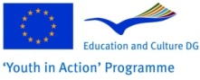
 |  | Monday 12 December | Tuesday 13 December | Wednesday 14 December | Thursday 15 December | Friday 16 December
 |  | Arrival day | Sports | Change of behavior | Art & Culture | Departure day
 |  |  | Breakfast | Breakfast | Breakfast | Breakfast
 |  |  | Getting to know eachother organisations | Departure to Youthwork organisation Divers in Den Bosch | Departure to Powered by New Arts in Arnhem | Departure participants
 | Morning |  | Defining individual learning objectives
 |  |  |  | Welcome & Presentation Organisation | Welcome & Presentation PbNA
 |  |  | Theoretical input about talent development |  | Project Visit
 |  |  | Lunch | Lunch | Lunch
 |  |  | Departure to Youthwork Central Holland (SJJMH) in Leiden | Project Visit | Evaluation
 | Afternoon | Arrival participants | Welcome & Presentation Organisation |  | Making short films about the results of the studyvisit
 |  |  |  | Return to accommodation
 |  | Dinner | Dinner on location | Dinner out | Dinner
 |  | Introduction | Project Visit | Youth in Action | Network Meeting
 | Evening | Getting to know eachother and icebreaking |  |  | Presentation of Results
 |  |  | Return to accommodation | Return to accomodation | Return to accommodation
 |  | Free time

