International Training Course for multipliers, coachers, counsellors
“COACHERS, COUNSELLORS, MULTIPLIERS – CAN CREATE MORE!”
5-8 of December 2011, Vilnius, Lithuania

This training course aims to provide opportunities for multipliers, coachers and counsellors to meet each other and share their different experiences, to raise their motivation for the future activities and develop competencies by using a diversity of methods.

The objectives:
- To clarify and understand better the role and functions of multipliers, coaches and counsellors in different countries;
- To provide space for sharing and analyzing different practices in multiplying, coaching and counselling in EU programme “Youth in Action” (YiA);
- To obtain skills for motivating and supporting non-organised youth (non-formal groups, non-experience in YiA) to be more active and/or get involved in YiA programme;
- To share methods and approaches in multiplying, coaching and counselling.

By different functions we mean:
multiplier – providing information about the programme and supporting development of project ideas;
coach - supporting youngsters throughout the project cycle (how to make a project, plan and evaluate non-formal learning);
counsellor – giving specific advice needed during a project, one to one bases.
Who can apply?..
Multipliers, coaches, counsellors:
- Having previous experiences and working directly in the coaching and multiplying field within Youth in Action programme;
- Able to communicate and work in English (support in Russian might be provided, if the group of participants will indicate this need in applications).
TC is open for multipliers, coaches, counsellors from Youth in Action programme countries.

 | Preliminary programme*
Monday |  | Tuesday | Wednesday | Thursday
Arrival before lunch  at 14.00 |  | What is behind words coaching, multiplying, counselling and  why we do it? | Ways to support non-organised youth | Needed competencies as a coach, multiplier, counsellor
 |  | Break
 |  | What and how  do we do it? | Methods and approaches | How can I support myself - my needs, strategies & plans
Lunch
Introduction to the training |  | Sharing and analyzing our experiences | Putting preaching into practice | Evaluation of the training course
Break |  |  |  | Departures after 18.00 or next morning
Getting to know each other |  | Non-organised youth as a target group | Exploring “signs of youth” in Vilnius | Departures after 18.00 or next morning
Dinner |  |  | Dinner in town | Departures after 18.00 or next morning
Mine and other cultures |  | Evening organised by participants – coach me! | Farwell Party | Departures after 18.00 or next morning
* programme can be slightly changed according to the needs of participants.
Working methods based on sharing of personal experience; learning new methods for exploring experiences, counselling each other; development on understanding of the role of multiplier, coach, counsellor; development on personal and professional levels; possibility to find partners for the future cooperation and activities.
When and where
5-8 of December 2011 in Vilnius, Lithuania
Financial issues

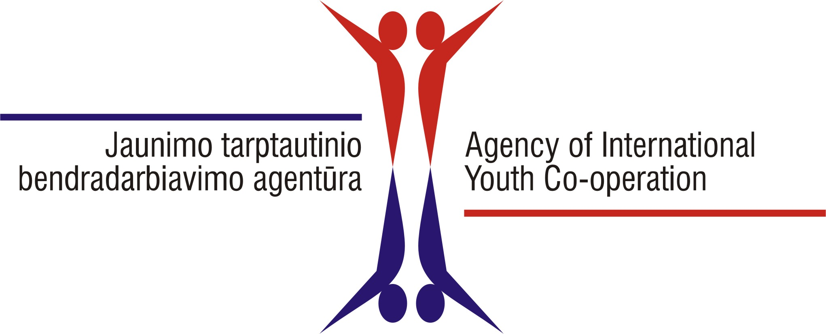
The training course is organized and programme, board and lodging, other activity costs will be financed in co-operation of EU programme „Youth In Action“ National Agencies of Lithuania, Estonia and Latvia.

The selected applicants from Baltic and other programme countries can expect the support to travel and insurance costs as well, BUT the National Agencies may request some financial contribution from participants (eg. participation fee) based on national practices and needs. Please contact your National Agency for further details.
Further info
If you are interested in this training course, please do not hesitate to contact the National Agency of Youth In Action programme in your country or
Agency of International Youth Co-operation (Jaunimo tarptautinio bendradarbiavimo agentūra) -
National Agency of Youth in Action programme in Lithuania.
Pylimo str. 9-7, 01118 Vilnius, Lithuania. www.jtba.lt
Contact person – Loreta Eimontaitė, loreta@jtba.lt, tel. +370 5 2497003.
If you have questions or clarification concerning the content of the training course, please contact trainers:
Alina Šimkevičiūtė, Lithuania, alina@krc.lt or Kristi Jüristo, Estonia, kristi@magnol.ee
Who are the trainers?
Alina Šimkevičiūtė since 2003 is dedicated most of her positive energies to the field of youth work and EU programmes „Youth“ and „Youth in Action“. She is trainer, youth worker and social worker, 2 NGO‘s member. Alina has long experience in youth exchanges, EVS, youth initiatives. From 2005 she is working as a multiplier, coacher and counselor. From 2006 she works as a free-lance trainer, from 2008 Lithuanian NA trainer. 2009 were organizing long term training course for Lithuanian multipliers, coaches and counselors. She is organizing seminars and training courses on different themes such as: youth participation, creativity, open space technologies, intercultural learning, leadership developing, youth work training and etc.
Kristi Jüristo is a trainer-consultant. Kristi has been involved with international youth work more than 15 years, through a wide variety of roles, beginning with youth camp leader, ending as a programme officer in Estonian NA for YOUTH programme. For the last 6 years the main focus has been training of young people and youth workers, both in Estonia and abroad. Her special passion are topics such as volunteering, diversity, youth participation and inclusion. Beside trainings Kristi has designed and implemented several development programmes for youth as well as youth workers, has been an editor in various handbooks and manuals and consulted numerous organizations and international youth projects over the years.
How to apply?
If you are interested and would like to participate in this training course, please apply by submitting the application form on http://www.salto-youth.net/mySALTO/applicationonline/780/ by 25.10.2011.
Candidates will be informed about the final selection by 08.11.2011.

