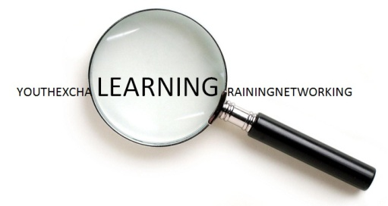
FACILITATING LEARNING
How to design and manage learning / educational processes in short-term Youth in Action projects?
Draft Programme
2nd March | 3rd March | 4th March | 5th March | 6th March | 7th March | 8th March
Arrivals | Getting to know each other  Learning objectives  Time table  Intro to TC  Outdoor activity (group building)  Learning experience | HOW DO I KNOW THAT I LEARN?  Self-assesment  Key competences  Youthpass  Life long learning | LEARNING IN INTERNATIONAL YOUTH ACTIVITIES  Specifics of international youth work as a field of learning  Facilitation of learning processes in international youth work | LEARNING IN INTERNATIONAL YOUTH ACTIVITIES  How to: Phases 1 and 2: Planning and preparation | LEARNING IN INTERNATIONAL YOUTH ACTIVITIES  How to: Phase 4: follow-up, evaluation, dissemination | Departures
 | Lunch | Lunch | Lunch | Lunch | Lunch
 | HOW DO I LEARN?  Sources of learning  Formal, non-formal, informal  Learning styles | HOW DO I FACILITATE LEARNING?  Planning learning  Debriefing, reflection  Steps | Free afternoon | LEARNING IN INTERNATIONAL YOUTH ACTIVITIES  How to: Phase 3: Activity | Closing the cycle  Participants‘ own Youthpass  Evaluation  Introducing mentorship phase
Dinner | Dinner | Dinner | Dinner | Dinner | Dinner
Welcome evening

