Guides on the Road to Social Inclusion
Training for Youth Workers working with marginalized groups

Call for participants – EU and Mediterranean Region!

Goal of the training: To provide Youth Workers working with marginalized groups with deeper insight about social exclusion, and effective tools to combat it.

Topics of the training: - understanding exclusion of different origins
- awareness of stereotypes and prejudice
- how to create non-formal educational situations in the topic of exlusion for both excluded and non-excluded youth
- debriefing techniques, or how to draw learning from real-life or created situations
- community building techniques – inclusive communities
- mediation and conflict resolution techniques
- techniques for building trust and self esteem

Methods of the training: - Adventure education (*see below) and learning through experience
- Small group discussions and interactive presentations
- Sharing of best practices brought from participants’ organizations through practical demonstration
- a chance to try out the new techniques learned in a small community building project with a local youth group still during the training
- documenting the learnings in a „Practical Handbook for Guides on the Road to Social Inclusion” – all participants get a copy

Date: September 17-25th, 2011 (not including travel days)
Place: Galyatető, Hungary
Participants: 32 Youth Workers (aged 18+) working with marginalized groups, 16 from EU and 16 from the Mediterranean region, specifically from:
Egypt, France, Hungary, Italy, Izrael, Jordan, Latvia, Libanon, Morocco, Palestine, Portugal, Romania, Slovenia, Tunesia, Turkey
Number of participants from each sending organization can be found in the Conditions of Reimbursement (attached).
Costs: The project is funded by the Youth in Action program covering 70% of all travel fees, as well as all food, accomodation and visa costs.
Your contribution will be 30% of your travel to and from Hungary, your travel insurance (a must!), and 80 Euros participation fee if you are from a Western EU country, or 40 Euros if you are from the Mediterranean region or Eastern Europe.
Travel and visa costs will need to be prepaid by you, and we will reimburse them after the program according to the Conditions of Reimbursement (attached).
How to apply: Fill in the attached Application Form and send it by email to the organization you got this call from by June 15th (or earlier)!
If you are selected:
If you are selected for participation by your organization please sign and scan your Application Form and send the scanned version by email to kovacs.etelka@elmenyakademia.hu by June 20th (or earlier). Give the original signed version to your organization.
If you are from a country needing a visa, please also fill in your data in the Invitation Letter for Visa (attached), and send it to us, together with the address where you want it posted, in the same email with the scanned Application Form. You will need the Letter of Invitation signed by us and your passport (valid for at least 6 months after the training) to obtain your visa, so the faster you send us this info, the faster you can start obtaining the visa (which might take a lot of time!!). Don’t forget to ask for an invoice for the cost of your visa (as described in the Conditions of Reimbursement).
If you have your visa, or do not need one, you can proceed to buy your travel tickets to Hungary according to the Conditions of the Reimbursement.
Arrivals and departures:
Arrival till | 18:00 | Friday 16th September, 2011
The program starts | 09:00 | Saturday 17th September, 2011
The program finishes | 22:00 | Sunday, 25th September, 2011
Departure till: | 12:00 | Monday, 26th September, 2011

We are asking you to arrive on the date given above, to the accommodation.
If you arrive 1-2 days earlier or leave later, please arrange your own accommodation for the extra time.
We expect you to participate on the whole exchange! (It means coming later or leaving earlier is not allowed!)
Venue
The training will take place in Galyatető, Hungary, at the Fogadó a Táncoló Kecskékhez.
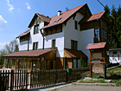
In the accommodation there are 3-4 bed bedrooms with shower.
The address is: Galyatető, Madách u. 7. and their website: www.tancolo-kecskek.hu (only in Hungarian, but you can check the photos☺)
How to get there?
Arrange your trip to arrive on time at the arrival day!
Take a flight from your country till Budapest Ferihegy Airport.
Catch a bus till Kőbánya-Kispest (metro station) and go with the metro BLUE till Deák Ferenc tér! From Deák Ferenc tér you change metro line to the RED one and go till Stadionok station.
ATTENTION! You have to buy ticket for the vehicles (price: 300 HUF). Use one ticket for the bus and one for the metro (ticket price includes metro transfer)!
At Stadionok station go to the ticket officer at the bus station and ask a ticket to Galyatető! Watch out there are buses that go there directly 3 times a day. Time schedule is: 8:15; 13:15; 16:45.
What to bring?
Bring clothes for nine days, considering that some of the days include intensive movement. We will do exercises both inside and outside, also sit on the floor in the training room. Consider that we will move many times between the accommodation and the forest around. September in Hungary might bring summer weather of up to 25 degrees, but it can also be a time for the first frosts! There can be wind, rain or hot sunshine as well... There is no washing machine at the accommodation - of course you can handwash.
Towel.
All personal medication.
Material you want to share about Social Inclusion.
Some food and drinks and material to introduce your country to the others.
Camera, MP3s with music, laptops –optional if you have them and find them useful.

The project has received for grant form the Youth in Action Programme of the European Community.
Information on the Programme is available at http://europa.eu.int/comm/youth/index_en.html
However the content of the project doesn’t necessarily reflect the opinion of the EU
and the Hungarian National Agency.
The project is not under the responsibility of these institutions.

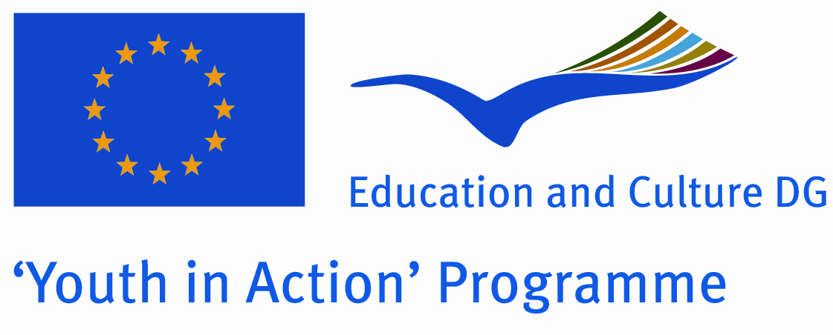

*About adventure education:
Adventure education uses the world of experience as a classroom, where participants try themselves in adventure activities and challenge, through which they can discover and develop the resources hidden within, so they can learn to better tackle certain problems, such as the question of inclusion and exclusion.

Rock climbing, raft building, river crossing on a rope bridge, and expeditions in the wilderness can all be part of adventure education.

Still, the experience of these programs offers a great deal more than just fun. They offer an opportunity for participants to get to know themselves, each other, learn from the success or failure of certain behaviours, and have a chance to try new behaviour in an emotionally safe environment. Adventure education challenges participants, and meeting these challenges develops new tools for coping with problems, self-confidence and endurance. Team adventure activities help build trusting communities, develops communal decision-making skills, leadership skills and tolerance.

About the organizer – Academy of Experience (Hungary):
Academy of Experience public benefit association was founded at the end of 2005 by 12 volunteers, who would like to dedicate their future to the non formal education and development of young and adult people. The objective of the organization is to develop the public and personal skills and attitudes of participants by using so called “outdoor activities”, and applying the methodology of experiential education (learning by doing – planning –evaluation). Our organization focuses on increasing the feeling of personal and social responsibilities, sustainable environmental education, helping the development of life-leading skills. Our organization gives the possibility to use the world of experiences as classroom, to discover and develop your hidden resources through real adventures and challenges. More info at: www.elmenyakademia.hu.

