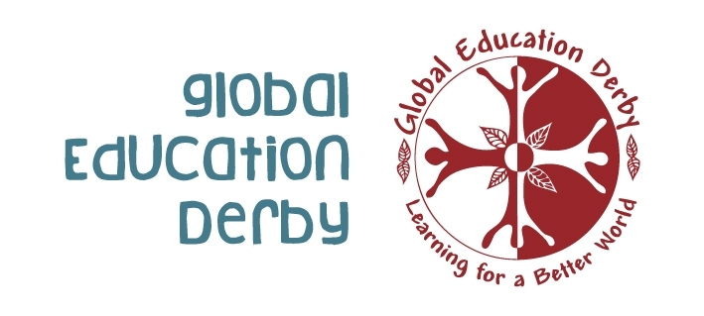
CONNECT CHALLENGE CHANGE
Training to support youth workers seeking to support young people make sense of this globalised world

Short description of project:
The training course aims to increase the knowledge and competencies of participants in using an innovative global youth work methodology. Rooted in non-formal education this methodology will enable participants to work with young people in processes related to participation, empowerment, active citizenship and self-development to think globally and act locally.

Target Participants: Youth work practitioners (sometimes called community workers or social workers), particularly those working with young people with fewer opportunities, who are interested in implementing global youth work methodology and disseminating this learning to others.

Countries involved: UK, Poland, Romania, and Turkey

Number of participants: 20

Date: Monday 4th – Friday 8th July 2011 plus 2 travel days (3rd and 9th July)

Venue: The Voicebox, Derby, England

Language of the Training: English (all participants are required to be able to communicate in English).

Costs: 30% of vouched travel costs.
70% of Vouched travel costs will be refunded. Course materials, food, accommodation and activity costs will be covered.

Application deadline: If you are interested in the training course then please complete the application form below and return by Tuesday 31st May 2011. You will be notified by Friday 3rd June if you have been successful or not.

Context:
Young people throughout Europe are connected to the wider world through food, clothes and music; via the internet and other media; through their experience of and concerns about fairness, conflict, poverty and the environment; and through the social and economic forces that shape their identity, their community and their lives. For youth work to truly empower young people it must enable them to make sense of, reflect on and respond to the changing nature of the globalised world they are growing up in. A global society needs global youth work.

Global Youth Work:
Global Youth Work has been independently evaluated as being “qualitatively different from general youth work and having more benefits in terms of supporting young people to reach their full potential as active global citizens” as evidenced by its:
- Higher aspirations for young people
- Values base
- Outcomes achieved, especially helping them to integrate identity, values and actions
- Disposition to be more ‘political’ cutting edge and current
- Ability to capacity build young people to take action and ‘be the change’

Project Objectives:
- To train participants in an innovate Global Youth Work methodology (“Connect, Challenge, Change”) which has been developed and implemented in the UK
- To increase participants knowledge of global issues such as environmental sustainability, poverty, equal opportunities
- To reflect on personal and professional values, experiences, attitudes and behaviours in youth work in relation to personal, local, national and global issues
- To widen participants perspectives and challenge their attitudes and perceptions to global issues through critical thinking methodology and activities
- To educate participants in techniques and skills which will help them to engage a wide range of young people, especially those with fewer opportunities, to make sense of a rapidly globalising world and their place as global citizens within it
- To reaffirm participants’ competences in adapting activities related to global youth work and global issues to different situations and youth groups
- To develop activities and projects to be implemented at a local, national and European level aimed at empowering youth through global youth work in the frame of the Youth in Action Programme
- Through study visits to showcase best practise of Global Youth Work in the East Midlands region of England which is the hub of Global Youth Work in the UK
- To explore e-learning as a tool for youth workers seeking to develop their professional practise
Project Methods:
Workshop/training sessions
- session dedicated to getting to know each other, the introduction of the training course and building trust in the group of participants
- session about the background of the participants, their associations and organisations, their country’s situation related to youth, non-formal education, politics, global issues and global youth work
- 3 full day training sessions on Connect, Challenge, Change as a methodology with theory linked to activities applied in youth work settings
- 1 day session dedicated to planning the follow-up activities to foster the networking of good practices and developing new projects, through the e-learning platform
Expert speakers
Talks on specific global issues such as poverty and climate change to increase participant’s knowledge of a range of global issues.
Study visits
Visits to youth groups across the region of the East Midlands to witness firsthand the positive effect of global youth work methodology in empowering young people to take action and become active citizens in their local communities

This training course is funded through 4.3 of the Youth In Action Programme.
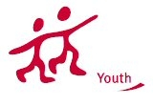
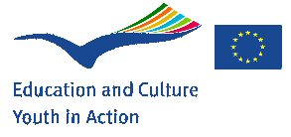

This project has been funded with support from the European Union and British Council. This publication/communication reflects the views only of the author, and the European Commission and British Council cannot be held responsible for any use which may made of information contained therein.

Application Form for ‘Connect Challenge Change’ training for youth workers seeking to support young people make sense of this globalised world

PART I

First name:

Family name:

Date of birth:

Male: Female:

Private address

Street and street number:

Postal code and place:

Country:

Tel:

E-mail:

Work address (Your youth/community organisation)

Name of the organisation:

Street and street number:

Postal code and place:

Country:

Tel:

E-mail:

Fax:

Web site:

Language proficiency

The working language for the training course will be English.
Please indicate your level of English with a X:
Fluent____, Working level____, basic____, None at all____.

Please indicate special needs and requests (Dietary requirements, Religious needs, Medical needs, mobility, translations etc.):

PART II

Please give a brief description of your organisation´s/ group’s activities:

Briefly describe the target group of young people your association/group works with:

What is your role/position in your association/ group and your main tasks?

Please describe your interest and motivation in applying for and attending this Training course?

How could you and young people in your association/group benefit from your participation in this training?

Have you ever been involved in any global youth work activities or training before? If yes, please explain briefly what were the activities/training you were involved in. If no, this is not a problem, this is why you are applying for the course!

As part of the training course we would like you to develop a plan of a global youth work project and then implement it. Do you already have an idea or a plan for such a project? If not no problem.

Do you have any future plans to develop/get involved in actions under the Youth in Action progamme?

What do you expect to gain from this Connect Challenge Change Training course, professionally and personally?

We would like to make the program close to your expectations, what knowledge and skills would you like to gain during this training course?

Any other comments:

EMERGENCIES
Indicate the name and full contact details of a person to be contacted in case of emergency:

Name:
Phone (include international dial codes):
Email:

DECLARATION:
Please take note of the following conditions which will apply if you accept a place on the training.

- You hereby declare to have carefully and entirely read and understood the training course description, objectives and methods.
- You hereby commit to participate to the whole process of this course including remote preparation pre and post course.
- Obtaining full travel insurance policy is your own responsibility and at your own expenses.
- Only 70% of your travel costs are refundable. You need to fund the 30% balance.
- Your contact details and the details of your organisation may be shared with the other participants during the course and with the other project partners
- The provision of the above information on special needs does not remove your own personal responsibility for ensuring your own safety.

Signature: Date:

Please email the completed application form to:

alison@globaleducationderby.org.uk

Application deadline: Tuesday 31st May 2011
All applicants will be notified by: Friday 3rd June 2011

If you have any questions please contact: alison@globaleducationderby.org.uk or ruth@globaleducationderby.org.uk

This training course is funded through Action 4.3 of the Youth In Action Programme.
This project has been funded with support from the European Union and British Council. This publication/communication reflects the views only of the author, and the European Commission and British Council cannot be held responsible for any use which may made of information contained therein.

