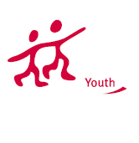


I N F O L E T T E R
20th June 2011 – 1st July 2011
Hungary

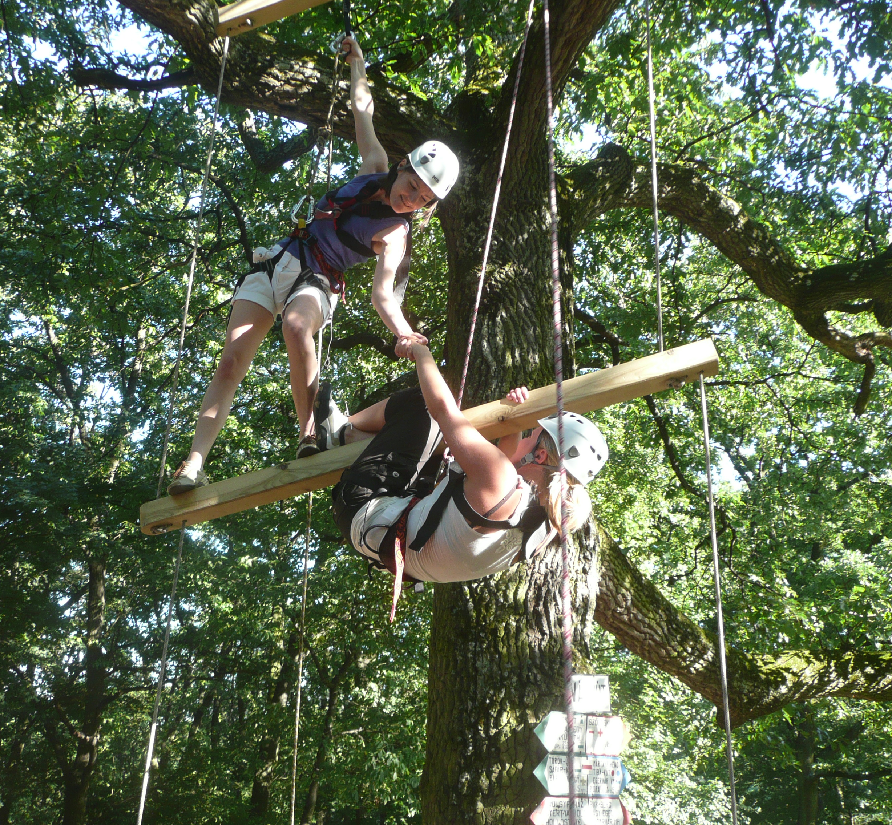

Dear friends,

We are happy to welcome you to the training course BTN! „Back to the Nature” which will take place in Hungary in June, 2011. It is an initiative organised by the Élményakadémia Academy of Experience Association. In this information letter you will find information you might need about this course, including the goal, the program and the practical information about accommodation, dates, countries included, financial conditions and others. Attached you will find the application form for the 10 days course.
We hope to answer all your questions and are looking forward to seeing you in Hungary in June!
Élményakadémia Közhasznú Egyesület

C O N T E N T S

W H A T ? 4

T H E M E S, P R O G R A M M E 4

P A R T I C I P A N T S & T RAINERS 5

P R A C T I C A L S 6
- DATES 6
- VENUE 6
- WHAT TO BRING? 7
- COSTS 8
- APPLYING – SELECTION – CONFIRMATION 9

A T T A C H M E N T S
- REIMBURSEMENT 10
- APPLICATION FORM 13

WHAT?
BTN! is a 10-day outdoor programme for 18+ aged youth workers aims to explore outdoor tools – climbing, low-high rope elements - that are used in experiential education. By the end of the project participants will be able to create alone high- and low rope elements and will gain basics about rock-climbing practices. The project will be organized with the participation of 9 partners from following countries: Romania, Slovakia, Hungary, Portugal, Latvia, Bulgaria and Italy. Their youth workers will take part on the 10 days course starting from 20.06.2011 till 1.07.2011 in Hungary. The main aim is to get technical knowledge about climbing and building, using highrope-elements, soft skill development about experiential education will take a less highlighted part.

THEMES & PROGRAMME
Tools are:

Rock-climbing, high/low ropes activities + building, theoretical and practical education.

Themes are:
- How to use rock climbing and ropes course in experiential education,
- Knots, equipment
- belaying
- safety management
- practice; climbing, abseiling, building rope elements

PARTICIPANTS & TRAINERS
Participants:
- Age limit: 18+
You are outdoor instructor, youth worker, working with groups of different age and target.

Trainers:
Climbing instructors from Hungary.
If you don’t meet any of the above criteria:
We have a limited amount of places available for people who are from other countries. If you are one of them and really really want to come, contact Erika Schmidt with a plan about how you will cover your travelcosts, whether and how you can contribute to the costs of the training as well.
We suggest that you do your own fundraising, look up local funds from your country, search for the opportunities of study and adult education grants, e.g. the Gruntwig, the Leonardo and the Erasmus programs.

PRACTICALS
Dates
Arrival till | 18:00 | Monday 20th June, 2011
The program starts | 09:30 | Tuesday 21st June, 2011
The program finishes | 22:00 | Thursday, 30th June, 2011
Departure till: | 12:00 | Friday, 1st July, 2011

Arrivals and departures
We are asking you to arrive on the date given above, to the accomodation of the exchange:
3234 Galyatető, Madách str. 7. , Hungary.
If you arrive 1-2 days earlier or leave later, please arrange your own accommodation for the extra time.
We expect you to participate in the whole exchange! (It means coming later or leaving earlier is not allowed!)
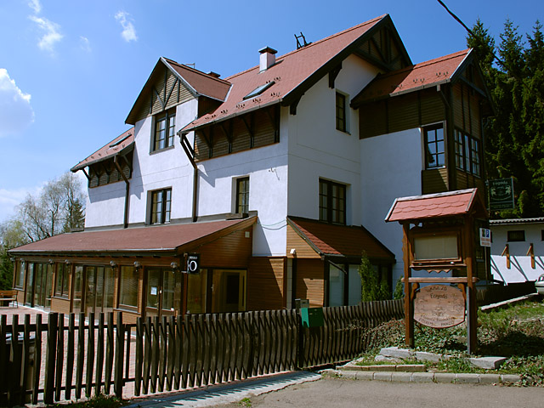
Venue
The exchange will take place in Galyatető, Hungary.

Accomodation is called Fogadó a Táncoló Kecskékhez
In the accommodation there are 2-3 bed bedrooms with shower.
How to get there?
Arrange your trip to arrive on time at the arrival day!
Take a flight from your country till Budapest Ferihegy Airport.
Catch a bus till Kőbánya-Kispest (metro station) and go with the metro BLUE till Deák Ferenc tér! ATTENTION! You have to buy ticket for the vehicles (price: 300 HUF). For each journey one ticket!
From Deák Ferenc tér You change metro line to the RED one and go till Stadionok station.
At Stadionok station go to the ticket officer at the bus station and ask a ticket to Galyatető! Watch out there are buses go there directly 3 times a day. Time schedule is: 8:15; 13:15; 16:45.
What to bring?
We are asking you to bring certain clothes for your physical safety, personal higiene of yourself and the other members of the group.
Take care that you have enough clothes for ten days of intensive movement. We will do a lot of exercises outside, also sit on the floor in the training room. Consider that we will move many times a day between the accommodation and the forest around. There is no washing machine at the accommodation - of course you can handwash.

Checklist:
If you have your own climbing equipment, e.g. harness, helmet, climbing shoes, carabineers, etc. please bring them.
Towel
Water bottleof minimum 2 L
Warm clothes for outdoor & indoor activities and for after-movement times
Long sports trousers - for both boys and girls it is obligatory that your trousers are at least knee length, covering your knee, min. 2 pairs
T-shirts / tops for physical movement (girls: sports bra!)
Socks made of a material that is healthy and breathable.
Indoor shoes for physical activities: holds your feet, and allows maximum flexibility.
Backpack
Raincoat
Hut
Outdoor sports shoes, boots that are holding your ancle and are waterproof!
Sleeping mat
Sleeping bag
Music of different atmospheres and rythms
MP3 players
Some food and drinks from your country
Your own medicines
Documents
passport or other official identification
bills and tickets described in the attachment
insurance (described below)
Hungarians: TB card

COSTS
Élményakadémia covers the following costs:
- accomodation
- food
- the costs of the programme
- maximum 70% of the travelcosts of foreign participants, funded by the Youth in Action Programmme, according to the conditions described in the attachment.

For this we received grant from the Youth in Action Programme, for participants from the countries mentioned above, without age limit.

Participants cover the following costs:
- The rest of your travelcosts from your living place to the project venue, which can be 0 – 100% of your travelcosts, depending on what kind of funding you are coming with.
- Your own insurance
- Participants’ contribution:
  - 90 €/ person.
To be paid in cash in HUF or € on arrival.

The procedure and the conditions of the reimbursement is described below in the attachment nr.1.
Please read it carefully and if you have questions, contact us in advance.

APPLYING – SELECTION – CONFIRMATION
Participants: until 20th May, 2011.
Send your filled in application form to Erika to the following address: schmidt.erika@elmenyakademia.hu
If you have any physical limitations, disease and/or use medicine we need to know about, indicate it on the application form. If you are a vegetarian, or have a special diet, let us know, indicating what you cannot or don’t want to eat, and also what you CAN eat, so that we can arrange suitable food.
Selection will be done by 23rd May.
Until 23rd May you will receive the confirmation letter. Then you will have 2 weeks to buy your ticket and confirm that you are coming. We will only take you serious, when you bought your ticket.
The ones not selected in the first round will be on the waiting list and as soon as there is an empty place, we will contact them.
Selection will be done according to the contents of your application forms, and the criteria given above taking into consideration the geographical, age and gender and social background-based balance of participants.
Note that by filling in and sending us your application form, you state that you have read, understood and accept the contents of this information letter.
Erika will be the training coordinator and if you have any question do not hesitate to ask her.
We are looking forward to see you in Hungary!

Élményakadémia
website: www.elmenyakademia.hu

The project has received for grant form the Youth in Action Programme of the European Community.
Information on the Programme is available at http://europa.eu.int/comm/youth/index_en.html
However the content of the project doesn’t necessarily reflect the opinion of the EU
and the Hungarian National Agency.
The project is not under the responsibility of these institutions.

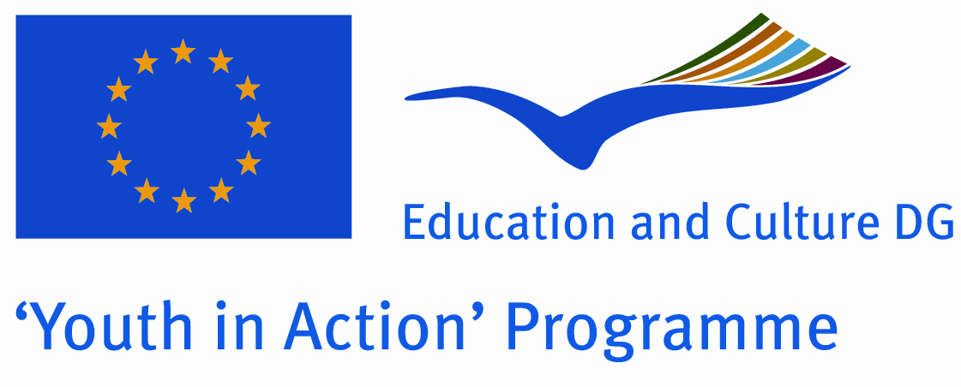

Attachment 1 // CONDITIONS OF REIMBURSEMENT
By law and the funding rules of the Youth in Action Programme we need to keep certain administrative procedures. We are asking for your support and cooperation in keeping these rules.
Please make sure that you read and understand the conditions and the procedure.

Conditions of reimbursement:

- Only if you participate in the whole program can you get the reimbursement.

- Save your original tickets and receipts, invoices and all related documents, because you can only get reimbursement for costs of which you can prove the amounts with original tickets and receipts. Only the amount written on the ticket will be reimbursed – that is, if you want your return ticket to be reimbursed, you have to give it to us. We cannot reimburse anything that you buy after the training.

- Reimbursement will be in HUF and it will by done by bank transfer. The exact procedure is described below. The exchange rate we will use is defined by the National Agency of the Youth in Action Programme.

ALL the following ORIGINAL documents will be needed:

- all your tickets and boarding passes
- invoices of buying your tickets described below
- passport or ID
- Official document from the bank or travel agency stating the exchange rate from your currency to Euro and/or HUF of the day you buy your ticket.

What is an invoice?
This is a document, signed and stamped by the seller.
It needs to be for the following address as buyer:

Élményakadémia Közhasznú Egyesület
1082 Budapest
Leonardo Da Vinci str. 44/23.

It must contain your name, the starting and finishing place and the date of the of the journey and the price of the ticket. Whatever official is your paper, if these data are not on it, you can not get it reimbursed!!! Use your name from your passport, no nicknames!

E-tickets:
An e-ticket is NOT an invoice! If necessary, call the airline/train company/etc., explain them the situation and ask them to give you a receipt/invoice with the data given above. If you buy tickets online, take care that you tick the box indicating that you want an invoice, and you fill in the address of Elmenyakademia where the invoice has to be sent by the airline company.
Invoices of tickets that you buy in Hungary are called ÁFÁS SZÁMLA (this is how you ask for it)

Reimbursement limits per country
- In the EU grant we will receive a certain amount of money for this purpose, which we are not allowed to exceed. These amounts are based on the costs our partner organisations told us when we wrote the application.
- Amounts given are for return tickets between your place of living and Galyatető.

- We reimburse public transport tickets and taxi costs from Budapest or from cities where you change transportation only if they fit into your limit and you bring the invoices of them as well.

Organization | Number of participants | max 100% travel cost/person | max reimbursement | Participant’s contribution
Élményakadémia Közhasznú Egyesület | 5 | 20 | 14 | 6
Outward Bound Romania | 3 | 150 | 105 | 45
Outward Bound Slovakia | 3 | 30 | 21 | 11
People to People | 3 | 100 | 70 | 30
Associação 5 Elemento | 4 | 500 | 350 | 150
TDM 2000 | 3 | 400 | 280 | 120
Twelve Stars | 3 | 380 | 268 | 112
World at Our Home | 2 | 350 | 245 | 105
Young Partners for Civil Society  Development Association | 3 | 300 | 210 | 90
Pro Vision International | 2 | 150 | 105 | 45

Reimbursement procedure for participants funded by the Youth in Action Programme:

- The amount of the reimbursement will be calculated as follows:

We take the 70% of your travelcosts between your hometown and Mátraszentimre, only those costs of which you have the tickets and invoices. From this we will calculate your reimbursement with the €/HUF exchange rate given by the national agency of the Youth in Action Programme. The exchange rate is 1 € = 275 HUF. We are not allowed to change this rate.

In case your costs exceed the limits given below, the maximum amount you can get is calculated from the 70% of your allowed limit. Limits are given below. Based on the receipts you give us, we will exchange your costs into euros and from euros to HUF.

In case you want that we exchange your currency directly to HUF, you need to bring an official document, signed and stamped original from the bank or the travel agency, showing the official exchange rate from your currency to HUF of the day when you bought your ticket/visa/insurance.

- You will check the calculation and sign a document stating that you checked and you accept the amount, the bank account number where it will be transferred and that you agree that the bank costs are covered from it and that you will send us back the original tickets, documents and invoices within 1 week from your arrival home.

- You will leave with us all the original documents that you don’t need for your journey home. During the training we will make copies of your documents, so that you can still use your ticket for the way home.

- You send us back all the original documents within 1 week from your arrival home.

- As soon as we receive all original documents from your country and the money arrives from the National Agency, we send you your reimbursement by bank transfer. We will do 1 bank transfer/country, either to your sending organisation or to the account of one participant from that country. Bank cost is approx 10€ /transfer from our bank, you need to check yourself if it costs anything from your bank or not. Bank cost will be taken from the amount by the bank. We have no separate funds to cover them, so this bank cost is yours. For the bank transfers we need these data from each country: bank account number, IBAN number, account owner name, bank name and address, SWIFT/BIC code

