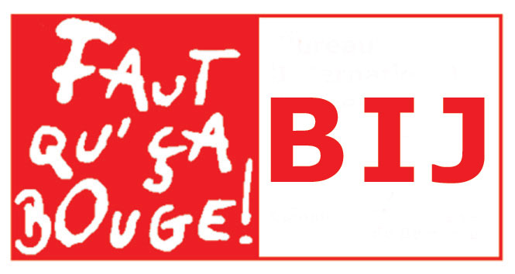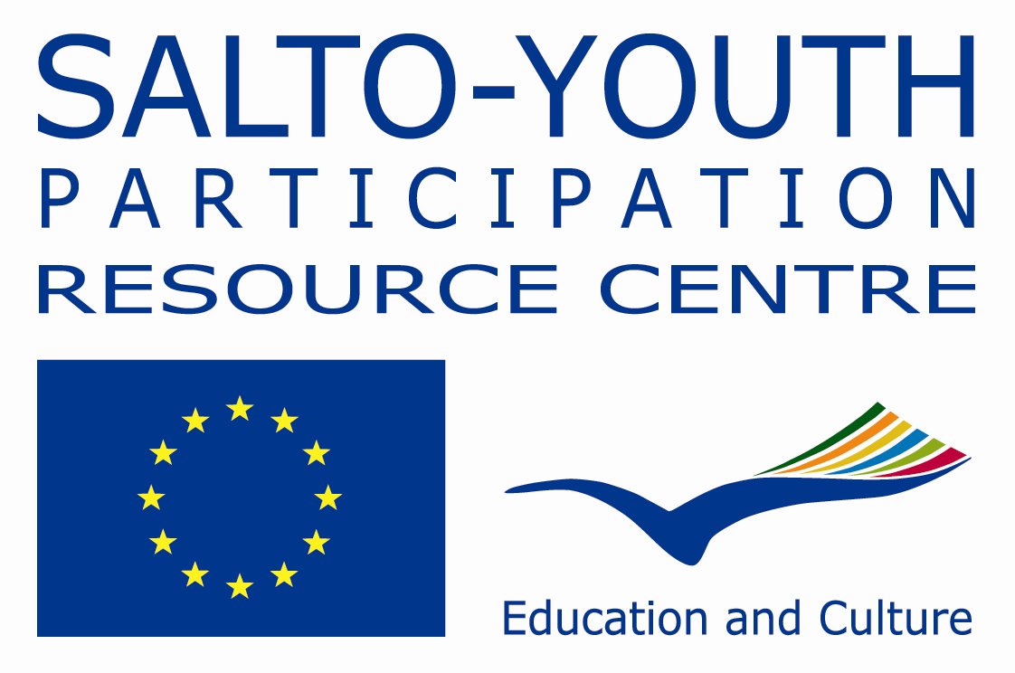

COACH 2 COACH: Coaching for Youth Participation

Invitation to apply for an International

Training Course on Coaching in Youth Projects

24 to 30 May 2011

Are you a youth worker, youth leader, trainer or
Action 1 officer looking for training opportunities on:

- How to support young people & ensure they are active throughout the whole project?

- How to offer the needed support in each step of the project?

- How to ensure a good balance between coaching and autonomy?

If so, take a look at the following invitation for an International Training Course on ‘Coaching’!

Background

During the last years youth participation became one of the most important issues in youth work and youth policy but also more in broader sense in society. Within the Youth in Action programme youth participation is emphasised as a precondition for active citizenship. Coaching is introduced as a way of supporting young people with the aim to increase their participation within the projects and in community/society. Number of events and specific work is done in the field of coaching during past years:
- SALTO Participation Resource Centre published a Coaching Guide. This is a publication on coaching Youth Initiatives and can be used as a tool to reflect and understand the importance of youth participation and ways of supporting young people (available for downloads at http://www.salto-youth.net/download/938/coaching_guide_www.pdf).
- In cooperation with several National Agencies SALTO Participation has organised international training courses Peer 2 Peer and Coach 2 Coach focusing on youth participation and coaching (reports are available for downloads at http://www.salto-youth.net/rc/participation/-coach2coach-description/).
- Other international and national developments on coaching and youth participation (see the publication ‘Where is my coach’ available for downloads at http://www.salto-youth.net/download/1724/whereismycoach.HD%5B1%5D.pdf)
With this training course Coach 2 Coach: Coaching for Youth Participation the idea is to focus on learning how coaching can be applied in supporting groups of young people who run youth project within the Youth in Action Programme and other youth targeted programmes of BIJ. In other words, how coaching can increase youth participation in any of the youth project?

Where & When?

The course will take place in Belgium, in the city of Brussels, 24-30 May 2011.

Why such a Training Course?

To increase the quality and support of youth group projects (e.g. Youth Exchanges, Youth Initiative, Youth Democracy Projects) in the frame of the Youth in Action programme and other BIJ programmes by supporting and facilitating experienced youth workers in improving their 'coaching competences'.

What for?

- To reflect and share coaching understanding and experiences;
- To work towards developing a common understanding of the term & actions of coaching;
- To be able to identify and improve knowledge, skills and attitudes of coaching;
- To be able to identify and improve their own learning processes as coach;
- To prepare participants to transfer their learning experiences with other coaches in their countries (multiplier effect) and apply in their work with young people;
- To be able to identify available support & resources required for the coaching process;
- To understand the relevance of the coaching process in supporting young people’s active
participation;
- To experience methods, tools, materials, practice and potential for using coaching within youth group projects

Who can apply?

The course will offer place for 26 participants with the following profile:
- Youth workers, social workers, youth leaders, trainers… who are directly working with youth group projects as a coach/support person during the creation and development of the projects
- Project officers in the National Agencies who are actively supporting the applications and processes of youth group projects
- Willingness to work as coaches (multipliers) supporting learning of young people involved in youth projects within the Youth in Action Programme and other BIJ programmes
- Able to communicate and work in English
- Resident in the Youth in Action programme countries (27 EU countries + Norway, Iceland, Liechtenstein, Switzerland, Turkey and Croatia).

What is it all about?

The programme will be designed to support participant in recognising and developing their knowledge and skills to work as youth project coaches, including the following:

Participants and organisations | Participants present themselves, their organisations/institutions; get to know other people and organisations/institutions.
Youth in Action programme and other BIJ programmes | General information is provided about Youth in Action and other BIJ programmes.  Practical information is provided about Youth Exchanges, Youth Initiatives and Youth Democracy and other youth projects supported by BIJ.  Exploring needs and opportunities for youth participation within youth group projects.
Coaching in youth group projects | The concept of coaching within different types of projects is introduced and is used as a tool for increasing youth participation.  Experience in supporting youth groups that run local, national or international projects is shared among the participants.
Coaching practice and reflection | Explore skills and competences in coaching youth groups that run projects. Practical experience is offered through coaching simulated youth groups.  Sharing and reflections on the roles and the practice of a coach and the understanding of coaching.
Coaching process | The main steps of the coaching process (as identified within the Youth/ Youth in Action programmes) is introduced: motivating, getting to know, building and maintaining the relationship, identifying needs & competences, supporting, evaluating.
Resources | Tools, publications and methods for coaching are provided and shared to support future youth projects.
Action planning | Planning for the implementation of personal and professional development of the learning gained from Coach2Coach training course.
Self assessment and Youthpass | Participants will have the opportunity to review their own learning process.

Which methods will be used?

The course will be based on the principles and practice of non-formal education taking into account participants needs, motivations and experiences. Communication between participants and mutual understanding will be encouraged in order to enable exchange of knowledge, skills and attitudes and to reflect upon them. The group will act as a resource for the learning process taking into account individual and group learning.
A diversity of working methods will be used to highlight the role of the ‘coach’ and the approaches for supporting youth group projects. To ensure a balance between theory and practice, a range of workshops, inputs, simulation exercises, presentations, discussions, debate and sharing will be included.
Previous experiences in coaching youth group projects will be the starting point of the programme and of the learning process. Space will be given for regular feedback and reflections and review.

Who are the training team?

The training team will be composed of:
- Buzz Bury (UK), youth worker and freelance trainer in UK, has wide experience in coaching and monitoring youth projects at local and international level; http://www.salto-youth.net/tools/toy/find-a-trainer/614;
- Nerijus Kriauciunas (Lithuania), freelance trainer, has experience in coaching youth groups, who run local and international projects; http://www.salto-youth.net/tools/toy/find-a-trainer/270;
- Noémie Cheval (Belgium), socio-cultural worker, member of BIJ trainer’s pool and experienced coach;
- Stéphanie Dreze (Belgium) Action 1.3 and Action 2 Officer from the BEFR National Agency.

And supported by:

- Thierry Dufour (Belgium) Action 4.3 Officer from the BEFR National Agency
- Fatima Laanan (Belgium) Coordinator SALTO Participation Resource Centre

The team will be responsible for the preparation, implementation and evaluation of the course.

How the costs are covered?

- Travel and visa costs of selected participants will be covered by the sending National Agencies. Please check with your National Agency if any additional participation conditions apply.
- Hosting costs (accommodation, food, programme activities, local transport) will be covered by the BIJ (hosting National Agency).
- Trainer fees will be covered by both the BIJ and SALTO Participation RC.

Working language?

English

How to apply for the course?

- Application online available on SALTO European Training Calendar www.salto-youth.net/trainingcalendar
- Deadline for applications is 15 March 2011
- Selection of participants and the allocation of places will be completed by 25 March 2011

