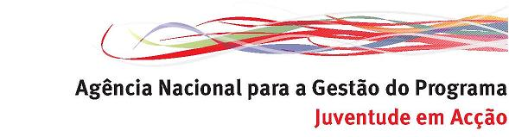

Diversity is More

20th-25th Febraury 2011 in Guimarães, Portugal

Please fill in this application form and send it by email or by fax to the National Agency of the YOUTH IN ACTION programme in your country of residence.

Deadline for applying: 15th January 2011

PRACTICAL DETAILS

Name: |  |  |  |  |  | Surname:
Name and address of the organisation/institution/ the group of young people you belong to

Type of Organisation/institution
Type | governmental |  |  |  | non-governmental |  |  |  | other
Scope | local |  |  | regional |  |  |  | national | European/international
Phone of your organisation/ group/institution |  |  | Fax of your organisation/ group/institution |  |  |  |  |  |  | Email of your organisation/group/institution
Private Address (to be used for all course correspondance)
Private Phone |  |  |  |  |  | Private E-Mail
Date of Birth |  | Sex (M/F) |  |  |  |  | Nationality
Please specify any of your special Requirements (Mobility, Medical conditions, Diets, Restrictions, Allergies, etc):

SOME MORE INFORMATION ABOUT YOU

- Can you please describe your experience and knowledge of the Youth in Action Programme?

- What is your motivation to take part in the training course? Why are you applying? What do you hope to get out of it?

- Have you already participated in any activity connected with the theme of the course?

- What is your experience in working with migrants groups and/or other minorities? What is your role within your support organisation?

- Do you have any migrant background or do you have experienced being a migrant yourself?

- Has your organisation any work experience in promoting the integration of young migrants?

- Please describe briefly the future plans of your organisation in developing work with young migrants.

Place | Date | Name and signature of the applicant

