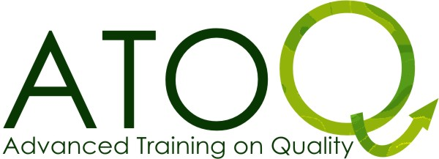

ATOQ TRAINING PROGRAMME
ATOQ Iceland 2010
Time | 8.3.2011 | 9.3.2011 | 10.3.2011 | 11.3.2011 | 12.3.2011 | 13.3.2011
8.00 |  | Breakfast | Breakfast | Breakfast | Breakfast | Breakfast
9.00 |  | Intro of the training, team and participants  Non-formal learning:  Try to sell it!  Youthpass:  just another certificate?  Expectations: Because we care. | Intro to the day  Project life cycle: a practical approach  Active participation of young people, partners… and (the) rest | Intro to the day  Quality in Youth Exchanges: workshops run in parallel, according to the learning interests & led by trainers  Consultation possibilities with present NA officer(s) | Intro to the day  Simulation exercise on Quality:  We invest in you(th)  Feedback on improving quality in exchanges | Departure of participants & team:  unless you loose your plane ;-)
13.00 | Lunch | Lunch | Lunch | Lunch (till14h30) | Lunch
  15.00 | Arrival of participants  17.00 Getting started | Exchange of “good” and “bad” practice in your Youth exchanges  Reflection time on own learning | Diversity and Intercultural learning  Making your project European  Reflection time on own learning | Share expertise about youth exchanges  16.00 Departure to town | Reflection time on own learning  Evaluation of the training course  Closure
19.00 | Dinner | Dinner | Dinner | Dinner in town | Dinner
21.00 | Welcome evening | Youth Exchange Market with cultural flavours and tastes | Evening of (free) choices | Evening in town | Goodbye evening
Note : This program can undergo slight changes on the spot according to the general level of experience of the participants!

