Open Call: Participants for the HR European School
Check out the full version of the open call http://tinyurl.com/39f52k8
or on www.aegee-budapest.hu/hres/
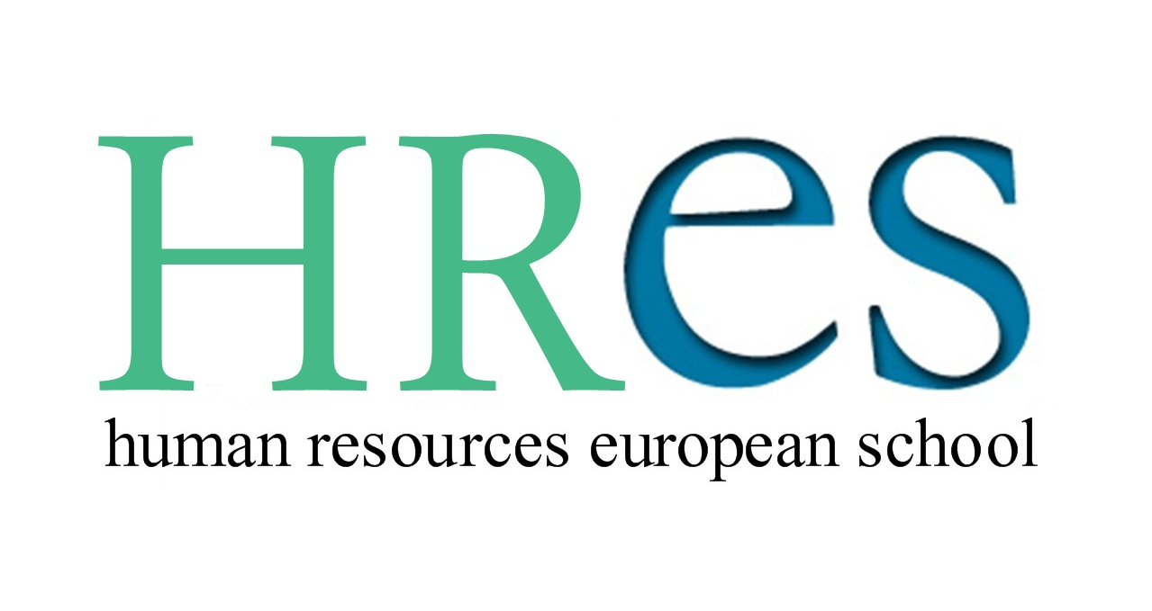
Dear friends,

a great adventure awaits you this autumn! HRES (Human Resourses European School) is a 7-day training on Human Resources management in youth NGOs. The event is prepared and designed by AEGEE Budapest in collaboration with the AEGEE-Academy, the AEGEE Human Resources Working Group.

In the course of this training you will...
1. learn to develop and implement HR strategies for your local student group.
2. get an insight into current motivational theories and the tools of both teambuilding and coaching.
3. be able to apply the techniques of strategic planning and change management at local level.
4. get a glimpse of the big and fascinating world of youth participation at European level.

* If you already dispose of some first experience with either board work or local projects or you just want to get involved...
* If you feel you are motivated to improve the HR situation of your local, but you don’t know where to start...
* If you are really passionate about empowering others and about of making the best out of teams in your local group...

... then we are looking forward to receive an email from you with the following information:

1. Name, date of birth
a. If you are from AEGEE: what is your AEGEE-local?
b. If you are from another organization: please tell us the name of your organisation and what this organization is doing.
2. Your experience in AEGEE or other organizations (in bullet points)
3. Why you would like to be involved in HRES (max. 200 words)
4. What are your plans for the future in your organization (max. 200 words)
Please send your application to aegee.hres@gmail.com until 10 October 2010, 24:00 CET.

For further information just browse our website www.aegee-budapest.hu/hres
or visit us on facebook: http://www.facebook.com/pages/HR-European-School/155532034466466?v=wall

For any questions or details on the contact contact the managers: Mircea Vădan and Astrid Schrader. For questions related to travelling, the venue or any other logistical matter please contact the Bernadett Polya from AEGEE-Budapest (bernadett.polya@aegee-budapest.hu). We will be glad to help you out.

We wish a fabulous day! Happy to hear from you.

Astrid Schrader (AEGEE-Passau: astrid.schrader@aegee.org)
and Mircea Vădan (BEST Cluj-Napoca: mircea.vadan@best.eu.org) )

General Information

What: | HRES – Human Resources European School
When: | 14 - 21 November 2010
Where: | Budapest, Hungary
Number of participants: | 25
Fee for participants: | 70 euros for those who require a visa, 80 euros for those  who do not
Arrival for participants: | 14 November (programme starts at 17:00)
Departure for participants: | 21 November
Deadline to apply for participants: | 10 October

