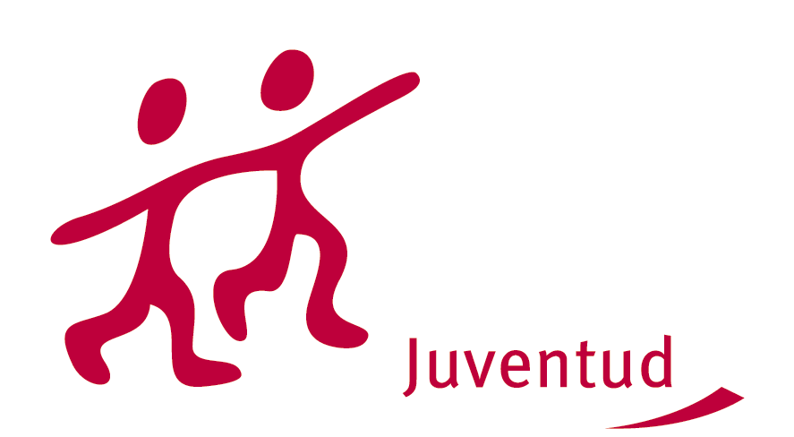
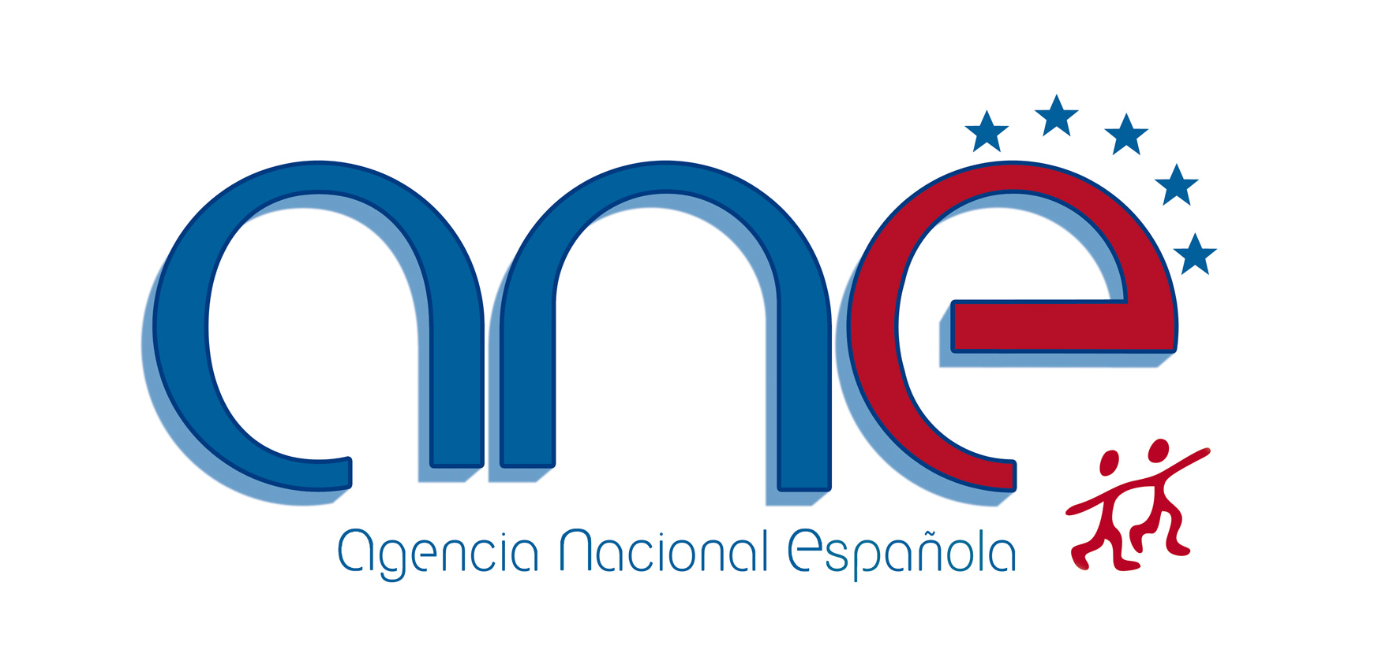


REMOVING LINGUISTIC BARRIERS IN ENGLISH WITHIN INTERCULTURAL COMMUNICATION - SOUTH COOPERATION NETWORK (SCN)

6th -12th NOVEMBER 2010 IN SEGOVIA, SPAIN

Please fill in this application form and send it by email or by fax to the National Agency of the YOUTH IN ACTION programme in your country of residence.
(For participants from Spain: por favor, envíe la solicitud al responsable del programa en su Comunidad Autónoma)

Deadline for applying: 17th SEPTEMBER 2010

PRACTICAL DETAILS

Name |  |  |  |  |  | Surname
Name and address of the organisation/institution/ the group of young people you belong to

Type of Organisation/institution
Type | □ governmental |  |  |  | □ non-governmental |  |  |  | □other
Scope | □ local |  |  | □ regional |  |  |  | □ national | □ European/international
Phone of your organisation/ group/institution |  |  | Fax of your organisation/ group/institution |  |  |  |  |  |  | Email of your organisation/group/institution
Private Address (to be used for all course correspondance)
Private Phone |  |  |  |  |  | Private E-Mail
Date of Birth |  | Sex (M/F) |  |  |  |  | Nationality
Please specify any of your special Requirements (Mobility, Medical conditions, Diets, Restrictions, Allergies, etc):

SOME MORE INFORMATION ABOUT YOU
Language(s) abilities: Please mention all languages in which you are able to work and indicate your level for each of it (A1, A2, B1, B2, C1, C2. Please see attachement called “self-assessment-grid-en” in order to identify your own level).
 | Listening | Reading | Speaking | Writing
English
Other languages
[please specify]

What are your roles (volunteer, youth worker, board member, director ...) and your tasks at the moment in your organization or association?

Do you need to speak in English or another foreign languages in your job? How often? What kind of tasks do you usually do in English?

What is your level of knowledge of the programmes listed bellow?
 | Low | Medium | High
“YOUTH in Action” programme in general
Action 1: Youth for Europe
Action 2: European Voluntary Service
Action 3: Youth in the World
Action 4: Youth Support Systems
Action 5: Support for European cooperation in the youth field

What would you like to learn, understand and experience during this training course?

How do you plan to use the outcome of this activity in your work?

Mention other international activities, training courses or seminaries within Youth in Action programme you were involved in as a participant or as an organizer:

Place | Date | Name and signature of the applicant

