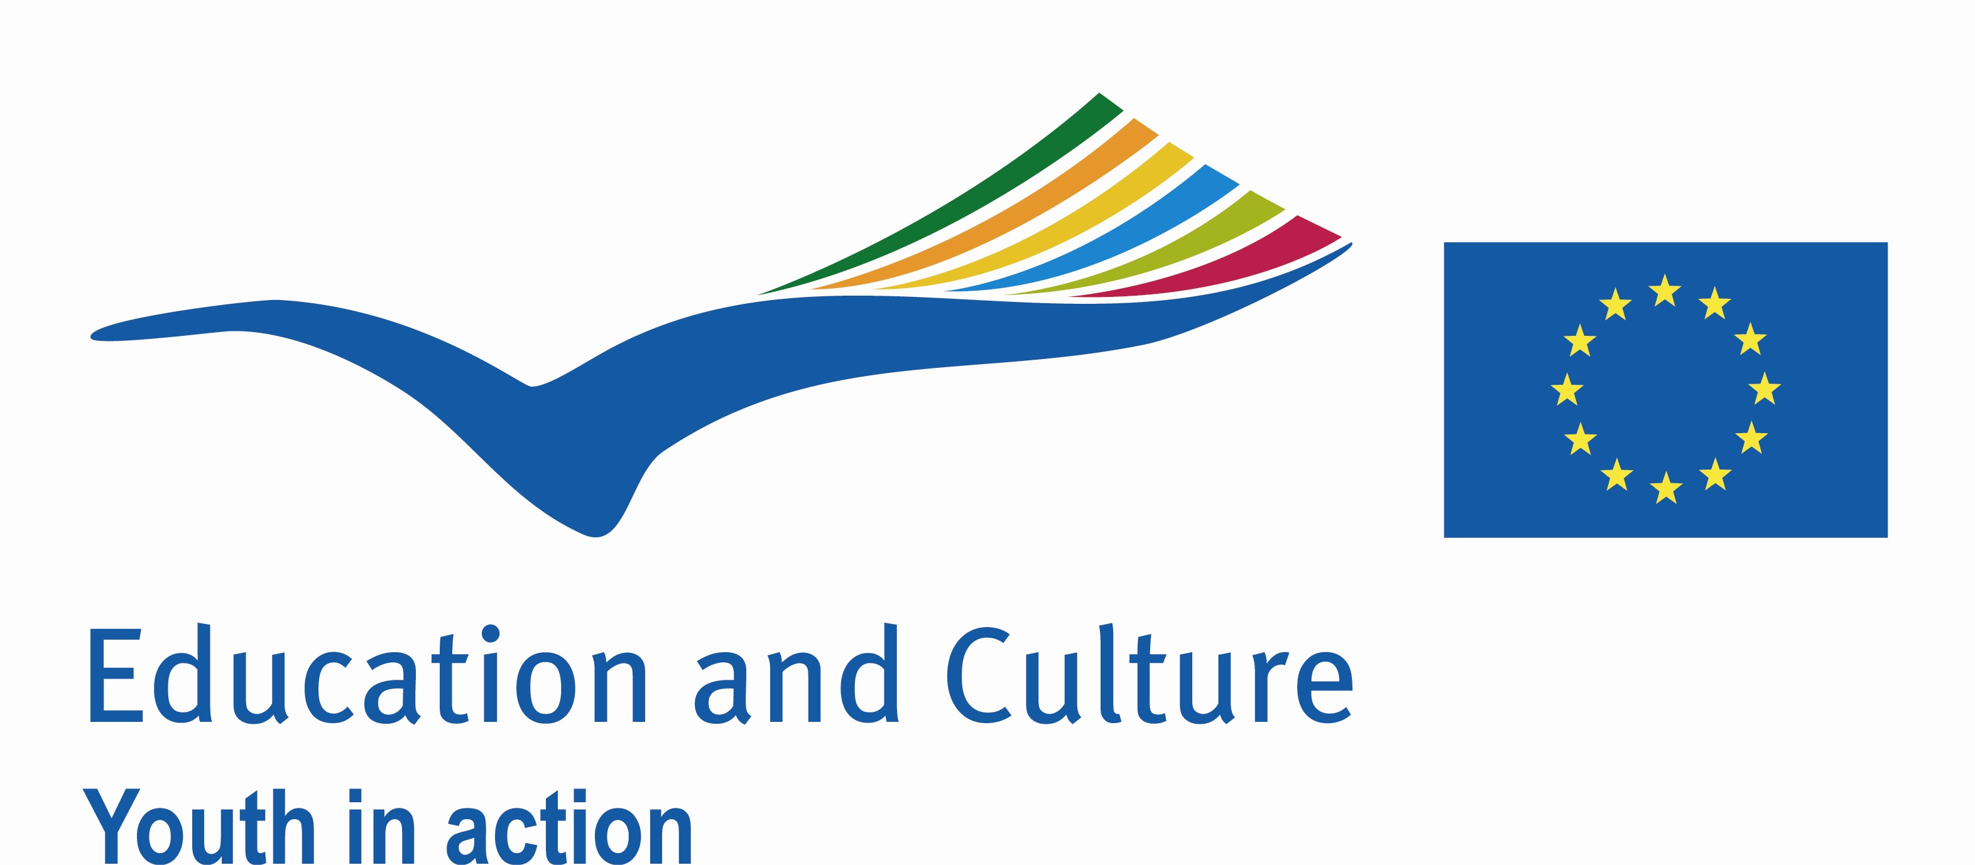
CATCH!
Partnership-building activity
for international youth exchanges with young people from disadvantaged (sub-)urban areas

An opportunity to meet new projectpartners and get your next project started

20-24 September 2010 - De Glind - The Netherlands

Why do we organise CATCH!? | Youth exchange is one of the tools that is being used by many organisations to give young people the opportunity to look beyond their own ‘borders’ and to interact with people from different cultures. A learning experience for every youngster, but especially for young people with less opportunities. This partnership building activity brings youthworkers and youthleaders together who work with young people from disadvantaged (sub-)urban areas.  An opportunity to meet new international projectpartners who work with the same targetgroup and to set up international youth exchanges within the framework of Youth in Action and to explore how other Youth in Action projects could support and strenghten international partnerships.
aims and objectives | By the end of CATCH! participants have:  - met 31 possible new international projectpartners  - explored the possibilities of setting up new youth exchanges with the other participants working with young people from disadvantaged (sub-)urban areas  - exchanged information and experiences about their organisations, targetgroups and projects  - had the opportunity to work on projects with their new projectpartners  - received input on the different aspects of a youth exchange project (f.i. programmebuilding, intercultural learning, participation, follow up)  - experienced the importance of good partnership  - gained insight on how to include non formal learning and Youthpass in your project  - a clear view of the possibilities and priorities of Youth in Action.
How will we do this? | Non formal learning, the theoretical input (minimal) will be as practical as possible.
Working language | English
Number of participants | 32 Participants from Programme countries, Macedonia, Croatia and Switzerland
Profile participants | - Participants working with young people from disadvantaged (sub-)urban areas  - Participants working directly with young people  - Participants who are looking for an international partner(s) to organise a youth exchange within the framework of Youth in Action.  - Participants are at least 18 years of age and are able to communicate in English.  - Participants knowing what their objectives are and knowing what their young people want to reach with a youth exchange.
Team | CATCH! will be facilitated by two experienced international trainers:  Wim Vogelaere (freelance trainer) & Ingrid Van Ommen (freelance trainer)  and Marrie Kortenbosch (projectofficer National Agency Youth in Action - NL).
When and where | CATCH! starts on Monday the 20th of September in the afternoon and ends on Friday the 24th of September after breakfast. All participants will be picked up from Amersfoort Central Station on Monday the 20th at 16.00 pm by bus.  The seminar will take place in YMCA De Glind in De Glind (near Amersfoort) in the Netherlands www.ymcadeglind.nl.  Participants will be accomodated in shared rooms.
Costs | Board, lodging and programme costs will be provided and paid for by the Dutch National Agency of Youth in Action.  The travel costs will be paid by the National Agency of Youth in Action in your country (in case they will support your participation).  In some cases National Agencies ask for a participant contribution. Check your National Agency.
How to apply ? | Please fill in the application form and send this 16th of August 2010 at latest to your National Youth Agency.
Selection procedure | Your National Agency will make a pre-selection. National Agencies are kindly requested to send their pre-selection to m.unger@nji.nl 23rd of August at latest. The final selection will be communicated on the 25th of August.
More information? | The Dutch National Agency of Youth in Action:  Marrie Kortenbosch (m.kortenbosch@nji.nl, 0031 30 2306580)

