information letter

Social and Audiovisual Media to Empower Youth NGOs
How to Use Social and Audiovisual Media to Empower Youth and Youth Organisations?
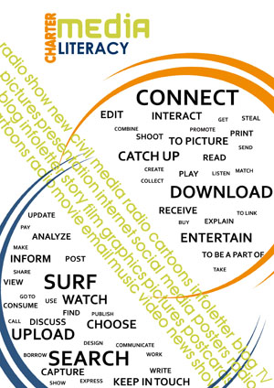

Dates: 12-17 July 2010

Location & Accommodation: Ommen, Netherlands

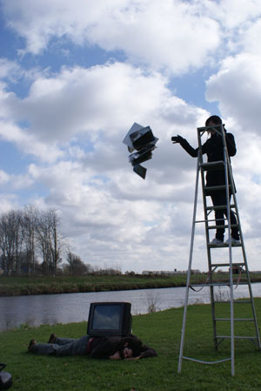

Training’s Aim:

The aim of this basic training is to master the use of new media for youth work and in the service of promoting youth activities. We will achieve this by analyzing, accessing and creating social and audiovisual media.
Audiovisual media is defined here to include all forms of audiovisual communication, from television production to cinema, from video art to documentary photography, where content is communicated in a one-to-many fashion, from creator(s) to audience.

Social media is defined to include all forms of web-based communication that allows individuals to engage in many-to-many interaction, thus empowering people to create media content themselves.

Rationale
How does this training support youth work(ers) and NGOs?
- The training AV to Empower follows the developments in communications technology and exploits it for maximizing participation. There has been a true social media revolution in the past decade (video, photo and file sharing online, online film distribution, social media sites, social networking sites). This already has an impact on how young people can be reached and involved in youth work Europe-wide. Youth NGOs can greatly benefit from learning how to reach their target grops through communication channels used by the target group itself.
- Because of the above development, there is an ever-growing need for literacy in new communications technologies. Media literacy is to become a vital personal and social skill for youth workers, as well as for young people.
- Literacy in new communications technologies supports the employability of youth, therefore it supports all forms of social inclusion.
- Social and audiovisual media is a communication channel not a theme, an available technology, not a philosophy of life. This allows youth workers to work with any theme or content by looking at social/audiovisual media as a “language” (analyzing media), platform (accessing media) or as a form of expression (creating media content).
- It opens new perspectives in knowledge transfer between generations of youth workers and helps organisations to harness the advantages of audiovisual communication for their organisational and staff development.
- Projects involving audiovisual media are excellent for promoting cultural diversity, European citizenship, creative expression, or any other long-term objective.

Objectives

- To use media literacy and new media as a powerful tool in youth work
- To practise working with media in group context
- To use media for process-based youth work
- To foster a holistic approach for youth work and for media education, which combines working with the young person’s social, physical, emotional and spiritual intelligences
- To broaden youth workers’ experience of different kinds of media form and content to encourage innovation & creativity
- To develop specific skills in new media (creating)
Expected Outcomes
- You will learn effective, powerful methods for using media in youth work
- You will participate in processes of media making in teams
- You will have the chance to express personal-universal messages with videos and digital photography
- You will have an overview of what is media literacy and how it can be useful for working with youth in any context

The Method

This training course is based on the method of learning by doing. Participants will actively create the playing field and work directly with audiovisual media. Different non-formal learning techniques will be used, among them: games, simulations, theoretical input followed by active experiences and reflection, small group work, individual goal setting, sharing of experiences in the large group.

Equipment

We provide wireless Internet connection and basic audiovisual equipment, which includes 5 video cameras, 4 tripods, tapes and other necessary accessories. We do not provide computers, laptops and digital photo cameras, and external hard drives, so you are encouraged to bring along these items if you have them.

Learning the technical parameters and functions of digital equipment will not receive particular emphasis during the programme, although there will be chance for indvidual progress and practice in using these tools at a basic level.
Trainer & Team
This training will be led by Miki Ambrozy, an experienced media educator and video maker. He has been involved in international youth work since 2005, actively working in the Synergy Group for the past 2.5 years. A team of experienced volunteers will support the training course.

Participants contribution

As Synergy group we want to keep the expenses for participants as low as possible so everyone can participate. We realize that still for many individuals the travel and participation fee can be a big investment. We invite you to be creative with it, there are all kind of cheap ways to travel, if you spend some time to look for it or ask someone to support you in it. Sharing with people that you are looking for cheap way of travelling to Holland is mostly very effective. Also asking and sharing about the participant fee is a very effective way of getting support. If you think this training is for you do not let the money be an obstacle to give yourself this experience.

- This training is financially supported by the Olde Vechte organisation
- There is a participant’s fee of € 250.
- Participants take care of their own travel expenses, there is no reimbursement.
- Hosting, catering and training expenses are covered by the Olde Vechte organisation.

Dates
- Arrival is on 12th of July until 17.00
- Start of the program 12th of July at 20:00
- End of the program 17th of July at 23:00
- Departure day 18th July before 12.00
- In total there are 4 working days.

If you want to arrive earlier or leave later and you need accommodation contact us before the training, so that we can help you to find a place to stay.

Accommodation
During the training you will be hosted in the Group accommodation Olde Vechte and Zeesse www.oldevechte.nl. During your staying we ask the participant to support us is some light house hold duties. In order to keep the participants fee as low as possible.
Address of the Guesthouse:
Zeesserweg 12,
7731 BG, Ommen,
The Netherlands
Phone: 0031 529 451963,
E-mail:oldevechte@hotmail.com
www.oldevechte.nl
www.s-gr.com

In the house there is wireless internet connection and a washing machine available. The accommodation is near the city of Ommen and 500 meters distance from its shopping centre. More information about how to get there and what to bring with you we will send you after your application form is approved.

APPLICATION FORM SYNERGY GROUP – Media Training:
Social and Audiovisual Media to Empower Youth NGOs

“Social and Audiovisual Media to Empower Youth NGOs”
Media Training

12nd until 17thof July 2010

Send the filled application to oldevechte@hotmail.com
Deadline for applying: 1 July 2010

Answer the questions below Fill in the answer in this column
Country:
First name:
Last name:
Name you want to be called in the training:
Address:
Zip code:
City:
Date of Birth:
For people who need visa:
Passport number
Expiry bate of Passport:

Phone number Regular:
Mobile:
E-mail:
Special Diet:
What is your present health condition? Detail health problems and their present state. Specify and describe any medication you take or have taken within the last 6 months
Contact person in case of emergency
Full name:
Address:
Phone numbers:
Relationship to you:
How did you know about this training:
Level of English: (bad, medium, good, excellent)
Occupation or profession:
What do you want to learn in this media training concerning your personal and professional development?
What media skills do you want improve during this training?
Other remarks or questions:

