

Call for participants:
Training course “UNIQUE R.I.D.E.”
- unique space for further personal and professional development of trainers working in the youth field
13-20. June 2010, Austria
Deadline for application: 18th April 2010

Organisers: UNIQUE, European network of training, consulting and research organisations (www.unique-network.org) and Interkulturelles Zentrum, Austrian National Agency of “Youth in Action” programme (www.iz.or.at).

Why UNIQUE R.I.D.E.?
The training is an exciting, but stressful job, where trainers, themselves, are the main tools, who need proper maintenance, too…
…therefore, it is no surprise that there is a natural need to have a break, reflect about your practices, get feedback from your colleagues, exchange good practices, develop new competences and reflect about the future directions/professional development objectives. These needs were clearly expressed in several meetings within the trainers community (e.g. Future Forum in Italy, 2006; Seminar on To/fT methodologies “Forming or Performing” in Germany, 2008).
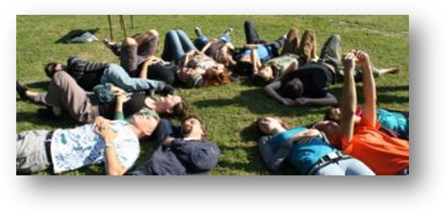
Abilities like dealing with conflict situations, self-management in training, understanding one’s own and participant’s emotions, handling short-term and long-term stress, increased level of self-awareness and acquiring healthy work-life balance are not only personal objectives, but also essential professional competencies.
TC “Unique R.I.D.E.” deals with essential competencies to secure quality of the learning process and well-being for all in a training situation.

What participants of UNIQUE R.I.D.E. in 2009. said about the event:

“The event which speaks for itself!”

The first UNIQUE R.I.D.E. (Reflection – Innovation – Development – Empowerment) course was organized in Lithuania in August 2009, hosted by Association of Youth Non-formal Education in cooperation and with great hosting support of Lithuanian National Agency and support of NA’s from Austria, Iceland, Italy, Finland, Netherlands, Poland and Slovenia.

Below you may find what participants-trainers said about after the UNIQUE R.I.D.E. in 2009:
This course is like one more new colourful safety rope and a helmet for a trainer climbing the mountain of professionalism!

- “This training was like 6² hands massage of my mind, body and soul!”
- “This course is a form of therapy that enables to work and develop those areas that we, as trainers, normally neglect or sometimes even ignore.”
- “It gave potential of changing traditional concepts of trainings and challenging different aspects”
- “It opens doors to recognising some emotions & commitment to work on them further.”
- “I discovered the new dimension of emotional awareness in my profession”
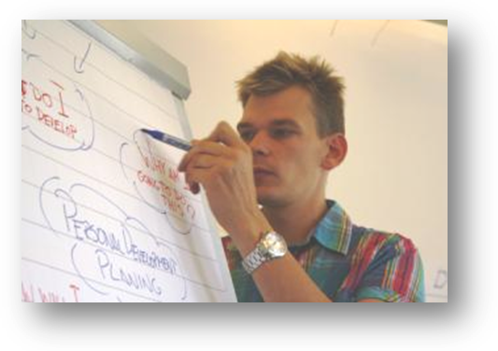
- “The Unique R.I.D.E. is a place to relax and work in great environment on your personal and professional challenges, supported by many colleagues.”
- “Thanks to people, time frame and activities there, you have chance to support yourself and others in your learning path.”
- “I solved the problems and situations which I came here with”

For more information about UNIQUE R.I.D.E. 2009 you may wish to read the report from the training course, downloadable from:
http://www.unique-network.org/images/download/report_unique%20ride_2009_final.pdf

Target group for UNIQUE R.I.D.E.

- Trainers working for training pools of Youth in Action National Agencies
- Freelance trainers working in the youth field at national and European level
- Actively working as trainers at least two years
- Able to communicate in English
- Able to participate in the full duration of the course
- Motivated for further personal and professional development
- Supported by National Agency or willing to self-finance the participation

Key benefits for trainers-participants:

- Increased level of self-awareness and enhanced emotional competence
- Trying new techniques and approaches transferable to their own trainings
- Increased understanding of challenging situations in training
- Gained useful insights and tools from psychology and psychotherapy
- Increased ability to handle stress in training and life in general
- Meaningful discussions about “burning issues” and training-related dilemmas
- Clarity on reasons and desired directions in further professional development
- Set personal and professional development plan
- Regained passion and motivation for work

The methodology and approach of UNIQUE R.I.D.E.

- Combination of outdoor and indoor educational methods
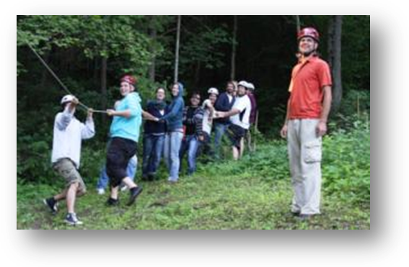
- Involves professional coaching and inter-vision possibilities
- Brings together insights from psychology and psychotherapy and experiences from training
- The programme is run in a carefully planned stress-free timeframe
- Includes optional well-being space to share effective strategies and practices in dealing with stress
- The R.I.D.E. is held in a “well-being venue”, which support reflection and provides possibilities for relaxation, sport and enjoyment

The UNIQUE R.I.D.E. topics:

- Personal and professional development
- Training-related dilemmas and challenging situations
- Understanding emotions in training
- Emotional intelligence in training
- Stress management and burn-out prevention
- Well-being in training and achieving the work-life balance
- Understanding own core qualities as a trainer
- Rediscovering passion and motivation for work
- Innovative approaches in youth training field
- Discussion on relevant “burning issues” set by the participants

The team of UNIQUE R.I.D.E. trainers brings extensive experience and unique combination of expertise in youth work, professional training, non-formal education, experiential learning, supervision, psychotherapy and coaching. The team members are:
- Žilvinas Gailius
- Darko Markovic
- Marija Pavic
- Laimonas Ragauskas

Practicalities and financial conditions for participation
The UNIQUE R.I.D.E. includes the programme of 6 full working days plus arrival and departure days and it will be held in a beautiful venue called Jugend und Familiengaestehaus Grundlsee next to the lake called Grundlsee in central Austria. For more info: www.jufa.at/grundlsee.php.
The participation fee for the course is 120 EUR and should be paid by bank transfer within 1 month after the selection. The travel costs are covered by your National Agency for Youth in Action programme or self-financed. For contact details of your National Agency see: http://ec.europa.eu/youth/youth/contacts_en.htm#top

How to apply?
- Contact your YiA National Agency for a possibility to cover your travel costs
- Fill in the application form on-line http://www.salto-youth.net/applicationonline/464/
- Deadline for application is 18th April 2010.

