UNIVERSAL “i”  12-14 March, 2010  Thessaloniki | Story Development Workshop for Docs | 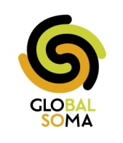 | universal “i”  Non-Profit Cinema and Media Workshops

Application Form*
Please fill it and send it back to global.soma@gmail.com
Name & Surname
Name you want to be called in the training
Telephone *
Country of origin
e-mail to reach you
Any information the organisers/trainers need to know (socio-economic background, health, regular medication, mobility-disability etc)
Are you a member of an organisation? If yes, please name it!
Do you need English into Greek translation?
If you are among the first 5 applications from abroad, do you want a free hosting place?
Tell us something about your motivation.
Any other questions you may have? We will answer them within 2-3 days!
* Your participation will be confirmed in person or by telephone by one of our volunteers!

