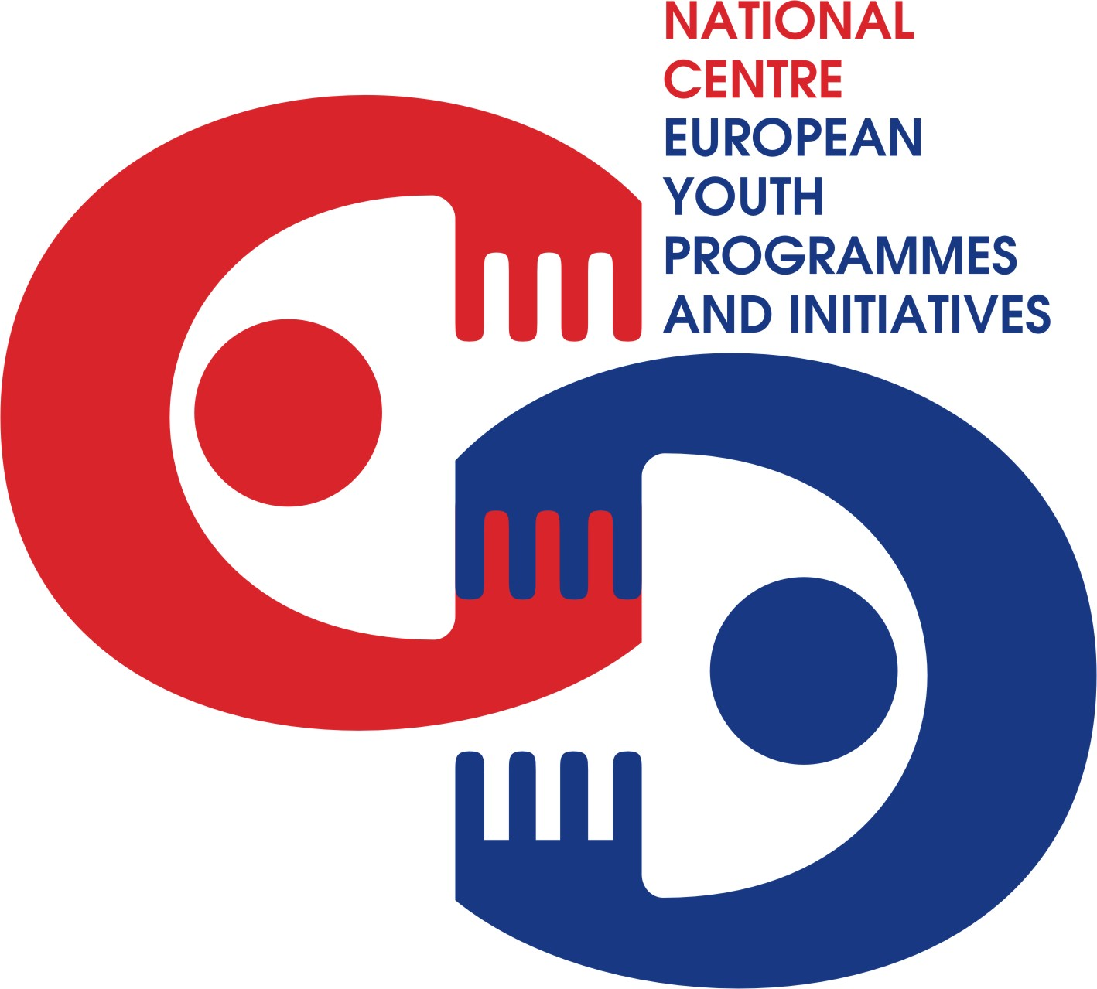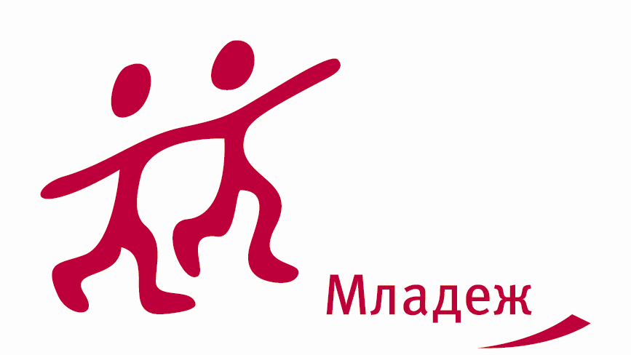

15 – 21 March 2010



Aim of the ToT

Increasing the pool of trainers of EVS at European level.

ToT for EVS aims to bring together motivated young people, youth workers, youth leaders, former EVS volunteers ,trainers, mentors to deepen knowledge, skills and attitudes in order to better planning, organizing and implementing TCs for EVS in order to contribute to develop high quality and innovative learning opportunities.

Objectives

- To provide space of common understanding and implementing learning opportunities of EVS
- To discover potential for qualitative work with volunteers and NGOs
- To increase knowledge, skills, abilities when delivering training courses
- To give opportunities for learning new methods
- To share practices
- To manage with conflict situations within EVS projects
- To promote EVS

Target group of the ToT

- This seminar is meant for youth workers, former EVS volunteers or mentors, youth trainers with less experience in EVS or youth leaders and trainers who are:
- less experienced in Youth in Action Programme and EVS in particular
- directly working with young people
- able to communicate and work in English
- aged 18 years or older
- residents of the Youth in Action Programme Countries (27 EU countries + Norway, Iceland, Liechtenstein, Turkey and Switzerland)
- ready for active participation during the training, ready to work and support directly EVS volunteers and willing to perform EVS trainings on National and International level

Dates and venue

- The training course will be held on 15-21 March 2010 in Plovdiv, Bulgaria.
- Participants are expected to arrive on the 15th till 3.00 p.m. and depart on the 21th after breakfast.

Working language

- The working language of the training course will be English.

Trainers

- Tomáš Pešek
- Leo Kaserer

Deadline of applications

- Applications will be accepted till 24 February 2010
- After your application is accepted, you will receive a confirmation and further information.
- Please do not book any tickets before you receive confirmation for being selected and discussed with your NA.

Financial conditions

- Board and lodging will be provided by the Bulgarian National Agency of YiA Programme
- Travel costs will be covered by your National Agency (please check before applying).
- Health insurance is private responsibility of each participant.

For more information, please contact Lilia Martinez lmartinez@youthbg.info or Antonia Bocheva abocheva@youthbg.info

