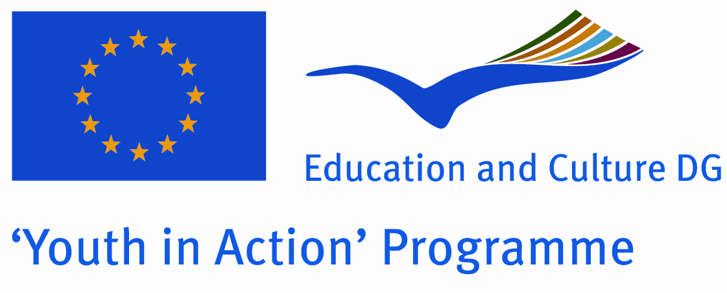
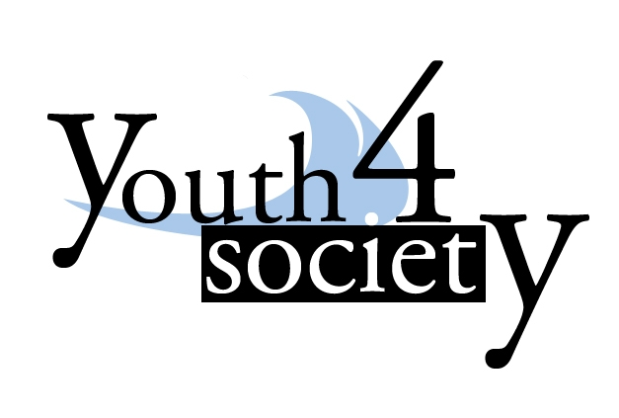

APPLICATION FORM

Path to interfaith dialogue
organized by Albanian organization YOUTH 4 SOCIETY
Project granted by Youth in Action

Durres Albania
03-09 February 2010

Please submit your application and send it by e-mail to ermilm@yahoo.it . We must receive your application no later than 25th of December 2009.

Personal information

Name |  | Surname
Nationality |  | Date of birth (dd/mm/yyyy):
Sex |  | Occupation:
Address (complete for correspondence – street, number, postal code, place): |  | Telephone (please include international access dialling codes):
E-mail: |  | Special needs (e.g. diet, disability, vegetarian)

Level of English:
Language | Describe your ability to communicate in the language  (e.g. I am able to speak basic English and understand a lecture or presentation if the terminology used is not too complex…)
English
Other

Your organisation
Name of your sending organisation: |  | Address:
Website |  | Email address
Telephone |  | Fax
Contact person (other then you) |  | Contact person in emergency case
Your role in organisation (e.g. board member, volunteer, employee): |  | Country
Describe shortly your organisation (main aim, activities)

Motivation and experience

Please answer the questions below with 3-4 sentences each:

- What is your motivation for taking part in this training course?

- How you will contribute in the activity?

- Do you have previous experience in the topic of the course? If yes, please describe.

- Have you participated in international training courses/meetings/projects, Youth in Action programme before?

Please submit your application and send it by e-mail to: ermilm@yahoo.it
Please respect the deadline. Thank you.

