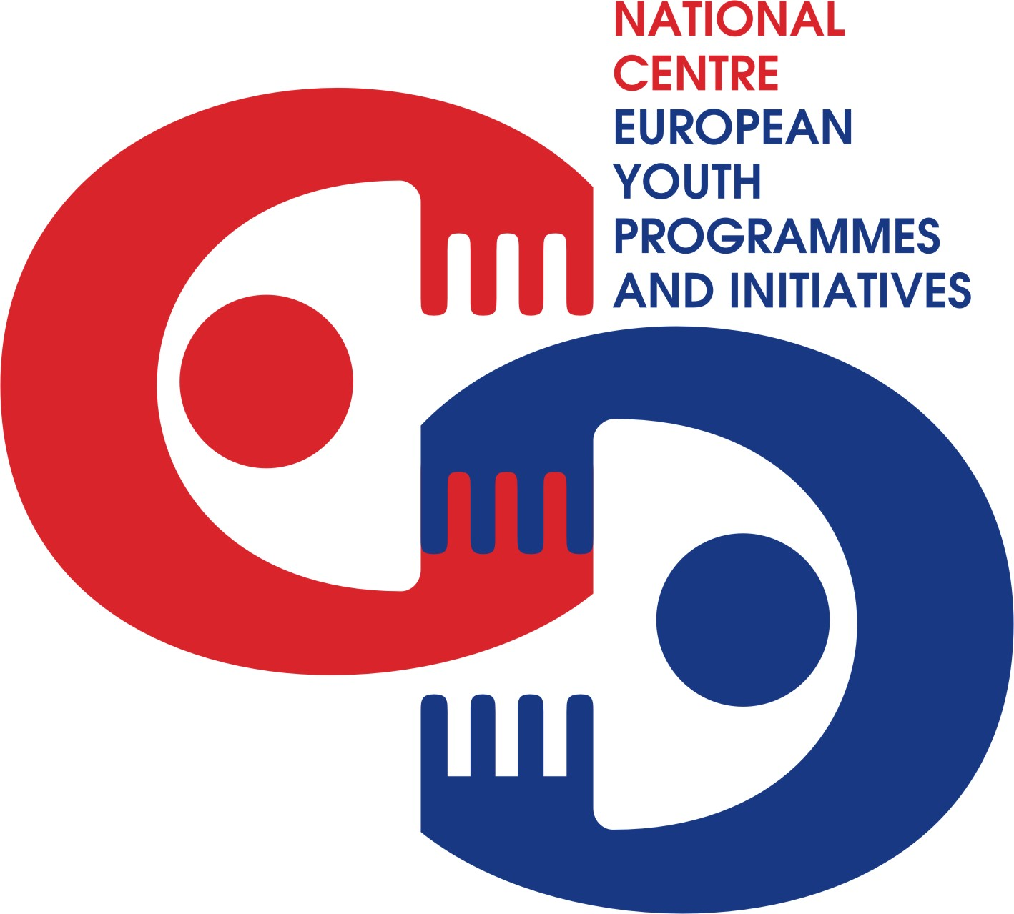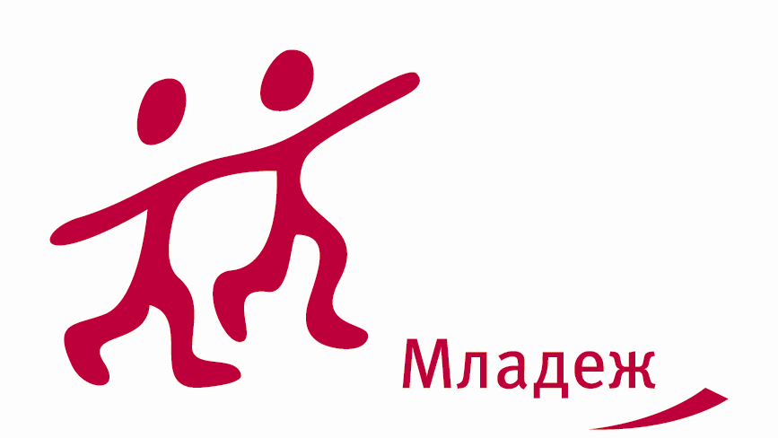



Aim of the CMS

CMS aims to bring together youth workers from small NGOs from rural and distant areas without big experience within YiA Programme from distant areas to deepen knowledge, skills and attitudes in order to better planning, organizing and implementing YiA projects; to contribute to development of high quality and innovative projects in Youth in Action Programme.

Objectives

- To find/build partnerships and developing of concrete international projects with youth of rural background.
- To provide space for cooperation, sharing knowledge and experiences between participants working directly with youngsters
- To contribute for development of high quality and innovative projects in Youth in Action Programme.
- To boost imagination of youth workers and leaders when planning and realizing project
- To discover creative approach to youth work
- To create an opportunity for exchanging ideas
- To share good practices in YiA Programme
- To prepare youth workers and leaders in their environment (tools,
strategies, methods)
- To discover potential of participants and their creativity

Target group of the CMS

- This seminar is meant for youth workers and youth leaders who are:
- less experienced in Youth in Action Programme
- directly working with young people
- able to communicate and work in English
- aged 18 years or older
- residents of the Youth in Action Programme Countries (27 EU countries + Norway, Iceland, Liechtenstein, Turkey and Switzerland)
- ready for active participation during the training

Dates and venue

- The training course will be held on 15-20 December 2009 in Sofia, Bulgaria.
- Participants are expected to arrive on the 15th till 2.00 p.m. and depart on the 20th after breakfast.

Working language

- The working language of the training course will be English.

Trainers

- Markus Albrecht
- Enrique Miana

Application procedure

Please apply online at http://www.salto-youth.net/find-a-training/1635.html

Deadline of applications

- Applications will be accepted till 15 November 2009
- After your application is accepted, you will receive a confirmation and further information till 24 November 2009.
- Please do not book any tickets before you receive confirmation for being selected and discussed with your NA.

Financial conditions

- Board and lodging will be provided by the Bulgarian National Agency of YiA Programme
- Travel costs will be covered by your National Agency (please check before applying).
- Health insurance is private responsibility of each participant.

For more information, please contact Lilia Martinez lmartinez@youthbg.info

