
Factory Intercultural
20. – 26. 11. 2009, Slovakia

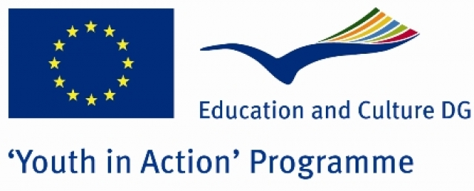
Application Form

Data of Applicant

Full Name |  | Gender
Street & no. |  | Nationality
City |  | Post code
Country |  | Phone
Mobile |  | Fax
Date of Birth |  | E-mail
Vegetarian (Yes/No) |  | Working languages

Data of Organisation

Name
Street & no. |  | Post code
City |  | Country
Phone |  | Fax
Web |  | E-mail
Contact person
Describe briefly your association

What is your role in the organisation?

Practical issues

If you are accepted as a participant on this course, will you require assistance in obtaining a visa for Slovakia? If yes, please indicate:
Passport no. |  | Date of issue
Place of issue |  | Date of expiry

Experience in youth work
What is your experience in international activities? (types, topics and target groups)
What type of training (if any) have you followed regarding youth work?
Have you applied for or participated in any other training 2007, 2008 or 2009? (which one(s)?)
What are the concrete activities, youth-exchanges or other project(s) in which you will be involved in during 2009 /2010 ? (name of the activity, organisers, place and dates, target group, topic, your role)

Motivation and expectations
What is your motivation for taking part in Factory Intercultural?
What would you need or like to learn at this course?
Which type of training do you expect? What do you expect from the trainers?
What is for you a good youth-exchange? Describe very briefly what you understand as intercultural learning during an exchange
Declaration:
I agree that my personal data given in this application form may be made available to other participants. I confirm that the information I provided is true to the best of my knowledge. I also agree to the terms of the participant criteria that was given to me by my youth organization.
Date and place |  | Signature

Please send this form to contact person according to your country. Selection of participants will be made till 30th of Sepbember

Contact persons:

Slovakia – Tomas Pesek - tomas@healthynetwork.org
Serbia – Jelena Stojanovic - jelena@healthynetwork.org
Latvia – Ilze Salnaja – Verva - ilze@healthynetwork.org
Estonia – Siim Varv - siim@healthynetwork.org
Albania – Ana Dervishi - ana@healthynetwork.org
Turkey – Evren Ergec - evren@heatlhynetwork.org
Croatia – Kresimir Makvic - kreso@healthynetwork.org

