  Turkish National Agency for the Youth in Action programme | 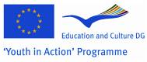

Training Course “ACTOR IN THE SHADOW - personal development in youth work”

11th – 18th October, 2009 Antalya region, Turkey

We are there as personalities, in the processes of non-formal education, with our characters, attitudes, beliefs, sympathies and antipathies. No matter if we want or not, our personality does influence our professional environment and outcomes.
Working as youth workers we focus on young people, on our organization, fund raising, writing projects, etc. But in all our activities there is also this person that remains often beyond the focus,
in the shadow - and that is ourselves!

The aim of this training course is to provide space for youth workers, youth leaders and multipliers to reflect upon and work on own personality and to learn various reflection and peer counselling methods in order to deal more effectively with the every day youth work reality.

Educational objectives

The aim will be reached through providing space and tools
- To learn ways for self-development and self-renewal
- To become more authentic and effective in youth work by managing inner and role conflicts
- To develop emotional competence and learn ways to cope with stress and prevent burn-out

Target group

Choosing personal pathways…
This training course is open for:
- youth leaders, youth workers, trainers and multipliers actively engaged in the youth work,
- from all the “Youth in Action” programme countries,
- able to communicate in English,
- having clearly expressed needs for personal and professional development.

Methodology
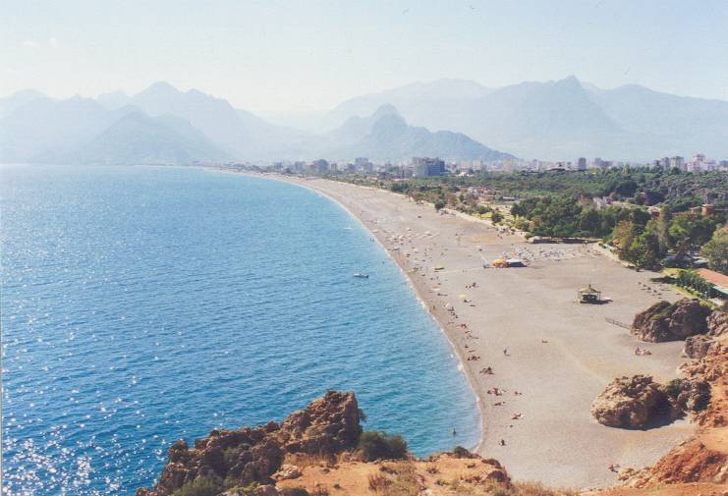
Activities in mountains, forests and beaches!

Stepping out of the mental and physical comfort zone, sharing the experience, learning methods of peer counselling, working outdoors will be central learning areas of this training course. Here are few examples of the methods to be used:
- personal case studies from the youth work
- outdoor education methods, rope course, etc.
- creative movement and drama
- methods of peer counselling


Space for reflection
Participation costs
Board, lodging and programme costs will be covered by Turkish National Agency.
Travel costs will be covered by your country’s National Agency (NA) of Youth in Action programme, if they will support your participation. We advise you to contact your NA before you apply.
There is no participation fee!

Working language: English

Organizer: Turkish National Agency of the Youth in Action programme
Trainers: Dijan Albayrak, Evelina Taunyte, Laimonas Ragauskas.

For further information, please contact Handan Boyar from the Turkish National Agency by e-mail: handan.boyar@ua.gov.tr

Preliminary programme*

11th Oct. | Day 1, 12th Oct. | Day 2, 13th Oct. | Day 3, 14th Oct. | Day 4, 15th Oct. | Day 5, 16th Oct. | Day 6, 17th Oct. | 18th Oct.
Arrival | Me and the group: names, expectations, learning objectives  Intro to the TC: idea, objectives, programme, methodology | Leaving for outdoor activities  Going out for getting in: rope course  Lunch out | Introspection to myself, my roles as youth worker  Analysis of cases from youth work about inner conflicts, dilemmas | Intravision as a tool for professional development | Learning space for other issues and questions, that matter  Space for exploring various issues, techniques | Meaning of the learning outcomes for me  Sharing and finding peer support for future development | Departure
Arrival | Lunch break |  |  |  |  |  | Departure
Arrival | Getting to know deeper: what moves me forward?  Trust building | Going back to the venue  Reflection on the experience: my emotions, personal challenges, behavioural patterns, insights | Continuation of case analysis  Middle check-point: looking back – looking forward | Visit to Aspendos and Perge  Free afternoon in Antalya | Exploring Inner voices for coping with internal role conflicts  Coping with Stress | Youthpass  Evaluation of the TC | Departure
Welcome evening | Daily reflection moment |  |  |  |  |  | Departure
Welcome evening | Dinner |  |  |  |  |  | Departure
Welcome evening |  |  |  | Dinner in Antalya |  | Farewell evening | Departure
* This is just a draft. The programme may become even more exciting and adjusted to the specific needs and expectations, identified by participants

EU member states, Turkey, Iceland, Norway, Lichtenstein.

