YOUTH OPENS THE SPACE

Active Participation for Sustainable Development
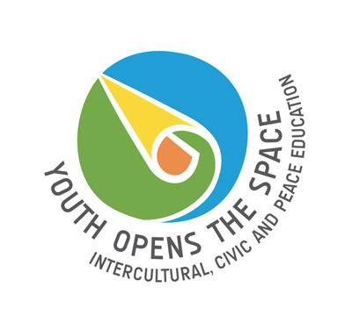
27th – 31st of August 2009, Wroclaw (Poland)

PERSONAL DETAILS
First Name: |  | Family Name:
Address: |  | City:
Country: |  | Nationality:
Date of birth: |  | Gender:
Phone number: |  | E-mail:
Diet needs: |  | Special needs:
Estimated travel costs: |  | Visa needs:
VISA DETAILS (if applicable)
Passport no.: |  |  | Date of expire:
Date of issue: |  |  | Place of issue:
DETAILS OF YOUR ORGANISATION
Name:
Website:
Basic info (aim, main activities, target group):
Your role:
- Please indicate the level of your language skills:
English:
elementary ◻ intermediate ◻ advanced ◻

Other:
elementary ◻ intermediate ◻ advanced ◻

- What is your motivation for taking part in the forum?
- What are your expectations towards the forum?
- How do you actively participate in the society?
- Did you participate in the YOUTH OPEN THE SPACE forum in 2007?
If yes, how did you use learning gained during the forum afterwards?
- Please propose a good practice (method/workshop/project/initiative example) that you could present during the forum. Describe it briefly.
I confirm that I am committed to take part in the full duration of the forum.
Date: |  | Signature/name:
Please send the application form till 25th of April 2009
to the e-mail address: yots@unescocentre.pl

