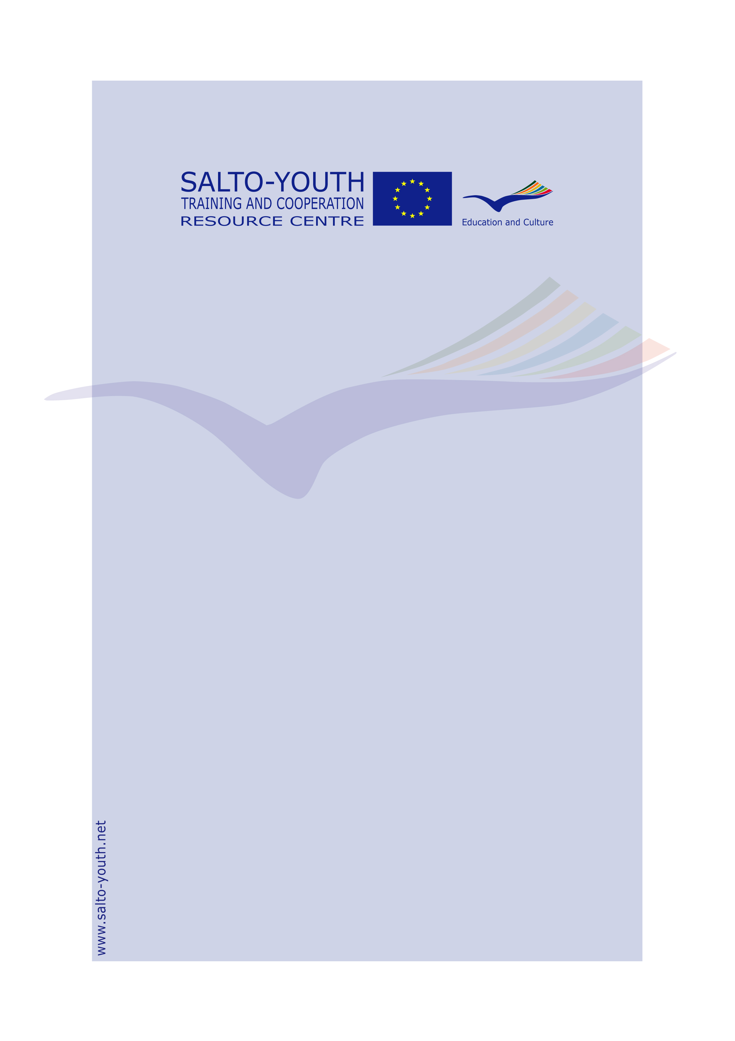

BiTriMulti
Training Course

Info Pack

for

PARTICIPANTS
(from Programme Countries, South East Europe
and Eastern Europe and Caucasus)

Valid from January 2009

Info Pack for Participants
about BiTriMulti Training Course
Season 2009-2010

BiTriMulti Training Courses (further in the document BTM)
Co-ordinated and monitored by the SALTO Training and Co-operation Resource Centre
Organised by the network of National Agencies for the Youth in Action Programme
Financed by the Youth in Action Programme of the European Commission

BTM Info Pack for Participants compiled and edited by
the BTM trainers pool:
Jo Claeys
Elizabeth Kasa
Evi Koutsospirou
Nerijus Kriauciunas
Gerald Dowden
Sandra Siere

in collaboration with
the SALTO Training and Co-operation Resource Centre

Published by
the SALTO Training and Co-operation Resource Centre
c/o JUGEND für Europa – German Agency for the EU Programme YOUTH IN ACTION
Bonn, January 2009

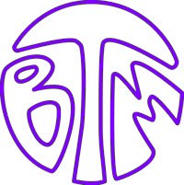
PARTICIPANT PACK
Gives you(th) wings!

BTM TRAINING COURSE

Dear participant,

We are looking forward to meeting you and to working with you in the international training course BiTriMulti (BTM) on how to tackle all of the basic elements of organising an international Youth Exchange under the Youth in Action Programme. It will be a learning-by-doing experience for you, built on a simulation exercise.
In this training course you might find new partners, BUT THIS IS NOT THE MAIN OBJECTIVE OF THE TRAINING COURSE.

ABOUT THE YOUTH IN ACTION PROGRAMME
We kindly ask you to bring this BTM Info Pack for Participants with you, which include a brief explanation of the European Youth in Action Programme focusing on Youth Exchanges. You can find more information about the Youth in Action Programme at http://ec.europa.eu/youth/yia/index_en.html or at the web site of your National Agency (please contact them or your regional SALTO Resource Centre for further information).

IN THIS PACK YOU WILL FIND:
- The day-by-day programme of your training course (the programme is flexible and may be changed),
- A brief presentation of the European Youth in Action Programme with a focus on Youth Exchanges

ABOUT YOUR ORGANISATION
Please bring information (printed information, leaflets, booklets, or any other relevant material) about the main activities of your organisation to share with other participants in the BTM training course. There will be no possibility of making a presentation about your organisation to the other participants using a computer during the official programme. However, you might be able to do so during the informal moments of the training course if any other participants are interested.

ABOUT INTERCULTURAL EVENING
On the second day of the BTM there will be an intercultural evening when you will have the opportunity to share something about your culture with others. You are welcomed to bring “gastronomic” specialities from your region or country: food (it may be possible to heat food, but not to cook it at the training centre) and drinks for this evening.

Please bring a map, posters, postcards and leaflets to give a picture of where you come from.

Please note that, if you bring videos or computer presentations with you, you will only be able to show them during your free time if other participants would like to watch them.

You may bring CDs of music, modern or traditional, that you want to play during the intercultural and other evenings. Bringing with you different games to be used during informal moments is not forbidden!

For further information (e.g. practicalities of your BTM TC), please contact your National Agency.

Looking forward to meeting you,
the BTM trainers and National Agency team

PARTICIPANT PACK
Gives you(th) wings!

BTM TRAINING COURSE

BRIEF DESCRIPTION OF BTM TRAINING COURSE

1. TARGET GROUP
The training course is designed for voluntary and professional youth workers working directly with youngsters who are interested in setting up international exchange projects. The focus remains on training and not on partner finding.

The course is mainly aimed at those who have no experience of organising an international Youth Exchange under the Youth in Action Programme. However it doesn’t matter whether you are just interested in doing a Youth Exchange or are definitely planning to do one. If you represent an organisation or group with little experience of Youth Exchange but you see that you could still benefit from the input of a BTM training course, you can still participate, remembering that the course is essentially designed for beginners.

2. AIM AND OBJECTIVES
The aim of the BTM training course is to offer an international learning experience to practitioners active in the youth work field, enabling them to develop their competences in setting up quality Youth Exchange projects under the Youth in Action Programme.

Objectives of BTM:
- To provide an informed introduction to the Youth in Action Programme, focusing on Youth Exchanges and their capacity to enhance active (European) citizenship, especially (though not exclusively) for newcomers to the programme;
- To offer an individual and group learning experience through a simulated process on setting up a Youth Exchange project;
- To develop the necessary knowledge, skills, and attitudes to organise a Youth Exchange, based on the non-formal learning practice, principles, and quality standards of the Youth in Action Programme;
- To enable participants to reflect on their learning and to familiarise themselves with Youthpass – the strategy on the recognition of non-formal learning in the youth field, its technical tool to produce Youthpass Certificates, and its application in Youth Exchanges in particular and the Youth in Action Programme in general;
- To offer the opportunity to meet possible partner groups and to make contacts in other countries.

The main aim is to train people and a sub-goal is to offer the opportunity for participants to find partners. Other things, like getting to know other youth realities, are not an aim, but a (nice) side effect.

3. THE PROGRAMME
The BTM programme is built around a simulation game, which is interspersed with information sessions as well as activities to improve the group dynamics, and ends with an evaluation. On the next page you will find the programme of the course.
PROGRAMME
BTM TRAINING COURSE
Gives you(th) wings!

DAILY BTM PROGRAMME FOR PARTICIPANTS

Arrival Day

Day 2

Day 3

Day 4

Departure Day
Breakfast
Entrance to intercultural course
Intro to the course
Break
Intro to the Simulation Game
Simulation Game 1:
Partner finding
Lunch
Entry to the Youth in Action Programme

Workshop on project building and young people’s learning

[Break]

Reflection time
Dinner
Intercultural evening
08.00
09.30

10.30
11.00
11.30

13.00
15.00

16.00

18.00
19.00
20.00

Breakfast
Intro to the day
Simulation Game 2:
Partner meeting

[Break]

Lunch
Simulation Game 3:
Applications

Break
Afternoon out

Dinner out
Evening out
08.00
09.30
10.00

13.00
15.00

16.30
17.00

20.30

Breakfast
Intro to the day
Workshop on Cultural Diversity & Citizenship

Break
Simulation Game 4: Review of the Applications
Lunch
Info market: Youth in Action programme & Quality standards
Break
Reflection time Youthpass and young people
Evaluation of the training course
BTM check-out
Dinner
Good-bye evening

08.00
09.30
09.40

11.10
11.30

13.00
15.00

16.30
17.00

18.30
19.00
20.00

Arrival of participants and WELCOME!

Check-in
Dinner
Getting to know and group dynamics

16.00

18.00
19.00
20.00

Departure of the participants and the team

PARTICIPANT PACK
Gives you(th) wings!

BTM TRAINING COURSE

THE YOUTH IN ACTION PROGRAMME

The European Commission, the European Parliament and the Member States of the European Union have agreed on establishing the Youth in Action Programme for the period from 2007 to 2013. Youth in Action is the EU programme in the field of youth, which provides young people with opportunities for non-formal and informal learning with a European dimension.

AIM
The Youth in Action Programme encourages the concept of Lifelong Learning and is aimed at inspiring a sense of European Citizenship among the youth of Europe and at involving them in constructing the future of the community.

OBJECTIVES
- Promote young people’s active citizenship in general and their European citizenship in particular;
- Develop solidarity and promote tolerance among young people, in particular in order to foster social cohesion in the European Union;
- Foster mutual understanding between young people in different countries;
- Contribute to developing the quality of support systems for youth activities and the capabilities of civil society organisations in the youth field;
- Promote European co-operation in the youth field.

ACTION 1.1 and 3.1 - YOUTH EXCHANGES

1. WHY HAVE YOUTH EXCHANGES?
Youth Exchanges are intended to contribute to the personal development of the young participants. The exchanges are open to all European young people, regardless of their background, education, or socio-economic situation.

2. DEFINITION
A Youth Exchange brings together groups of young people from two or more countries, providing them with an opportunity to meet, discuss, and confront various themes, while learning about each other’s countries and cultures. The main aim is to encourage and promote the personal and social education of young people, reinforcing their feeling of being European citizens.

3. TYPES OF ACTIVITIES
- Bilateral (one-to-one) exchanges; i.e. one sending & one host organisation
- Trilateral exchanges (involving partners from THREE countries)
- Multilateral exchanges (involving FOUR OR MORE countries)

4. WHO ARE THE PARTNERS IN A YOUTH EXCHANGE?
Each Youth Exchange has a host group and one or a number of sending groups. The first step is to form a group which will develop the project idea. The second step is to identify partners for the future exchange.

5. WHERE CAN THESE YOUTH EXCHANGES TAKE PLACE?
Youth Exchanges may take place in countries which are eligible to participate in the Youth in Action Programme – 27 Members States of the European Union, 3 members of the European Economic Area and 1 candidate country (to become a Member State of the European Union) as well as the Neighbouring Partner Countries. In the ‘Programme Guide’ you will find a list of all the Programme Countries and Neighbouring Partner Countries. At least ONE of the groups involved in the Youth Exchange project must come from a European Union Member State.

6. WHO CAN PARTICIPATE?
Groups of young people between 13 and 25 years old who reside in a country eligible to participate in the European Youth in Action Programme, giving priority for young people from less privileged cultural, geographical, or socio-economic backgrounds, and young people with disabilities.
The eligible total number of participants in one Youth Exchange project is minimum 16 and maximum 60, not including in this number group leaders.

7. DURATION
The duration of the exchange activity itself is from 6 to 21 days, excluding travel days.

8. AN EXCHANGE IS NOT ABOUT…
- Business meetings of a youth organisation
- Holiday travel or tourist tour
- Language courses
- School exchanges (i.e. exchanges based on formal curricula)
- Study visits
- Performance tours
- Participation in a festival
- An activity which aims to make financial profit

9. HOW IS A YOUTH EXCHANGE PROJECT FINANCED?
The Youth in Action Programme grants are based on the principle of co-funding, with other public and/or private contributions (in cash, in kind, or both) and/or through fundraising activities undertaken by the young people. The total costs of a project cannot be covered by the Youth in Action Programme alone, which covers part of the costs. The grant is calculated on the basis of real costs for travel and fixed rates for all related costs. The exact amounts are detailed in the application forms.
You can get information about ‘How is the grant calculated?’, ‘How to apply?’, or ‘When to apply?’ from your National Agency or from the ‘Programme Guide’ of the Youth in Action Programme. Web site of the European Commission: http://ec.europa.eu/youth/yia/index_en.html

10. YOUTHPASS
Every participant is individually entitled to receive a Youthpass Certificate which confirms participation and validates the non-formal learning experience. Validating the learning experience of participants is important in itself and the document can be of benefit in terms of the educational or employment future of the participant. Through Youthpass the European Commission ensures the Youth Exchange activity is recognised as a non-formal learning experience. For more information on Youthpass you may wish to visit http://www.youthpass.eu

