International Training
“INTERcultural Dialogue in MULTIcultural Communities”

08 – 12 May

Brasov, Romania

organised by
Initiative Group Alpbach Brasov

with the support of:

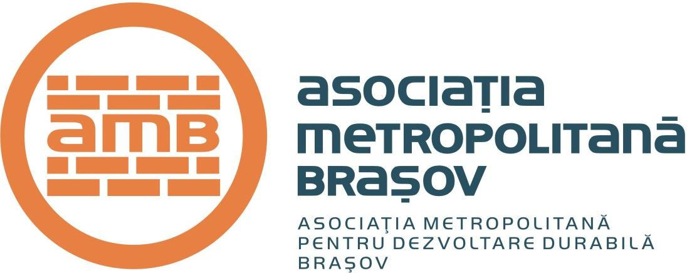
CONTEXT

In South East Europe, young people are under many pressures from the ethnic and cultural tensions arising in the communities they live in. Numerous Human Rights abuses and Discrimination actions are generated by cultural differences.

According to Council of Europe’s priorities in 2008, Intercultural Dialogue is one of the most important concepts to be used in the youth sector. In this respect, the INTERcultural Dialogue in MULTIcultural Communities Training is planned to be a practical approach on Intercultural Dialogue by using the experience and know-how in the field of human rights and intercultural education developed during the projects implemented in 2006 and 2007.

The effects of the “All different – All equal” campaign are expected to have a long term impact. In order to achieve its purpose the Campaign must have a follow-up. According to the long-term programme of our organisation, the “INTERcultural Dialogue in MULTIcultural Communities” Training is designed as a follow-up project of the other activities developed with the financial help of the European Youth Foundation.

OUR GOAL

To train young people, youth leaders, youth workers and NGO representatives to design practical responses to Human Rights abuses and Discrimination using INTERcultural Dialogue

OBJECTIVES

*to promote INTERcultural Dialogue among young people, youth leaders, youth workers and NGO representatives
*to develop the target group’s capacities (skills, know-how, (re)actions) to deal with culture, tradition and diversity
*to develop practical approaches to situations of discrimination and intolerance generated by cultural differences affecting young people

Organiser:
Initiative Group Alpbach Brasov

Dates:
08-12 May 2008

Place:
Brasov, Romania

Participants:
20

Participants should be from:
Bosnia - Herzegovina, Bulgaria, Croatia, Romania, Serbia, Montenegro, FYROMacedonia, Cyprus, Turkey, Greece

PARTICIPANTS

The training is addressed to youth organisations and young people coming from the countries targeted above; also, Roma representatives and young people with disabilities are encouraged to apply;
Age: 18 -30; young people over 30 are also welcome;
Strong interest and / or experience in the topic is required;
Commitment to participate in the activities of the training.

WORKING LANGUAGE

English

METHODOLOGY

The training will contain various methods and activities specific to non-formal education.
The training will focus on different methods using non-formal education in working with key concepts.
Also, the methodological approach of the training will focus on team work and learning by experience working methods.
The participants will have the chance to experience different situations (out-door activities, simulation games, working in teams, workshops, role plays, round table etc.)

PRACTICAL INFORMATION

Arrival in Brasov:
07 May 2008

Departure from Brasov:
13 May 2008

Participants are expected to make the cheapest travel arrangements and to check the travel costs with the organisers, before purchasing the tickets.

Accommodation and Meals:
Free accommodation and meals will be provided during the training.

PARTICIPATION FEE

20 EURO

The fee will help the organisers to provide you with effective and in-time services.

Thank you!

FINANCIAL ARRANGEMENTS

70% of the travel costs (including visa costs) will be reimbursed, on the basis of the original plane/train/bus tickets and invoices.

Participants are responsible for making their own health insurance arrangements.

Travel and visa costs will be reimbursed during the training.

PARTICIPANTS ARE EXPECTED TO ATTEND AT LEAST 80% OF THE TRAINING IN ORDER TO BE ELIGIBLE FOR TRAVEL REIMBURSEMENT.

For more information please contact:
INITIATIVE GROUP ALPBACH BRASOV
igalpbach_brasov@yahoo.com
Tel: +40 731 302373; +40 731 302370
Fax: +40 268 547676

DEADLINE FOR SENDING THE APPLICATION
FORM IS
15th of April 2008

Please complete the application form and send it
by e-mail to:
igalpbach_brasov@yahoo.com

