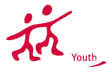
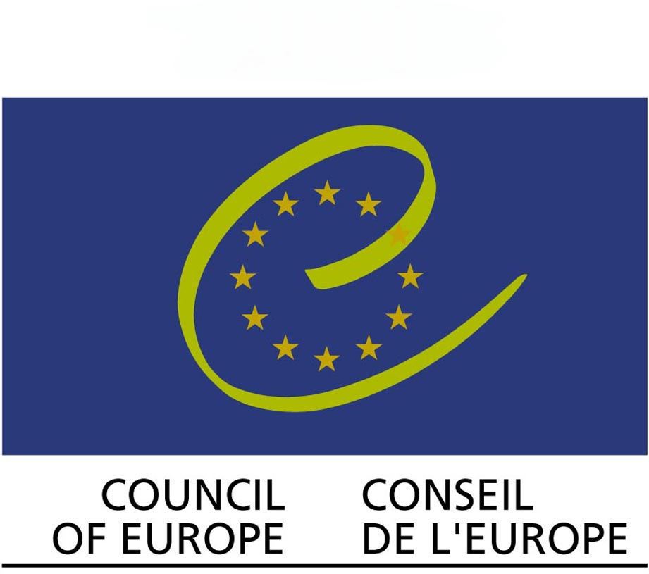
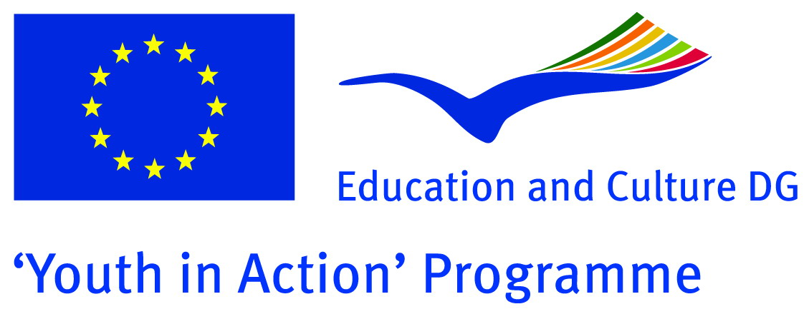
European Youth Foundation
”MEET MY NEIGHBOUR!”
Training course for youth leaders and youth workers on inter- ethnic conflicts and conflict resolution
17 – 24 May 2008 Subotica, Serbia

Theme of the training course
Themes of this project is primarily connected with conflict, conflict resolution and conflict management learning for Youth Workers who will work with this topic after their arrival to home country. Beside this primary topic, in this project we have focused on project writing and research topics, as this is still a problematic and usually main challenge that organizations and individual face.
Throughout the project, beside conflict resolution techniques and methods, exercises and skill- building activities, there is a strong multicultural sense and atmosphere, naturally by the participants themselves but also pushed forward by the trainers and responsible persons for the programme.
In a perspective of the Youth In Action programme, we believe that the next thematic questions are present in this project:
-post-conflict resolution and reconstruction
-fight against racism and xenophobia
-inter-ethnic and inter-religious dialogue

Overall aim of the training course
A general Aim of this project is to help the process of promoting sustainable regional and global peace through understanding inter-ethnic conflicts.
Through this training, participants will broaden their multicultural sense, develop communication and conflict management skills and build an awareness of how community problems can be approached and solved
The Training Course is supported by EU “YOUTH in Action” programme (Action 3.1) and European Youth Foundation of Council of Europe.

Partners of the training course:
Youth for Participation Association, YOPA – Szeged, Hungary
VAMADISZ - Subotica, Serbia

Learning objectives of the training course are:
Objectives and results of this training are, to empower young people from South East Europe and European Union who are already active in their NGOs as youth leaders and youth workers. Through this training participants will strengthen their multicultural understanding, emphasize empathy and solidarity as a tool for resolving inter- ethnic conflicts and create possible themes for future projects within the Youth in Action Programme.
Furthermore, this experience helps young people from different countries in broadening their knowledge of each other and their different cultures, habits, ways of defining and solving conflicts.

In the perspective of knowledge, learning objectives are:
- to define what inter-ethnic conflict is, how it happens and what are its causes
–to recognize stereotypes and prejudices, recall and list them
–to summarize and interpret roles and conflict styles and conflict management in inter-ethic conflicts
–to identify and later contrast personal behaviour regard to stereotypes, prejudices, feeling of empathy, tolerance and solidarity
to solve communication barriers in conflicting situations and to demonstrate effective way of communicating that resolves conflict
–to explain differences between different countries, traditions and habits, in regard to inter- ethnic conflict situations
–to paraphrase effective communication when giving feedback and use decision-making in the actual group work
–to produce and later use research materials
–to interpret, analyze and describe- and later produce a project proposal based on the comprehension of the research
–to state and later describe human and minority rights in inter-ethnic conflicts
–to apply the knowledge of inter-ethnic conflict in simulation or role-play and other similar activities
–to relate theory to simulations and role-plays
–to compare different conflict types in different given situations

In the perspective of skills, learning objectives are:
–to detect and identify personal conflict style and illustrate skills of solving conflict using personal communication skills
–to display skills of active listening of the other
–to choose between methods o research and show the actual work, later organize the research process
–to construct an outlook of the project proposal using knowledge
–to show active involvement in mediation processes using communication skills
–to practise different conflict resolution skill
–to practise feedback giving communication skills
–to actively react more efficiently in inter-ethnic conflict simulations, using communication and conflict management skills
–to present daily understanding of the learning material

The methodology of the training course:
The training contributes to the development of organizational and communicational skills of each group member in a specific group work environment. Through this training participants will comprehend the Youth in Action Programme together with the Youth PASS, and will be encouraged to further work on these topics using the Youth in Action Programme in developing new and creative projects.

Group members will experience process of democratic principles such as dialogue, mutual understanding, giving constructive feedback, decision making, self-exploration, attitude of analytical approach.

After completion of this training, participants will contribute to the development of their local community as to the region as well, through direct impact on youth in their work.

Who can participate in the training course
- Aged between 18 and 30;
- Youth workers, directly working with young people, having experience of running at least one youth project in local, regional, national level;
- Youth leaders, directly working with young people, having experience of running at least one youth project in local, regional, national level;
- Ready to take part in the whole training course;
- Have organizational support for further activities with young people;
- Are able to communicate English.

Eligible countries:
Albania, Bosnia and Hercegovina, Czeck Republic, Hungary, Italy, Macedonia, Poland, Romania, Serbia, Slovakia.

Financial conditions:
YOPA and VAMADISZ Associations will provide board, lodging and programme costs during entire training course. 70% of travel costs will be covered by organisers of the course.
We ask for your contribution to this training course, which is:
- 30% of your travel costs;

If you are interested in what was presented above, please fill-in application form (which is below) and send it to us by e – mail: meet_your_neighbour@yahoo.com till 31th of March, 2008.

If you have any question, please don’t hesitate to contact Endre Kiss or Zoltán Salata by phone: the given email address upon.
APPLICATION FORM
1. Personal Data
The contact details you provide us below will be used for all correspondence!
First Name  [as on your passport] |  |  | Family Name  [as on your passport]
Nationality |  | Age: |  | Gender | Female  Male
Complete address
Postal code |  | Town |  | Country
Phone (preferably mobile)  [with full international dial codes] |  |  | Fax  [with full international dial codes]
Email |  |  | Website
2. Language(s) abilities: Please mention all languages in which you are able to work and indicate your level for each of it (B-basic, G-good, VG-very good, F-fluent, MT-mother tongue) Anyway we would like to remind you that main working language will be English.
 | Listening | Speaking | Reading | Writing
English
Other languages
[please specify]

Do you have any special needs or requirements that the host organisation should know about? (E.g. mobility, medical needs, allergies, dietary restrictions, smoker/non-smoker)

3. Your organisation
Name
Complete address
Postal code |  | Town |  | Country
Phone  [with full international dial codes] |  |  | Fax  [with full international dial codes]
Email |  |  | Website
Activity level | local regional national international

Please describe briefly your organisation
How does your organisation support youth participation and youth projects? What are the ways and methods by which organisation provide the support?

What are your roles (volunteer, youth worker, board member, director ...) and your tasks? Please say how long you have been involved in youth work?

4. Personal knowledge and experiences
What experience do you have in inter – ethnic conflicts and conflict resolution and/or supporting youth projects (duration, type, content, your role etc.) during last 2 years?

What type of training (if any) have you followed regarding international youth work, non-formal education, conflict resolution, YOUTH programme or Youth in Action programme?

What is your level of knowledge of the programmes, listed bellow?
 | Low | Medium | High
EU “YOUTH in Action” programme in general
Action 3.1: international youth exchanges

5. Motivation and Expectations:
Please describe briefly your understanding of “inter – ethnic conflict” and “conflict resolution”:

What would you like to learn, understand and experience during this training course?

What contributions can you bring for the training course?

How do you plan to use the outcome of this activity in your work with young people afterwards?

Deadline for the applications: 31th March, 2008!!!
Please send this Application form to Endre Kiss and Zoltan Salata e-mail: meet_your_neighbour@yahoo.com
The selection results will be announced until 20th April, 2008.

