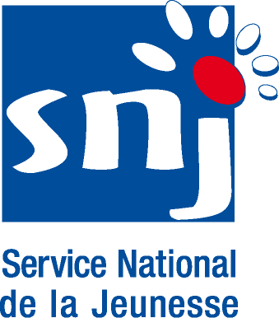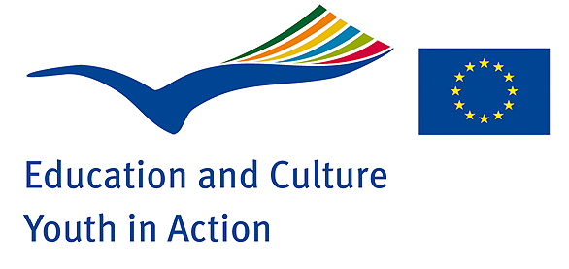
National Agency of the YOUTH in ACTION programme from LUXEMBOURG
CALL FOR PARTICIPANTS
for a
Training Course “Intercultural Competences”
from 05.07.2008 - 12.07.2008 at the Youth Hostel Lultzhausen, Luxembourg
OBJECTIVES OF THE TRAINING COURSE | - to develop mutual understanding for different cultures, religions, ethnic groups and languages,  - to develop intercultural competences and to promote intercultural dialogue,  - to help contact making between youth workers and youth leaders from the different countries involved,  - to share and learn from different experiences and work realities in the different countries,  - to put questions and find answers,  - to act as a multiplier after the training,  - to promote co-operation between youth workers, to initiate projects in the YOUTH in ACTION programme.
FRAMEWORK and METHODOLOGY | The aims of the Training Course will help those involved in youth work to acquire and develop:  - intercultural and communication skills,  - the ability to work with young people with an immigrant background and/or coming form mixed communities,  - organisational and management skills in order to develop and implement projects,  - long-term co-operation between youth organisations,  - possibilities of co-operation within the YOUTH in ACTION programme.  The Training Course will touch practical aspects of Youth Work through workshops, presentations, information space, exchange of experience, discussions, learning by experience, intercultural learning….  The participants will have the opportunity to present their personal, professional and cultural backgrounds.  They will also have the opportunity to share experiences about their work with young people and to see how to transfer their experiences to the reality of their everyday work with young people.
WORKING  LANGUAGE | English
NUMBER OF  PARTICIPANTS | We are expecting around 25 - 30 participants:  - 1 participant from each country Eastern Europe and Caucasus ( Armenia, Azerbaijan, Belarus, Georgia, Moldova, Russian and Ukraine),  - 1 participant from following countries of South East Europe (Albania, Bosnia and Herzegovina, Croatia, Former Yugoslav Republic of Macedonia and Montenegro,  - 2 participants from Serbia including 1 participant from Kosovo,  - 1 participant per programme country with special focus on the Nordic countries (Iceland, Norway, Sweden, Denmark and Finland),  - 4 participants from Luxembourg.
PROFILE OF PARTICIPANTS | Priority will be given to youth leaders, youth and social workers:  - who come from organisations who work with young immigrants and/or with multicultural and mixed ethnic groups,  - who have the will to set up projects with partner countries and programme countries,  - have an organisation commitment/support.
TEAM | Micke Michels, Werner Michl, Myriam Putzeys, Naristé Grün
DATES AND VENUE OF THE TRAINING COURSE | The Training Course will be held in Luxembourg /Lultzhausen.  The Training Course will start on Saturday, 5th July 2008 after 17:00 and will end on Saturday 12th July 2008 in the morning. No other arrival or departure days will be accepted !  Participants will be accommodated in the Youth Hostel in Lultzhausen and Luxembourg-City, bedrooms are to be shared by 2 – 3 people.
COSTS | Board and lodging will be provided and paid by the European Commission.  Travel costs for participants from neighbouring partner countries will be reimbursed by the Luxembourg National Agency. For the participants from programme countries the sending National Agency will pay.  The reimbursement will be made by presentation of the bills and the tickets. Because of limited funds we kindly ask you to book very reasonable connections.
APPLICATION PROCEDURE | For the neighbouring countries:  All applicants from neighbouring countries (South East Europe, East Europe and Caucasus) must apply by filling in the relevant application form and sending it back by 10.02.2008 to the SALTO Resource Centres. This early deadline is necessary as the visas procedures are very long!  For the Member States:  All applicants must apply by filling in the relevant application form and sending it back by 31.03.2008 to the different Agencies involved.
CONTACT ADDRESSES:  Luxembourg  Member States  Albania, Bosnia and Herzegovina, Croatia, Former Yugoslav Republic of Macedonia, Serbia and Montenegro  Armenia, Azerbaijan, Belarus, Georgia, Moldova, Russian and Ukraine |  | For more information please contact :  National Agency of the YOUTH IN ACTION Programme – Luxembourg  Ms. Myriam PUTZEYS or Ms. Naristé GRUN  26, place de la Gare  L – 1616 Luxembourg  Tel: +352 / 478 6477  Fax: +352 / 26 483 189  E-mail: myriam.putzeys@snj.etat.lu or nariste@pt.lu  Website: http://www.snj.lu/europe  Websites of the different Agencies:  www.youthprog.bg http://www.gioventu.it  www.lebij.be http://www.jaunatne.gov.lv  www.jint.de http://www.aha.li  www.jugendbuerto.be http://www.leargas.ie/youth  www.youth.cz www.mobilitas.hu  www.jugendfuereuoropa.de www.youthmalta.org  http://euroopa.noored.ee www.programmjeugd.nl  www.neagenia.gr www.ungieuropa.no  www.mtas.es/injuve http://www.jtba.lt  www.injep.fr http://www.youth.org.pl  http://ciriusonline.dk www.programajuventude.pt  www.ufe.is http://www.mladina.movit.si  http://www.iuventa.sk www.youth4ruope.at  http://www.cimo.fi http://ungdomsstyrelsen.se  www.ua.gov.tr http://www.britcoun.org/education/connectyouth/index.htm  SALTO South East Europe Resource Centre – Slovenia  MOVIT NA MLADINA  Dunajsk 22  SI- 1000 Ljubljana  Slovenia  Tel. : + 386 1 430 47 47  Fax. : + 386 1 430 47 49  E-mail: see.youth@mladina.movit.si  Website: http://www.salto-youth.net/see/  SALTO Eastern Europe & Caucasus Resource Centre - Poland  Polish National Agency of the Youth Programme  Foundation for the development of the Education system  Ul. Mokotowska 43.  PL - 00-551 Warsawa  Tél.: +48-22-622.37.06 / +48-22-628.60.14  Fax: +48-22-622.37.08/ +48-22-628.60.17  E-mail: eeca@salto-youth.net  Website: http://www.salto-youth.net/eeca/

