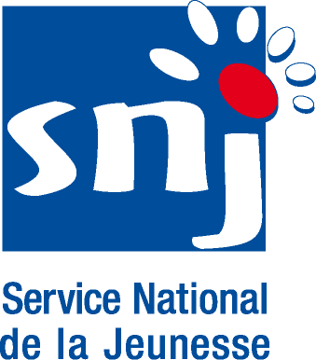
APPLICATION FORM PARTICIPANTS
Training Course “Intercultural Competences”
from 05.07.2008 - 12.07.2008 at the Youth Hostel Lultzhausen, Luxembourg
Surname: Name:

Date of birth: Place of birth:

Name of your organisation:

Type of organisation | □ governmental |  | □ non-governmental |  |  |  | □other
Your organisation is | □ local | □ regional |  |  | □ national | □ European/international
Name and surname of the responsible person in the organisation:
Main aim or purpose of your organisation:

What is your role in your organisation?

If your organisation has been a partner in / has co-organised the following projects supported by the YOUTHIN ACTION programme, please list and indicate which Actions:

What has been your role in these YOUTH IN ACTION projects (as listed above)?

What are your / your organisation’s plans regarding the future use of the YOUTH IN ACTION programme?

Why would you and your organisation like to participate in this training course?

Your contact address (where you can be reached for all questions concerning the seminar):

Street and number:
Post code: |  |  |  | Town:
Country: |  |  |  | Region:
Telephone: |  |  |  | Fax number:
E-mail:

Do you need a visa to come to Luxembourg? □ YES □ NO

If yes, please indicate:
Passport number: Issued at:
Issued on (date): Date of expiry:
Knowledge of Languages: (please indicate)

English: □ very good □ good □ sufficient □ poor
_____________ □ very good □ good □ sufficient □ poor
_____________ □ very good □ good □ sufficient □ poor
_____________ □ very good □ good □ sufficient □ poor
_____________ □ very good □ good □ sufficient □ poor

Do you have any special needs? (Please indicate any health or dietary details)

Please take note of the following conditions that will apply if you are selected to take part in the training course.
- I commit myself to participate in the whole process, including:
- to prepare myself carefully for the training course and to do all remote preparation work the team will ask for,
- to take part in the full duration of the training course,
- to participate in the whole evaluation process,
- to set up and implement a project within the Youth in Action Programme afterwards.
- I am aware that obtaining a health and a full travel insurance are my own responsibility and at my own expenses. I understand that the information I provided on my special needs does not remove my own personal responsibility for ensuring my own health.
- I authorise SALTO Resource Centres, National Agencies of the Youth in Action Programme and the European Commission to publish, in whatever form and by whatever medium, including the Internet, my correspondence address, information about my organisation and work as well as pictures taken at the course.

Please return the completed application form:

For the neighbouring countries:
All applicants from neighbouring countries (South East Europe, East Europe and Caucasus) must apply by filling in the relevant application form and sending it back by 10.02.2008 to the SALTO Resource Centers (Eastern Europe and Caucasus – eeca@salto-youth.net, South East Europe – see@salto-youth.net). This early deadline is necessary as the visas procedures are very long!

For the Member States:
All applicants must apply by filling in the relevant application form and sending it back by 31.03.2008 to the different Agencies involved.

For further information, please contact the National Agency of the YOUTH IN ACTION Programme – Luxembourg
Tel: +352 478 6477, Ms.Myriam Putzeys or Ms.Nariste Grün
E-Mail: myriam.putzeys@snj.etat.lu, nariste@pt.lu

