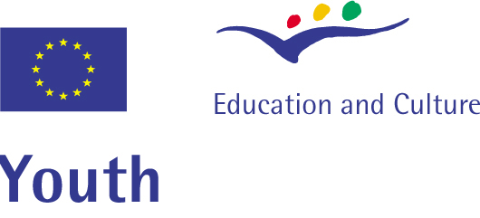
vol’n’action for inclusion t(w)o(o)
Training Course on Volunteer Resource Management

Dworp - Belgium
27/11 – 03/12/ 2007

Application form

Please complete this form in English and mail it to : henk_persyn@yahoo.com
or fax it to : 00386 4 584 19 76

Name |  |  | Surname
Name of the organisation
Work address
Tel. work/fax |  |  | Email of work:
Private address
Date of birth |  | Gender: | Private mobile phone + email :
What is your role in your organisation:
Please, indicate your direct involvement / activities with young people aged 15-30. Also, give details of the last three (international or local) projects you were involved in with your group.
Please, indicate your direct involvement / activities with volunteers aged 15-30. Also, give details of the last three (international or local) projects you were involved in, with volunteers, with your group.
What is you personal motivation in developing your volunteer management skills?
Why does your organisation need to develop involvement of volunteers?
What are your expectations towards this training? Which skills would you like to learn especially?
What is your expectation towards the “inclusion contribution” of this training?
Is there anything special you wish to tell about your self or about your target group?
Language abilities
English Fluent Good Basic

Do you have any special needs? ( are you vegetarian? Special diet? Please specify)
 | Place |  |  | Date

Please return this form
before 26 october 2007
to:
henk_persyn@yahoo.com
or by fax
00386 4 584 19 76

