DWORP -BELGIUM
from 27^{th of November} till 3^{th of December} 2007

PARTICIPANTS GUIDE



Take me with you and don’t loose me!

Welcome!

We would like to welcome you in the team of participants of the training course vol’n’action for inclusion t(w)o(o). You are among the 24 selected people who will take part in the course.

You are in this group, because we believe that you can benefit from this training. We also intend to give you the chance to share your experience with others and therefore to be the source of enrichment for the other participants.

We hope that the 6 full days you will spend at “vol’n’action for inclusion t(w)o(o) will be a vivid and useful intercultural experience for you. To achieve this we need to look at some practicalities as well, this is the reason why we have prepared this “survival participants’ guide” for you. It will not only help you to answer many questions but also will let you prepare for the course.

Read the guide carefully and keep it with you during your travel so you can check the information whenever you need.

Looking forward to meet you in Dworp.

THE TRAINERS AND STAFF TEAM

Agnieszka Henk Goele Bernie (support)
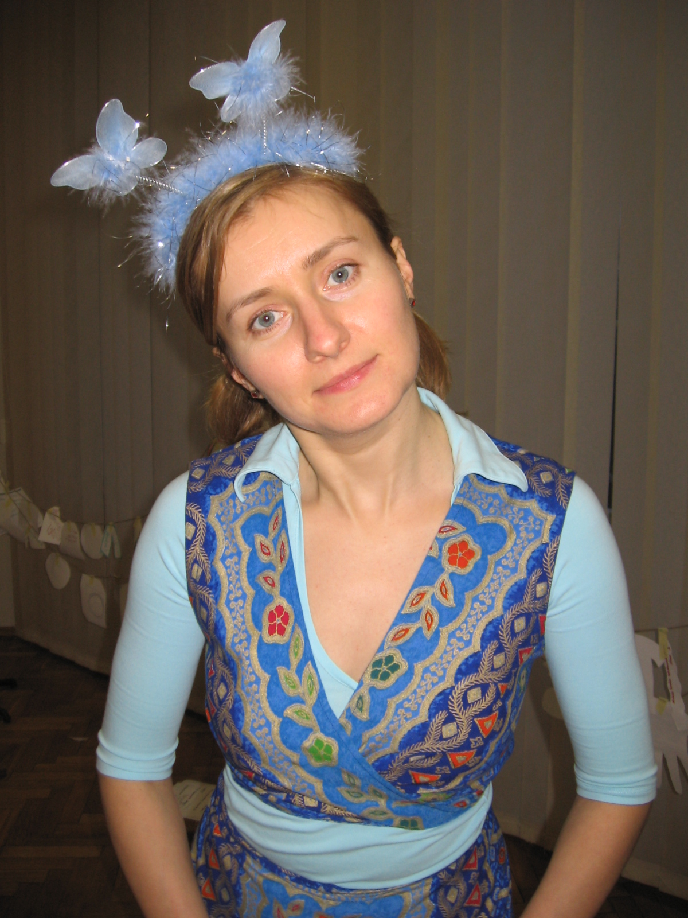 | 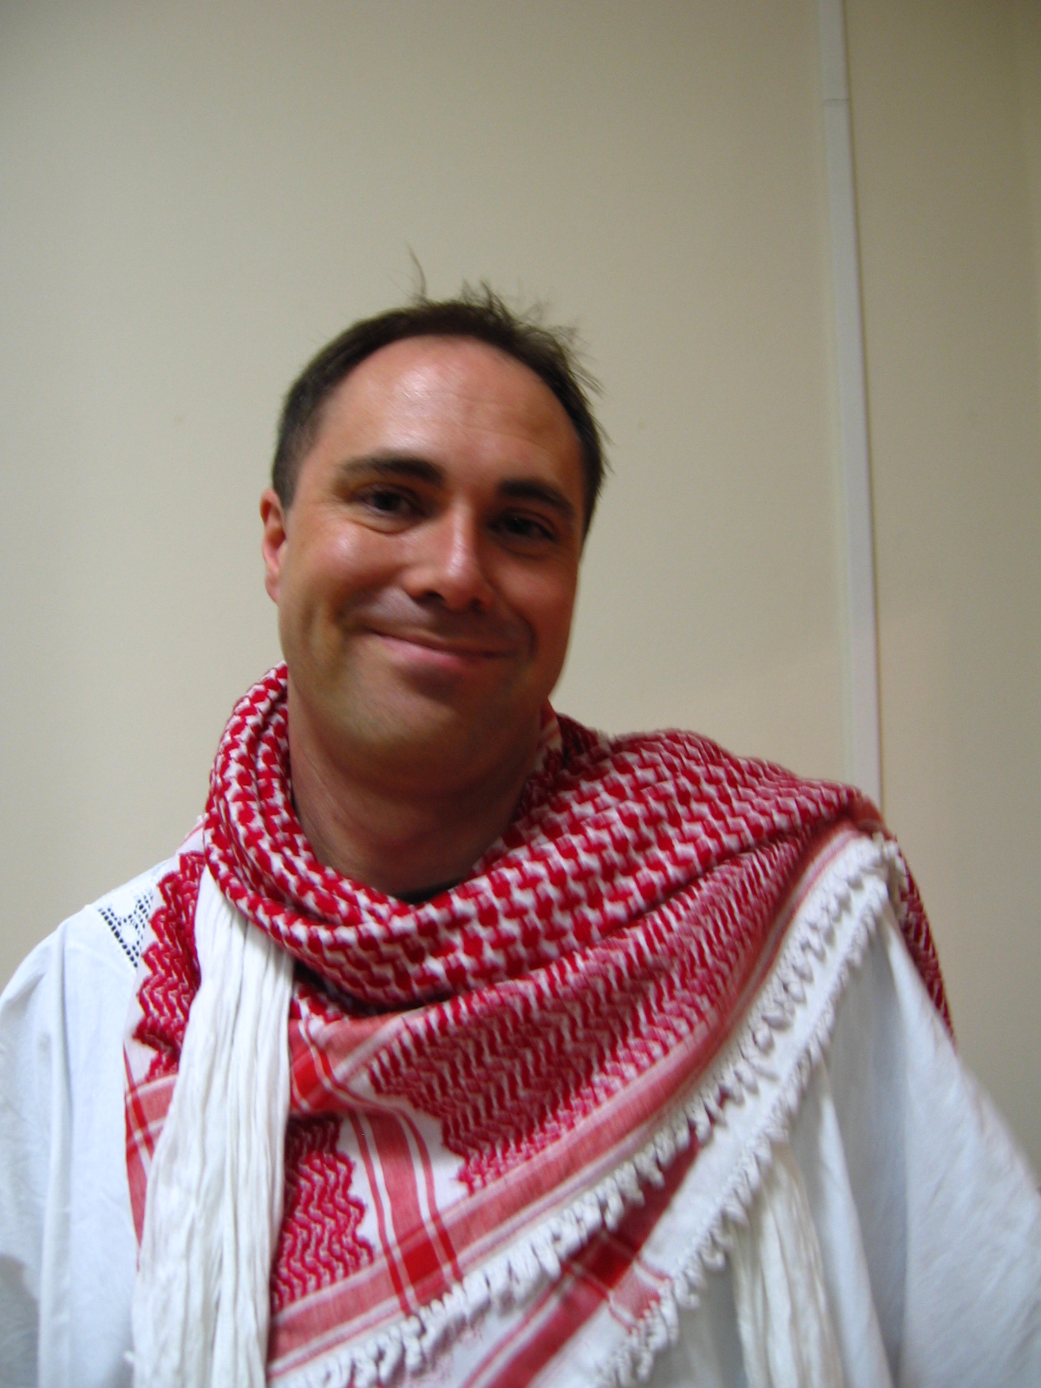 | 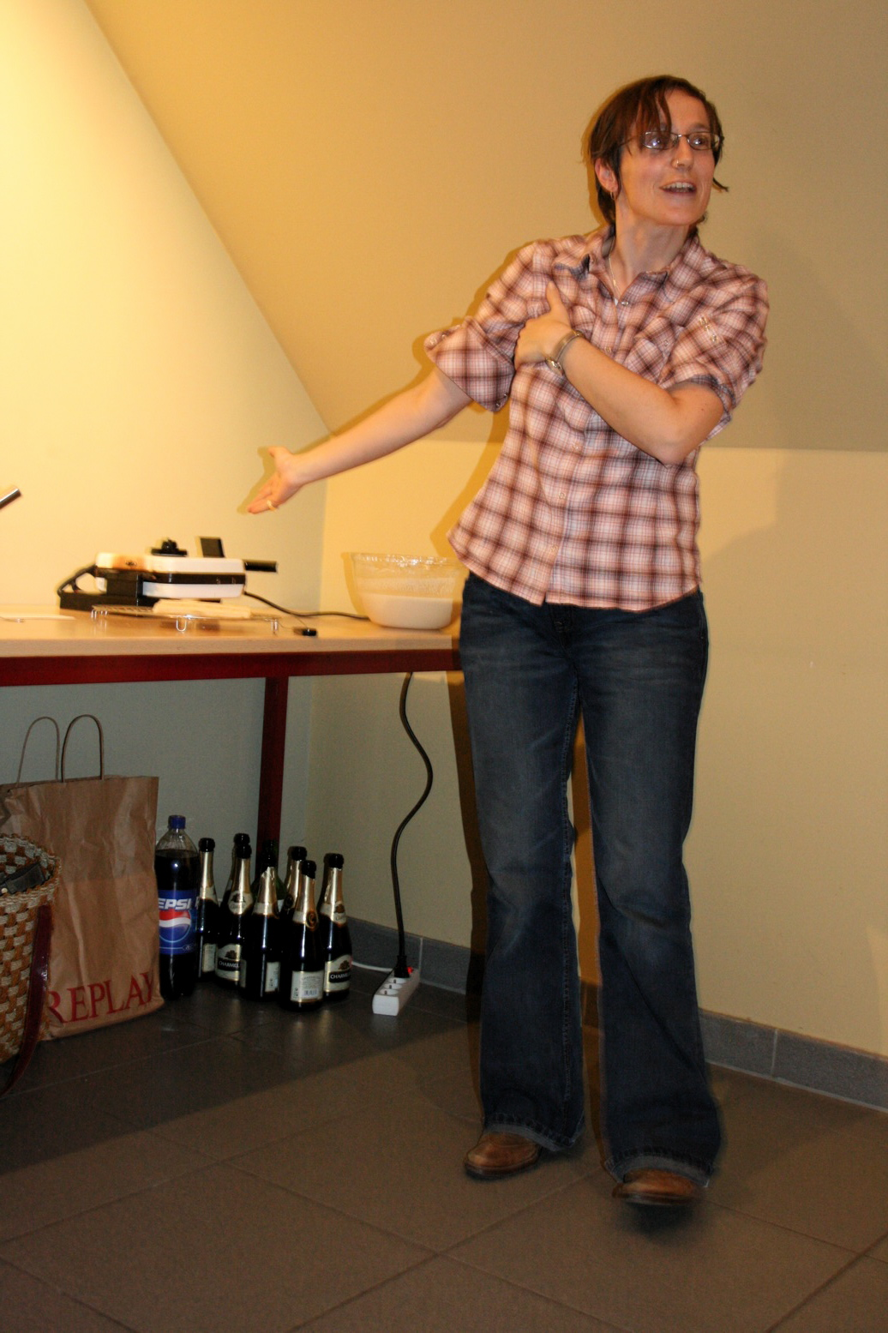 | 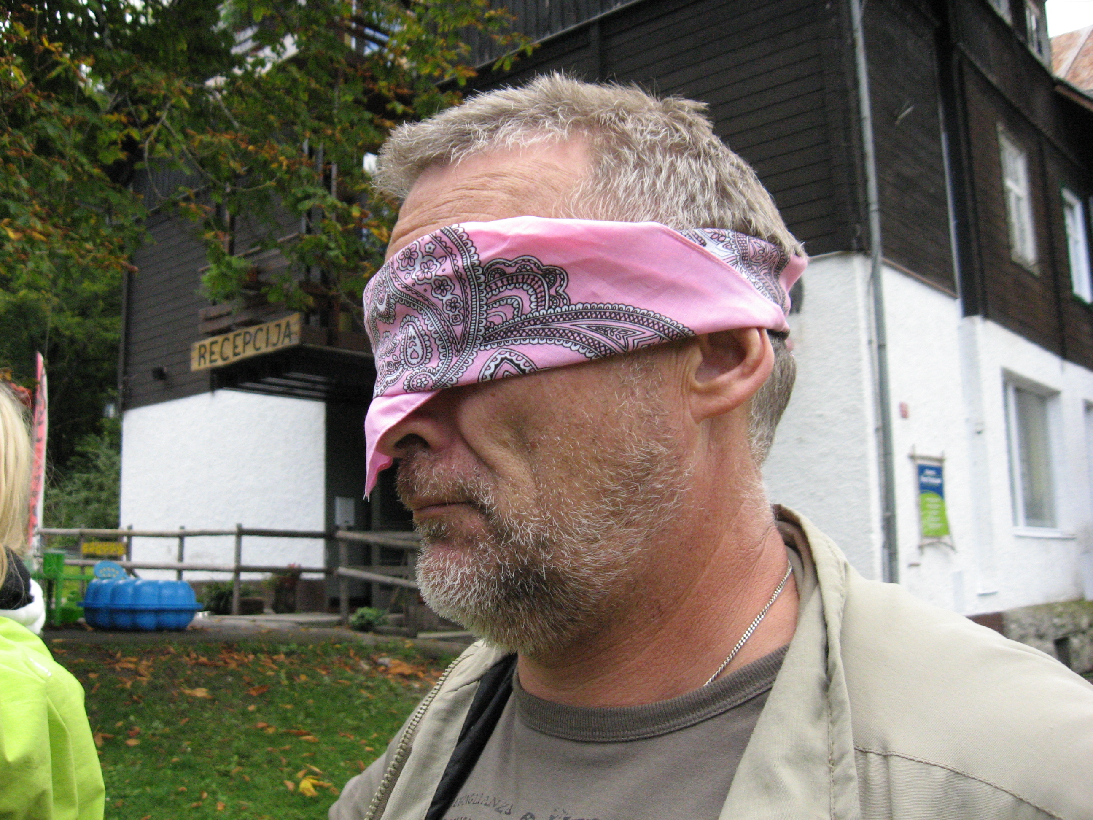

And how will we do it? It will be a training, but not one where you can sit back and relax. We will use active methods, based on experimental learning in combination with practical theory. It means that you will work in workshops, with role plays and exchange the experiences you have in your day to day work and work on concrete (individual) future project plans. We advise to bring of comfortable shoes (sport shoes) and comfortable cloths with you...

WHAT LANGUAGE WILL WE USE

However many of you speak many different languages the official training language will be English only. But don't be scared if you think your English will not be good enough... We will support you and many activities will be possible in your own language, because of the aim to reach your personal final result.

OUR AIM AND OBJECTIVES

Aim:
To increase voluntary participation of young people aged 13- 30 in on-going projects of the youth organizations and organizations working with young people facing social exclusion.

Objectives:
- To develop and improve participants’ basic skills in such areas as communication, project management, time management, leadership, team building,
- To develop specific skills needed for working with volunteers as recruitment, motivation, writing job descriptions, defining roles and responsibilities, assistance, monitoring and evaluation of experiences, awarding and appreciation etc.
- To establish international networking with the strong focus on pan-European cooperation of organizations working with local volunteers, for the benefit of youngsters facing social exclusion.;
- To establish a platform for experience exchange between participants;
- To introduce best practices by organizations working with volunteers,
- To strengthen the meaning of volunteering as a methodological tool for youth work;
- In the follow up to establish groups of involved young people, facing social exclusion, as a target for youth exchanges and candidates for EVS;
- To provide opportunity for the participants to discover their cultures and backgrounds.

INTERCULTURAL EVENING

On the second day of our training we plan to arrange the Inter-Cultural evening. You will present your own cultures – national, regional, personal or any kind of culture you feel you belong.

This presentations/activity should not be just a “lecture” so try to find most creative way to show your culture. It means that all options are possible. A culture may be presented by a song, a story, a poem, a dance, some local special drinks or food, etc. You can bring pictures, music or anything which you consider to be most appropriate to present your culture.( see also further on in this guide.)

COSTS

Board, lodging and programme costs will be provided and paid by grant from the National Agency of Flanders of the “YOUTH In Action” Programme.

Insurance will not be covered from Programme cost, what means that you are obliged to take care of PERSONAL travel and health insurance on your own.

THE REFUND OF THE TRAVEL EXPENSES:
There will be a refund of 70 percent of the real travel expenses (But they can not be more then the estimated amounts which were in the application to the national agency, a detailed list was sent to you a while ago… – IF YOU HAVE DOUBTS , PLEASE CONTACT US. )
We need to proof everything to the national agency: Without proof, unfortunately we can not refund. So please bring with you:
1 - a photocopy of your passport or identity card
2 - the original invoice of the flight ticket !( with clear mark how much you have paid) . This invoice should be addressed to yourself , or your organization or to “Wingerdbloei”.
(If you receive an electronic ticket, please print out a copy also for us. Next to this we also ask you to bring a copy of the monthly overview of your credit card. Please make black the other personal expenses (we wish to respect the privacy) and put on a mark or a stamp of your organization. This proofs the real cost of the ticket.
3 - A photocopy of your original flight ticket
4 - save all boarding passes ( we need them!)
5 - Save all original train and bus tickets or other tickets.
6 - If you need to travel by car to the airport: We need a personal signed declaration of honor about the exact distance between your home place and the airport and you need to fill your car with the necessary amount of fuel for that trip, on the same day as your traveling. Save the payment ticket and give it to us so we can refund you. Costs for parking will unfortunately not be reimbursed...Transfers by Taxi , also will not be refunded , because the NA does not except this way as being the cheapest ...
We wil try to reimburse you during the trainig, however, in some cases it will be possible that we will only be able to reimburse (maybe partly) by bank transfer... Please bring with you :

- your IBAN bank acount number
- SWIFT or BIC number
- name and address of your bank
Please note that we need to use the exchange rates of Belgium for foreign valuta...
VOL’N’ACTION for INCLUSION T(W)O(O)
Training course on volunteer resources management for young people facing exclusion
Programme* 27th November – 3th December, 2007, Dworp Belgium

 | tuesday  27/11 | wednesday  28/11 | thursday  29/11 | friday  30/11 | saturday  01/12 | Sunday  2/12 | Monday  3/12
08.00 |  | Breakfast | Breakfast | Breakfast | Breakfast | Breakfast | Breakfast
09.00 | Arrival of participants | Creating the challenge  ( Why inclusion ?) | Training  Project cycle  + time management | Training  Recruitment of Volunteers. Motivation.  Task division | Monitoring of ( target group) volunteers | Presentation of “Youth in Action” Program.  Common ideas for the projects. | Evaluation  & last commitments
13.00 | lunch | Lunch/Break | Lunch/Break | Lunch/Break | Lunch/Break | Lunch/Break | lunch
15.00 | Opening of the training  Hopes&Fears+  Common contract  Introduction to the program framework | Training  Team Work,  Group Dynamic | Training  Communication  +  Leadership Skills  and  “Booby traps” | Good Practice  (Visit to local organizations successful in volunteering) | Simulation game.  Debriefing Training | Next steps and networking. | Departure of participants
18.00 | Intro reflection | Reflection groups | Refl. groups |  | Refl. groups | Refl.groups
19.00 | Dinner | Dinner | Dinner | Dinner out | Dinner | Dinner
Evening | Ice-breaking games | Intercultural Evening at the Vol's Cafe | BELGIAN evening  with local volunteers | Free evening | Target group and participation values | Farewell Party
*this programme is subject to change

PREPARING FOR THE CONTENTS

In this section you can find web-links which will help to broaden your understanding of the “Youth In Action” programme, non-formal and intercultural education in the European context. These links will be useful for you before the training (in terms of introduction) and after the event (in terms of future project implementations as well as training opportunities).

General information on European YOUTH in ACTION Program

- http://ec.europa.eu/youth/yia/index_en.html
Information on the European Youth program. User’s guide is available.

- http://europa.eu.int/comm/youth/index_en.html
European Commission. Youth.

You can also contact your National Agency for further information.

Non-formal education and intercultural learning

- http://www.infed.org/biblio/b-nonfor.htm
Formal/Non-Formal/informal Education background
- http://www.efc.be/ftp/public/cpi/TCFF%20Intercultural%20Learning.pdf
Intercultural learning
- http://www.training-youth.net/INTEGRATION/TY/Publications/T_Kits.html
T-kit publications connected with European youth work

Information about SALTO (inclusion):
- http://www.salto-youth.net

HOW TO GET TO THE VENUE?
We will also send you a personally adapted guideline.
Use full website concerning Belgian airports :
- Brussels South- Charleroi : http://www.charleroi-airport.com
- Brussels national airport (Zaventem): http://www.brusselsairport.be/en/
- Belgian railways (NMBS): http://www.b-rail.be/nat/E/
Most of you will take the train from the airport to the venue.
If you fly to Brussels National airport (Zaventem):
Go to the basement of the building (there are signs) and buy a ticket for one direction to Halle. The price will be approximately 5 Euro per person in one direction. ( you don't need to buy a return ticket)
Save the ticket during the whole trip ( there can be inspection) and to give to us for for the 70 % reimbursement!

For those who arrive early and wish to do some sightseeing in the center of Brussels: Buy a ticket till the Brussels central station (there are lockers in the basement for your luggage). When you continue your journey to Halle, you buy a new ticket. (it is forbidden to buy the ticket direct from the airport and to interrupt your journey...) We will refund both tickets at the 70 percent base.
Leaving from the airport and going straight to Halle: there will be 3 options, depending on the time you take the train:
Option one: every hour ( till 22h) at 36 minutes past the hour: there is a direct connection ( you don't need to transfer from train)if you take the train direction “QUEVY”. You need to get of at Halle , your arrival time will be 16 minutes past the hour. For example you take the train at 15h36, you arrive in Halle at 16h16.
Option two : every hour ( till 22h) at 52 minutes past the hour. You take the train direction “De Panne”. You need to change at the North Station (Bruxelles Nord“ or “Brussel Noord “ : both languages, French and Dutch are used to indicate). You arrive there at 3 minutes past the hour and the train towards “Geraardsbergen” leaves at 14 minutes past the hour. You leave the train at the Halle train station at 35 minutes past the hour.
An example : you take the train at 19h52 at the airport , you change at 20h03 at Brussels North station and take the train direction Geraardsbergen at 20h14 , to arrive at Halle at 20h35.
Option three : every hour (till 23h) at 4 minutes past the hour, you take the train direction “Gent St-Pieters” you need to change at the South Station (Bruxelles Midi“ or “Brussel Zuid“ : both languages, French and Dutch are used to indicate). You arrive there at 25 minutes past the hour and the train towards “Geraardsbergen”(also) leaves at 38 minutes past the hour. You leave the train at the Halle train station at 48 minutes past the hour.
An example : you take the train at 18h04 at the airport , you change at 18h25 at Brussels South station and take the train direction Geraardsbergen at 18h38 , to arrive at Halle at 18h48.
In ALL THREE CASES WE WILL COME TO PICK YOU UP AT HALLE TRAINSTATION TO TRANSFER YOU TO THE VENUE ( it is only about 10 minutes by car). We will indicate later what time we will be at the station and how you will be able to recognize us.

If you fly to the Brussels South (Charleroi) airport. :
There are two options to get to the Brussels South train station:
option 1 : by public transport ( the cheapest)
A public bus (Line A) links all day long the Brussels South Charleroi Airport to the Charleroi-SUD Train station . Then you can take the train to easily reach any station in Belgium .
You want to combine these two services when you arrive in the airport ? You can buy a "bulk" ticket at the Airport desk in the Charleroi Airport( it is indicated). For approximately 10,50 EUR one way, you can use the public bus (Line A) and the train to reach any train station in Belgium. In your case you need to write “Halle” as the final destination.

You need to Buy this ticket at the airport at the counter in front of you when you leave the transit zone ( when you arrive in the arrival hall). Ask for the possibilities for a return ticket for Monday 3th of December. Save all tickets and invoices for the 70 % reimbursement!

The public bus stop is in front of the airport building! ( see also the website : www.charleroi-airport.com) and there is a sign ( direct connection to the Charleroi train station)

You need to take the train towards Antwerpen but you need to get out in Brussels South station ( which will be indicated as “Bruxelles MIDI “ or “Brussel Zuid “ : both languages ( French and Dutch are used to indicate). There you need to take the train to Doornik( Dutch), Tournai(French) or to Saint Ghislain ( only in French): You need to get of in Halle.
We will send you a more detailed and personally adapted schedule later!

OPTION 2: Private bus company

You take the private bus ( is indicated when you leave the building) towards the Brussels South station ( price is about 11 Euro, in one direction, tickets are sold inside the airport terminal (counter n° 1).). In the Brussels south station you need to buy the train ticket till Hamme ( the price will be approx. 3 euro in one direction)
We will send you a more detailed and personally adapted schedule later!

In BOTH CASES WE WILL COME TO PICK YOU UP AT HALLE TRAINSTATION TO TRANSFER YOU TO THE VENUE ( it is only about 10 minutes by car). We will indicate later what time we will be at the station and how you will be able to recognize us.

In case of emergency:
Henk: 00 386 51 412 568
Goele : 0032 (0) 497 94 21 25

THE VENUE ITSELF:

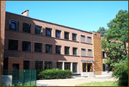
The venue “Hanenbos” ( which means “wood of the rooster”) is located near the small town of Dworp, in the surroundings of Brussels.
It is a typical location for youth work and offers plenty of possibilities for organising activities.

The rooms and sanitary accommodations are very sober without luxury. You can compare it with a youth hostel. Sheets and blankets will be provided, but you need to bring your own towels!

For the evenings there is a great bar, with a wide range of beverages for( for Belgian standards) democratic prices.
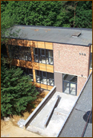
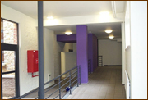
There is internet connection in the working rooms, ( But no wireless... so you will need a cable.)
Provinciaal vormingscentrum Hanenbos
Lotsesteenweg 103
1653 BEERSEL (DWORP)
Tel.: 0032 - 2-380 47 13
Fax: 0032 -2-380 47 14
e-mail: hanenbos@vlaamsbrabant.be
www.vlaamsbrabant.be/hanenbos

WHAT TO BRING WITH YOU

- Your personal clothes and hygienic needs (It is Belgium , so there is always a big chance on rain... Don't forget your rain coat!) The dress code is :
“ Wear the clothes which make yourself comfortable to attend this training !!!”
- Bring a warm sweater for the evening activities. (It can cool down quickly when evening falls…)
- Don't forget to bring your own towels!
- Please bring Euros (the Belgian currency) already with you from your own country. The venue will not change foreign currency and does not except credit cards (to pay your personals drinks, … during free time). Most shops in the area accept credit cards and Maestro. Many exchange offices will refuse certain currency or give you a very bad rate.
- Please ask your health insurance what documents you need in case you would become sick in Belgium... Bring these documents with you!
- A pen and paper for personal notes
- Information about your organization and home area (see further on):
ABOUT YOUR ORGANIZATION
Please bring clear information about the main activities of your organization, so that you can present it at an information market during the training course.
You can bring leaflets, posters etc. It would be nice if you could bring some information, which you have prepared with your target group youngsters together! How do they wish to present themselves???
But please notice that the space to present your organization is limited… Please note that, if you bring with you videos/DVD's, you will only be able to watch and show them during your free time which is sparse.
ABOUT YOUR COUNTRY/REGION/TOWN
Bring map, posters, postcards, and leaflets, etc. Also, please think about how to present your country.
An evening will be organized where each national group has a possibility to present themselves and their country. Please note that, if you bring with you videos/DVD’s, you will only be able to watch and show them during your free time which is sparse. We would like to ask you to make your presentation as interactive as possible. (Make the others sweat!!!)

LAST BUT NOT LEAST…
We remind you to bring gastronomic “treasures” from you region or country:
- food which is typical for your region (however, it may not be possible to heat food, and definitely not to cook it at the training centre) and drinks for the “intercultural evening“.
- Bring CDs of traditional / typical and party music or other things typical from your country that you want to share with us during the intercultural evening and during other evenings.
- We highly recommend to bring with you different games which can be used during informal times!

CONTACT DETAILS YOU MAY NEED

If you have an organizational question about the course, please contact
Henk : tel : 00386 51 412 568- henk_persyn@yahoo.com
or skype : “persynhenk”

If there is question you have that is connected with the programme, please contact
Henk Persyn: henk_persyn@yahoo.com . (00386 51 412 568)
or Agnieszka Pawlik : avanti@indexin.com.pl
or Goele Vercammen : project@wingerdbloei.be

See you in Belgium

The trainers and staff team

