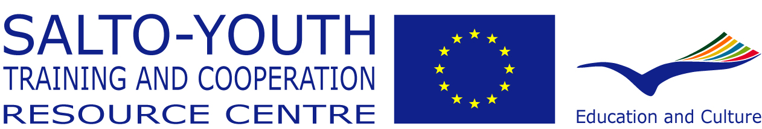 | 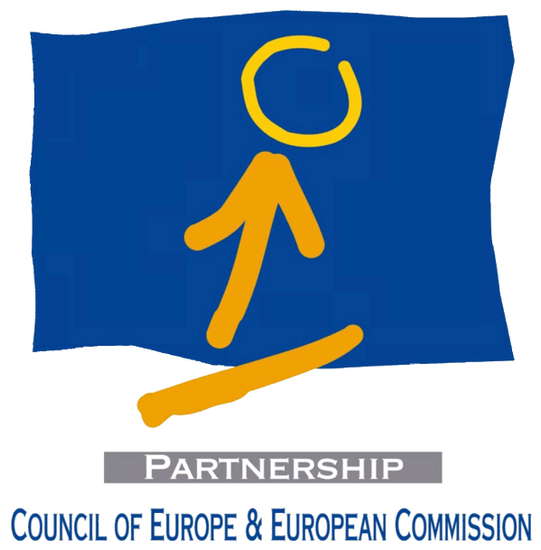

European Citizenship
Intercultural Training Courses
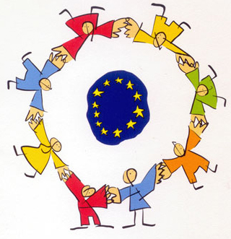

Course description for applicants
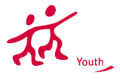
hello there!
Are you working with young people? Are you curious about this European Citizenship everyone keeps talking about? Are you keen on intensifying the European dimension of your intercultural work? Are your efforts supported by colleagues and your organisation?

Then the Training Courses on European Citizenship might be for you!

The six Training Courses organised from October 2007 to February 2008 constitute the central training courses on «European Citizenship» by the network of national agencies of the «Youth in Action» programme. They put into practice «Priority 1 – European Citizenship» of the «Youth in Action» programme by aiming to

«support the professional development of youth workers and youth leaders by extending their critical understanding of European Citizenship, by exploring and experiencing the potential of the notion of European Citizenship, and by enabling them to recognise and integrate European Citizenship in their youth work.»

Do you share this aim? Well then: why don't you read on and think about applying?


why european citizenship?!
European Citizenship has recently become a widely used buzzword and sometimes seems to be less beneficial for citizens than for political actors, but its promotion has been a longstanding priority of the Council of Europe and European Union alike – since 1998 have the two big European institutions worked together on European Citizenship.

This co-operation between the Council of Europe's Directorate of Youth and Sport on the one hand and the European Union's European Commission on the other hand happens in the framework of a partnership with the aims to:

- make young people and multipliers aware of human rights and the common values European citizens share and to provide them with the skills and tools to enhance their activities in this context,

- train, at transnational level, youth workers and youth leaders as well as other multipliers in the youth field, as well as to develop and consolidate innovative training approaches in this context, and to

- sustain and widen existing networks of youth workers and youth leaders; to promote the understanding of and respect for cultural diversity and intercultural co-operation.

Quite a few pilot activities have been run with youth workers and youth leaders between 2001 and 2006; a training kit (T-kit) was written and a series of shorter training modules was successfully tested. The new «Youth in Action» programme is taking these experiences one step further and makes «European Citizenship» a key priority by aiming to "promote young people’s active citizenship in general and their European citizenship in particular."

The Training Courses were developed to encourage the development of a critical, democratic and European Citizenship and in doing so, to support the implementation and quality of the «Youth in Action» programme.

Beyond these courses, the European Union and the Council of Europe support and organise a great variety of different educational activities on European Citizenship through instruments like the «Youth in Action» programme or the «European Youth Foundation». Projects range from introductory workshops to longer training courses; some of these activities are run by the institutions or their partnership directly, but the majority is implemented by partners such as non-governmental organisations. All of these activities are developed and put into practice with the vision for participants

«to develop a sense of time, space and place in contemporary Europe, the skills and motivation required to be active agents for democratic change while participating in the building of Europe and to provide the knowledge to make informed and future-minded choices within this context.»

The Training Courses on European Citizenship support this vision through a common curriculum which fulfills five objectives, namely to:
- critically explore the meaning relevance and implications European citizenship in
youth work in all its dimensions;
- promote and facilitate the active use of programmes and structures in support of
youth work on European Citizenship, including the «Youth in Action» programme;
- experiment and explore the potential of European Citizenship for active democratic change in society;
- associate the participants with the current discourse on European Citizenship (its concepts, formal meanings and expressions);
- exemplify the connection between European Citizenship, Human Rights, Democracy and Intercultural Learning and the underlying values.

Still interested? Read on!
target group
Each of the Training Courses on European Citizenship is intended for 25 individuals who

- are working with young people in a professional capacity on a paid or voluntary basis (e.g. youth workers, youth leaders, community and social workers, teachers);
- have experience in developing and managing directly a project with and for young people;
- have organised or co-organised at least one youth project with a European dimension;
- are committed and motivated to work directly with young people on issues related to European Citizenship;
- are supported by their organisation in their current and future work;
- have a general understanding and knowledge of youth and youth work realities in their contexts;
- are motivated to undergo training and able to attend the course for its full duration;
- are able to work in English and
- are resident in a Member State of the Council of Europe or in another country signatory to the European Cultural Convention.

Does this profile fit you? That's great!

main themes
The main themes are reflecting the aim and objectives of the Training Courses. They are:

European Citizenship: What is European Citizenship? How can it be used in youth work? What is the political relevance of the concept?
Europe and European identity: What does it mean to be European? How European are young people today? Where does Europe come from? What is its future?
Citizenship in Action: What does it mean to be an active citizen? Are young people active citizens? Should youth work encourage active citizenship? How could that be done?
Dilemmas around European Citizenship: Is it possible to be a critical European citizen? What about the world? How can European citizenship become reality?
Democracy, Participation, Human Rights and Intercultural Learning: What are the connections between these themes, practices and concepts and European citizenship?
Youth in Action: How can European Citizenship be approached in youth work? How can the «Youth in Action» Programme support youth work on European Citizenship?
programme flow
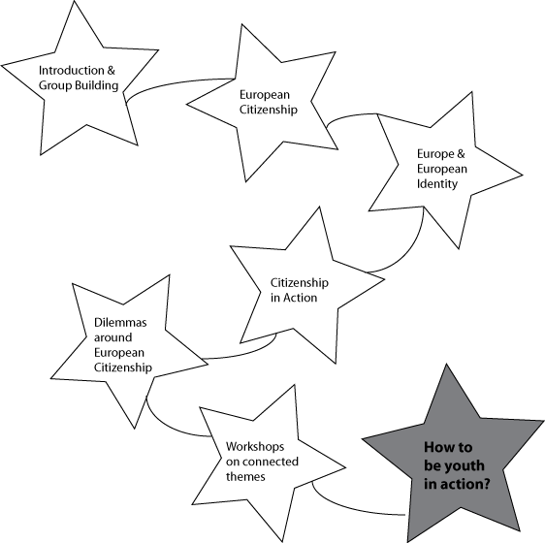

So do you think this could be for you? Go on, fill in the form and apply!

how to apply?
➔ If you are a national from one of the so-called “Neighbouring Partner Countries”
- in Eastern Europe and Caucasus (Armenia, Azerbaijan, Belarus, Georgia, Moldova, Russia, Ukraine)
- and in South East Europe (Albania, Bosnia and Herzegovina, Croatia, Former Yugoslav Republic of Macedonia (FYROM), Montenegro, Serbia),
please apply through the following on-line application form:
http://www.extraweb.coe.int/team40/citizenship/default.aspx

Deadline for this application procedure: 15 July 2007.

➔ If you are national from one of the so-called“Programme countries” (i.e. where there is a National Agency of the Youth in Action Programme), please follow the procedure and different deadlines described in the webpage below:
http://www.salto-youth.net/EuropeanCitizenship/
Thank you and… good luck!

