27/10/2026

“Accessibility is the Aesthetic”: Online Event Marking the Completion of P.A.I.R.

Tuesday, November 3 2026 | 15:00 EET / 14:00 CET | Online | Free participation

On Tuesday, November 3 2026, the European project P.A.I.R. (Paving Accessible and Inclusive Realities) will host its final online event, titled “Accessibility as Aesthetics.” The event brings together the artistic works, experiences and tools developed through the collaboration of artists and cultural organisations in Greece (liminal), Cyprus (Alternative Brains Rule) and Estonia (Estonian Agrenska Foundation).
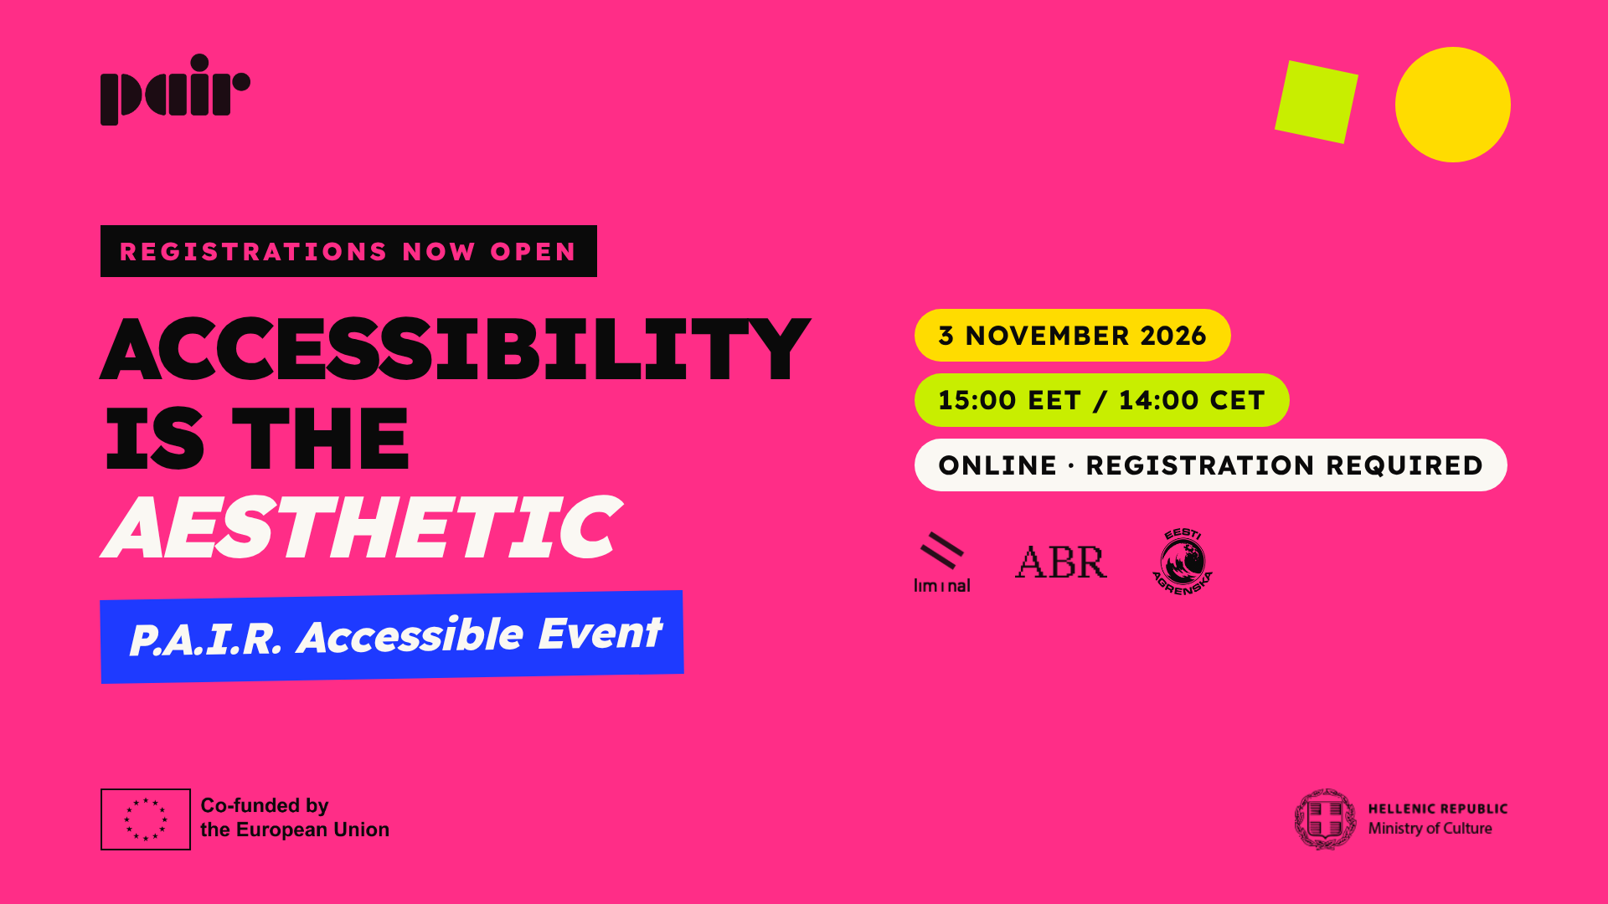

What will the event include?
The event will present the works developed as part of P.A.I.R., through conversations with the artists about the ideas, creative choices and challenges that shaped their creative processes.
Participants will also have the opportunity to watch a first excerpt from the documentary capturing the journey of P.A.I.R. and explore material from the Creative Accessibility Methodology Manual and the project’s digital zine.
Through artistic examples, shared experiences and open discussion, we will explore how accessibility can become an integral part of the creative process, what challenges arise in practice, and which approaches can inform future artistic and cultural initiatives.
Accessibility and languages
The event will be held in English. The following interpretation services will be available during the event:
- spoken interpretation into Greek and Estonian,
as well as
- sign language interpretation in Greek Sign Language, Cypriot Sign Language and Estonian Sign Language.
Interpretation will be available through separate channels, allowing you to choose the option that best suits you. Further details will be provided after registration.

Find out more about P.A.I.R.: pair.liminal.eu/

Useful information
Date: Tuesday, November 3 2026
Time: 15:00 EET / 14:00 CET
Duration: 1 hour 30 minutes, including a break
Location: Online
Free participation, with registration via the link below
https://us02web.zoom.us/meeting/register/dEcm-_6vSsaDtYpFSrMW3g

For any questions, please contact us at info@liminal.eu

Follow P.A.I.R.
pair.liminal.eu/ | Instagram | Facebook | LinkedIn

P.A.I.R. is co-funded by the European Union under the Creative Europe call (CREA-CULT-2024-COOP-1) Project Code: 101173834. With the financial support of the Hellenic Ministry of Culture.
Views and opinions expressed are, however, those of the author(s) only and do not necessarily reflect those of the European Union or the European Education and Culture Executive Agency (EACEA). Neither the European Union nor EACEA can be held responsible for them.





